The legacy of my family’s possessions after the Holocaust can be summarized in two images: a modern supermarket and a box of deteriorating clothes.

Both my parents were born in the same little town, Lask\*, in Poland.

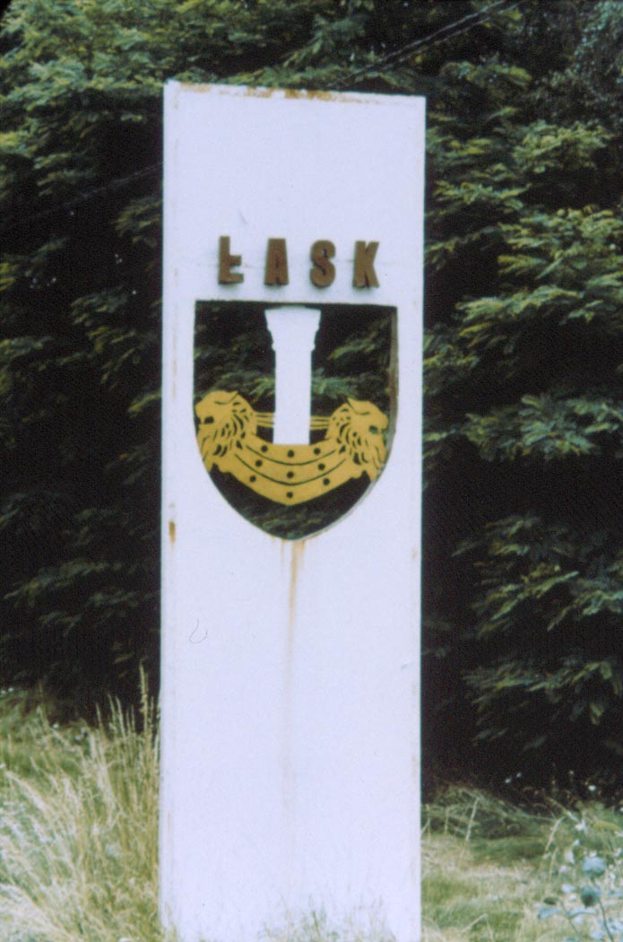

They were born in 1923 and were 16 when World War II began. Their families were religious. My mother was one of four children and my father one of eight. Neither family was wealthy: her family was poor and his family was poorer. What they had in abundance was love and a way of life rich with tradition.

In 1991 my family went to Poland to visit Lask. Someone told my father that his house was still standing and he wanted to see it. My mother, who died in 1970, was very much on my mind and I wanted to see the streets where she played as a child. And so we went…

As we approached Lask’s town square, a Supersam grocery store was pointed out to me. The big store looked out of place in the town of lovely older homes and I thought the oddity of the place was being noted. Not so. That grocery store stood on the parcel of land where my mother’s home once stood. The Nazis needed to widen the intersection because the road was too small for their vehicles so my grandparents’ home was destroyed.

My mother’s family lived in a fairly nice part of town, just a few steps from the market square. The area was charming and I liked it. I stood on the corner with the grocery store and looked at what my mother must have seen when she left her front door. It was as close as I was ever going to get to visiting these grandparents.

Looking around the town square I asked where was my father’s family’s home? His family didn’t live in this nice part of town. His house was in the part of town that was poor even before the war. In fact, when the Nazis made a ghetto in the town, it was on his family’s block of houses.

We found his home in a very different area. There were empty lots around some of the buildings on his street.

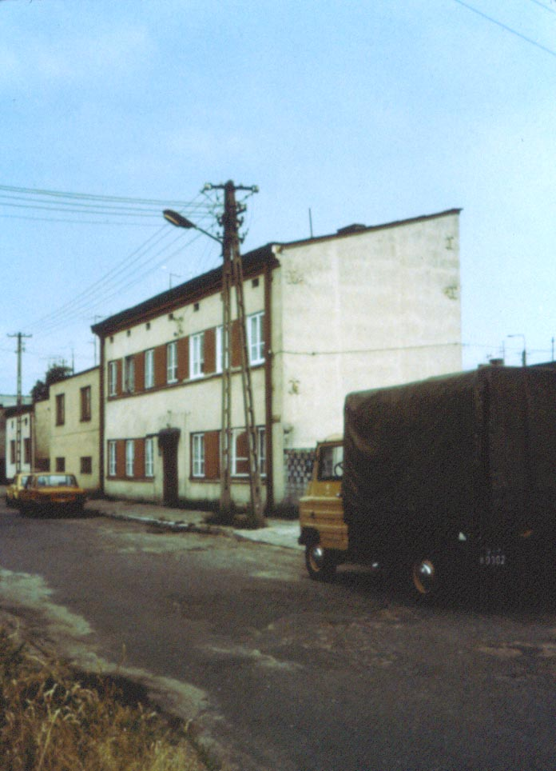

When his house was identified I looked at a very large, colonial-style home with an entry way and center hall. It was a big building and I was surprised he lived there since the family was poor. It would have been a large home if only one family lived there but it was divided into four apartments, none of which was large. My great-grandfather built that house and the family owned the entire building.

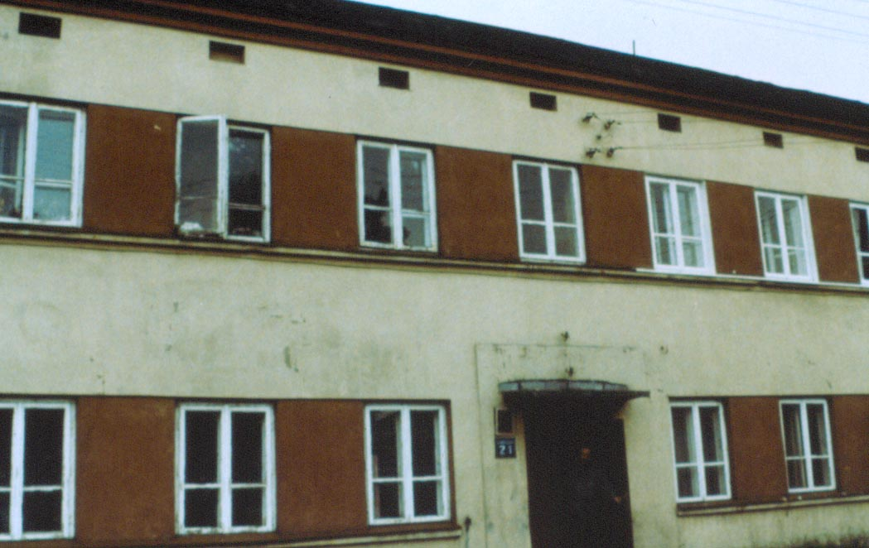

We knocked on the door and the current resident of my family’s apartment opened up and asked us what we wanted. He recognized my father (who looks very much like his parents) as someone who lived there before the war so he let us inside.

It was a small apartment with one bedroom, a living area and a tiny kitchen. I looked at it and had to ask my father how his parents slept 8 children in that small space and he replied, “a couple of the brothers slept in a bed over here…and a couple of the brothers slept in a bed over there…” My grandmother must have opened the door to let her children out to play because otherwise it would be hard to move in that place with all those children!

I mentioned the current occupant of the apartment let us in but not before he asked my father a question to verify his family identity. He asked about an event that happened immediately after the war when my father returned to Lask after years in concentration camps.

My father tried to return to his home but was turned away. He got a policeman to escort him so he could at least get into the back yard to retrieve something his family buried early during the war. The man asked what was in the box my father dug up?

The box contained clothes, their most valuable possessions. My father said the clothes looked beautiful but when he touched them they crumbled in his hands.

A box of deteriorating clothes…is what was left after the Holocaust. The image of normality was there but the substance was gone.

\*Note: A major Polish Air Force base was built near Lask so the whole nature of the community is now different.

Esther Toporek Finder, President, *Generations of the Shoah – Nevada* and

Member of the Coordinating Council of *Generations of the Shoah International (GSI)*