By Lydia Lebovic

In January of 1944, I turned 16. I was living with my mother (my father passed away in 1935), my two sisters and my brother in a modest home in Ungvar, Hungary. The town of 40,000 (9,000 of which were Jews) was located in the beautiful mountain range called the Karpathos. On March 19, 1944, Ungvar was occupied by German troops and I knew little about how much my life and future would be drastically changed.
My family had hardly finished Passover dinner when the authorities issued the first order. All Jews were told to pack 40 pounds of their belongings, essentially food, clothing and necessities. Everything else we owned was to remain in our houses and money and jewelry were to be turned over to the authorities. The police escorted us out of our homes and into a lumber yard that had been converted into a ghetto. We lived there, in horribly inhuman conditions, but we were all together and that gave me security and comfort.
In May, the next announcement informed us that we were going to be sent to central Hungary for agricultural work. My family marched to the railroad station without my older sister, who remained behind to tend to the sick in the ghetto hospital. The four of us were pushed into a cattle car with 60 to 70 other people, our relatives and neighbors from home. The three-day journey was a nightmare. Men, women, the old and young were squeezed tightly together, some panicking, others crying, screaming or praying.
My mother made her way to the car window to look out. She returned to us with tears in her eyes. She gathered us around her and told us, "We are not going to central Hungary; we have just passed the Polish border." She held my little sister in her arms and spoke to my brother and me. "I don't know what will happen to us. We will be separated. I can't look after you, but promise me that you will obey all orders. Do as you are told and you will survive. I will meet you at home. They are taking us to Poland, where Jews are persecuted. I know this road--we used to travel this way to visit your father's family."
And so, after three days on the train, we arrived in Auschwitz, where I was separated from my mother and little sister forever. I remained alone in Auschwitz a short time, never believing the stories about the crematorium, about the smoke, about the massacre going on all around me. All I wanted to believe was that I would be reunited with my mother and siblings.
In June, I was taken with others to Hamburg, Germany. I was put in a work camp and the conditions were better. We worked very hard , but because I didn't see any crematorium or smoke, my belief in my mother's words was strengthened.
A year passed into January, 1945. I turned 17 and was the youngest in the camp. My barrack-mates surprised me with a birthday cake, made of their daily rations of black bread, margarine and red beets. We all celebrated.
However, my happiness did not last long. In February, we were all taken to Bergen-Belsen in Germany
and, my G- d, what a sight it was. As we entered the main gate, there was a huge crematorium on our right with all four of its doors ajar. Dead bodies were all over the floor. I thought, "Is this what was waiting for me? Is this the end? Is this possible?" I kept asking myself how it could be. I had worked, prayed and obeyed for a whole year. I had to live. I had to tell my mother all I did.
While I was in a pondering stupor, a sudden commotion arose around me. We were told we were free to go into the camp. As I ran toward it, somebody called my name. It was a friend of my family who looked at me, bewildered, and said, "Have you seen your sister? When did you get here?"
I was shaking and screaming, "My sister! Where is she? I just got here. Tell me where she is!" She responded, "In Barrack 26--that way."
I started running again and finally reached the barrack. There, on the floor, between the sick, moaning and dying, I found my sister. She was so weak that she couldn't get up and her voice was hardly audible. I knew there and then that I needed to find food to save her. Typhus was raging throughout the camp. There were mountains of dead everywhere. It was Hell on Earth. But we knew the end was close. We could hear

--

artillery fighting day and night. Bergen-Belsen was surrounded by the British, and there was no way out for the SS guards. They were hiding in their barracks.
On April 15, the British army finally rolled in. The SS guards came out with a white flag and white armbands. We were free--the camp gates were opened and I started out towards the men's camp with hopes of finding my brother. After asking around, I found someone who told me where I could find him. I could hardly believe it was true.
I got to his cot and asked a man nearby, "Does Bert sleep on this cot?" "Yes, he does,"the man answered.
"Could you tell me where he is?"
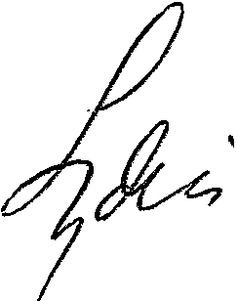
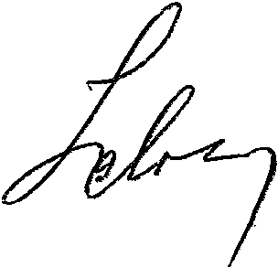
The man looked at me and smiled. "Oh, yes," he said. "He went to the women's camp to look for his sisters."
I found him, minutes later, feeding our sister.

I · ;
.
: :· - ,
, l.i -

. ·1 .
; • . :

... ..

