Eva Vayda nee Weisz

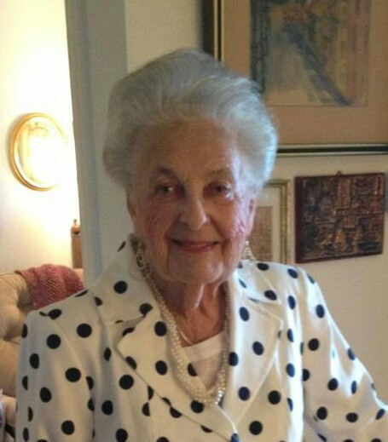

I was born in Mesobereny, Hungary on April 12, 1926. My parents divorced and both re-married. My mother, sister and I moved to Debrecen when I was about 18 years old. By this time the Germans were already in Hungary (Spring, 1944) and Jews had to wear a Star of David but we could still travel. My sister and I decided to take off our coats (with the star) and walk around. I didn’t look Jewish.
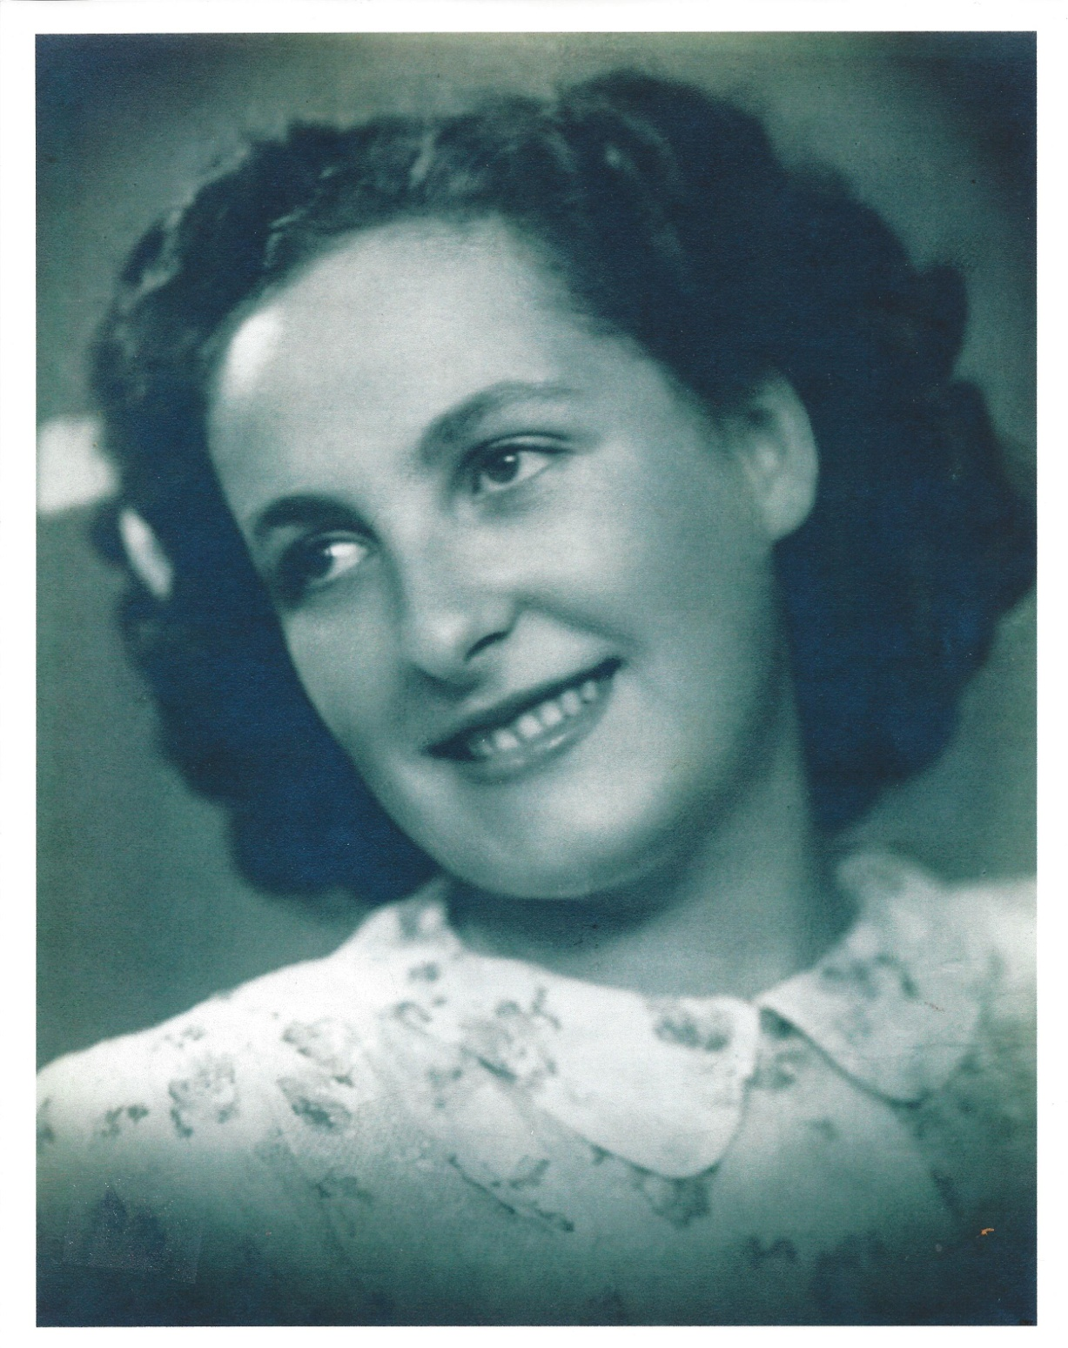

Under German influence, Jews were sent to ghettos. We were first sent to an apartment house that was restricted to Jews. It was a small ghetto. We were then moved to a larger ghetto. At this time the Allies were already bombing. We were then sent to a brick factory where Jews were assembled. Then we were shipped to Auschwitz. I was with my mother, sister and my step-father’s parents and we had no idea of where we were going or what was happening there. Nobody knew. We were told we were going someplace to work.

We were put into cattle cars. At the border between Hungary and Austria we were stopped at a town called Kassa. That was where prisoners were transferred. We were stopped and searched. “You are owing to your country to leave everything behind” is what we were told. I owed the country that kicked me out? I was singled out and searched. Why? People in the station watched and nobody helped me. A German came over and said I should be left alone, I was now his prisoner.

We traveled about a week with only the food we packed with us and arrived in Auschwitz-Birkenau on July 1, 1944.
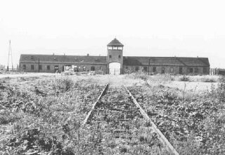

The doors to the cattle car opened and we were ordered out and lined up.

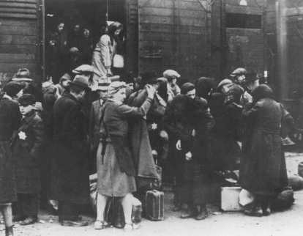

The elderly and children were directed to the right and workers to the left. Nobody had a chance to say goodbye and we were told we would see each other later.
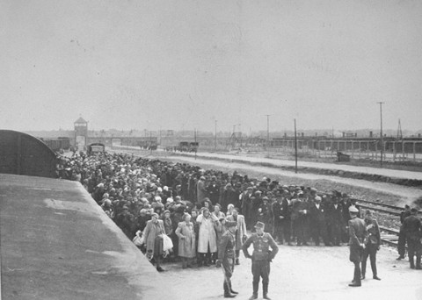

There was a selection. I found myself facing Dr. Mengele. He was handsome, elegant and polite.

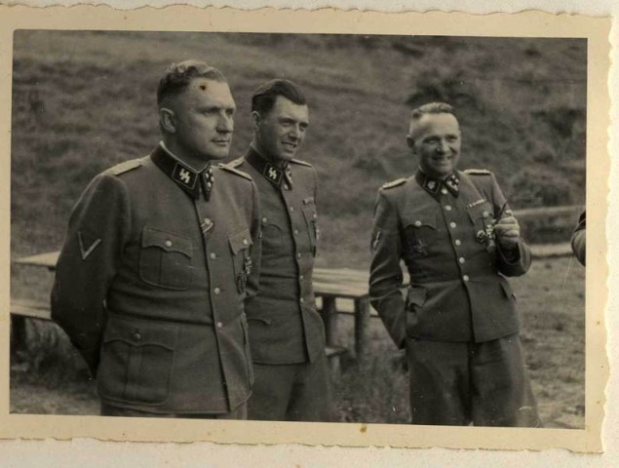 (Dr. Josef Mengele is in the center.)

I was with my mother, Lidia, and my sister, Anna. Mother told my sister to say she was 18 and I was told to say I was 20. My sister was years younger but she was tall and looked like she could be 18. Children were sent the other way and we wanted to stay together.

We went through the processing in Birkenau. We were ordered to strip and our heads were shaved. We did not recognize each other without hair. We were given striped uniforms and disinfectant was sprayed on our genitals. We were not tattooed. We were not given anything to drink and we were so thirsty we drank dirty water which made us sick. There was no barrack for us so we had to wait but we were assigned to barrack 7.

We asked about our relatives and one of the heftling (prisoners) pointed to the chimney and said “there they are”.

There was no work for us at first so we sat until it was time for the roll call and we were counted. The food we got was a watery soup with some scraps in it – the kind of scraps fed to farm animals. My sister would not eat that soup. We were also given some black bread which we shared with my sister so she would eat something.

One kapo hit me on my elbow. I don’t know why. My mother tried to shield us from beatings so she got hit more than my sister and I did. Our first job in concentration camp was to clean up the area around the barracks. We had to clean up stones.

Our time in Birkenau was only about 3 – 4 months. During that time there were regular selections and also the dead were taken away. In the fall of 1944 we were selected to be sent to another camp: Ravensbrück. This was a women’s camp and conditions were better: we had beds and there was a shower. There were also non-Jewish women there, including some German nuns I saw.
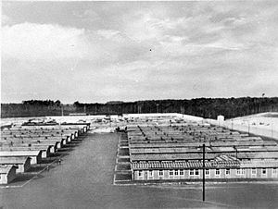 Ravensbruck camp

In Ravensbruck there was a selection and I was pulled out by a German doctor. I was selected to work in the camp brothel. I was young and attractive and did not look Jewish. My mother begged the doctor not to take her child! The doctor let me go back into the line with my family.

We were then sent to work in the Siemens factory at Neustadt bei Coburg in Germany. Mother was assigned to work in the kitchen and she was able to get us some extra food. My sister and I were repairing telephone cables to be used at the front. The cables were made of rubber and we were given sharp knives to use to fix them. We used those knives to sabotage the cables so they would leak. During the days the Allies were bombing so we worked at night. It was cold and snowy outside but we worked mostly inside.

The Obersturmführer (concentration camp supervisor) was from Czechoslovakia and he ordered an emergency evacuation of 400 women before the SS could come and kill us. We marched out and he personally provided food for us. Five of us marched together: my mother and sister were with me as was a mother and daughter from Czechoslovakia. That mother spoke French which was helpful because as we marched we came upon French military prisoners who had been assigned to work in the forest. They told us to stop marching because the Americans were nearby. Instead we were to go into the forest. But then later we were told we had to leave the forest because the Nazis set fire to it so we were taken out along with the French as “military prisoners” so they could bring us to safety.

The American 3rd Army liberated us and the Captain ordered the local people to give us food, clothes and a place to live. Mother got fabric and sewed clothes for us.

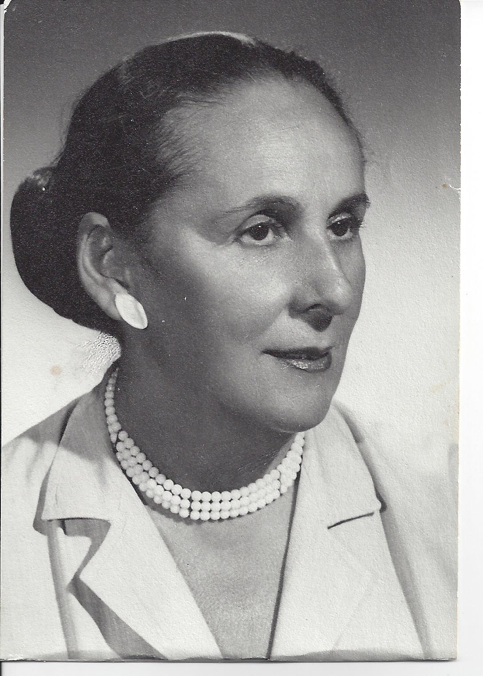
My mother, Lidia Weiszbrun Boszormenyi, in 1958

Captain Kahn wanted to marry me and take me to America. He said we should not return to Hungary because the Communists were there but Mother wanted to go home to see who might return. Nobody from our family returned: at least 100 members of our family were killed in the Holocaust.

I met my husband after the war. He was a distant cousin of mine and 16 years older than I.

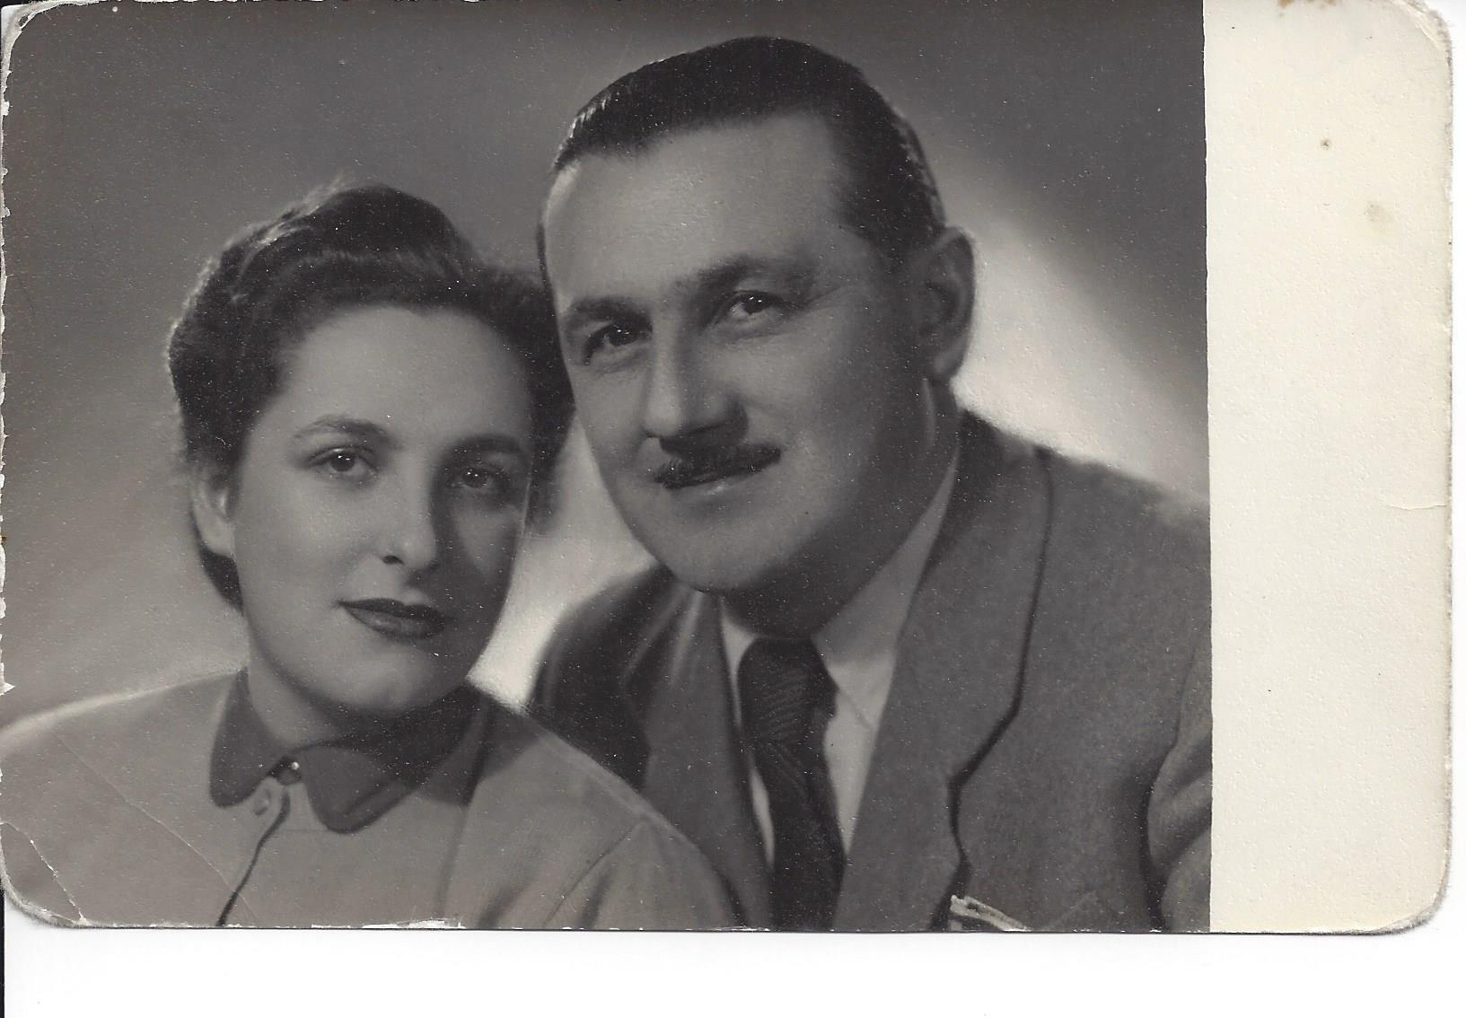
Eva and Andrew Weisz in 1950

We married and he tried to resurrect his family’s business but the day came when the Communists confiscated our home and business saying they belonged to “the people”.

My son and daughter were born. We stayed in Hungary until 1956 when we were able to make our way first to Austria, where we awaited our visas. We came to the US on an air force flight from Munich and we first settled in Camp Kilmer, New Jersey.

My sister came to the US four years before we did. My mother came in the mid-1980s.

After the war I learned some English so when I came to America I picked up the language faster than my husband. Our children learned English very quickly and they helped us. In fact, my daughter helped me study to become a radiology technologist.

We lived in New York for a while and moved to Lake Havasu, Arizona because I had asthma and needed the climate there. I came to Las Vegas, where my daughter lives, in July 2013.

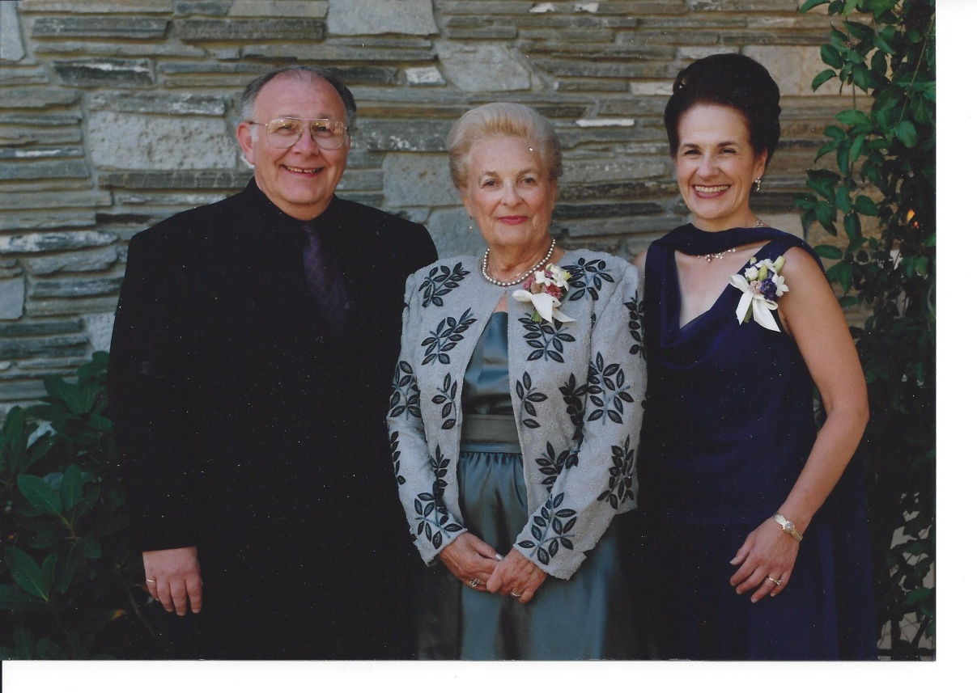
Paul Vayda, Eva Vayda and Judith (Vayda) Levine
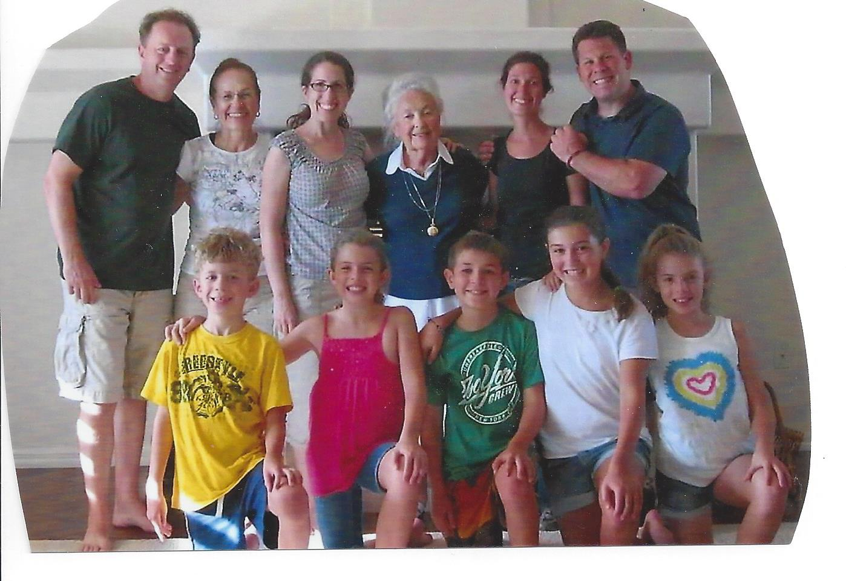
Kevin Corbett, Judith Vayda Levine, Julie Corbett, Eva Vayda, Sari & Jeffrey Vayda, Nathan Corbett (7), Katie Corbett (10), Andrew Vayda 9, Emily Vayda 10, Eily Corbett 10.
My first grandson, Daniel Kowalsky, 1989.

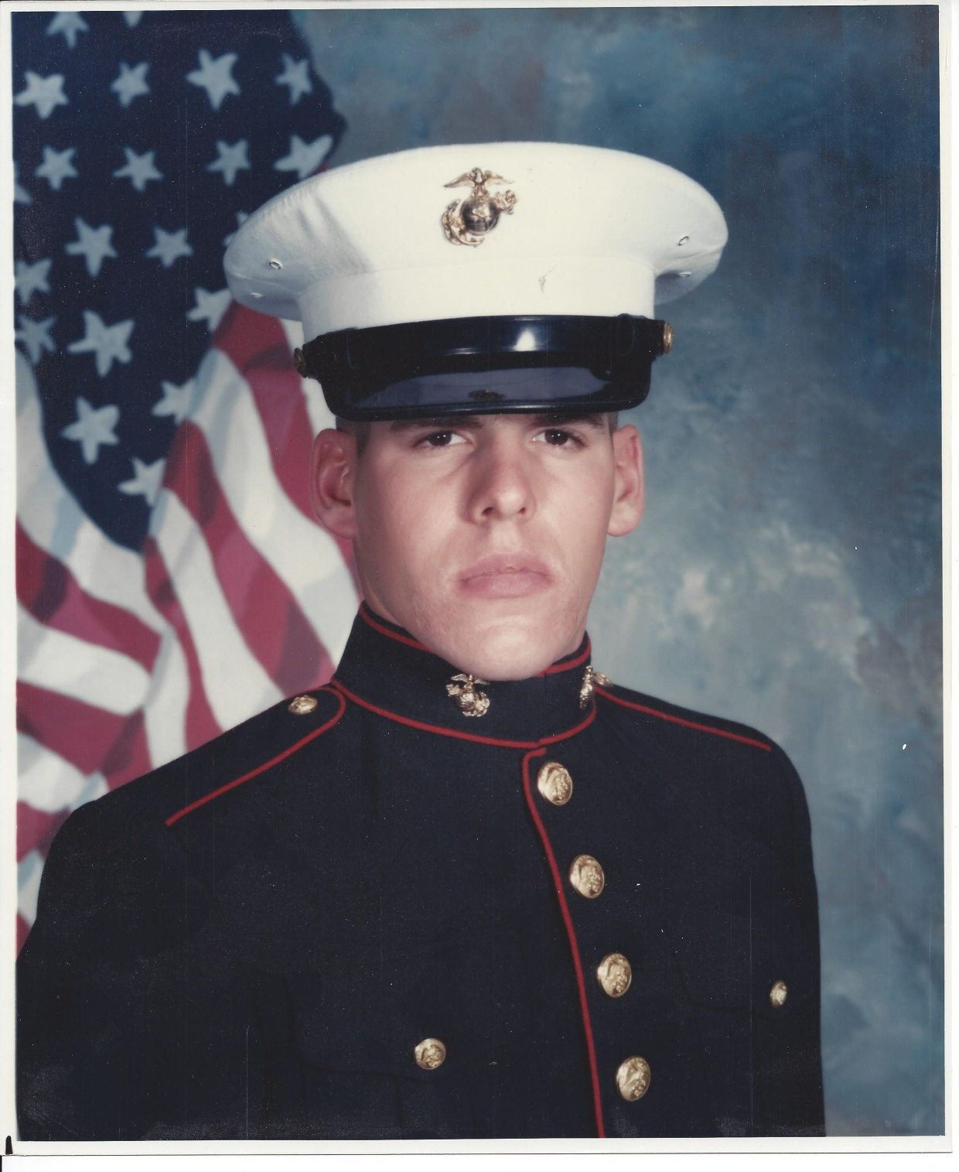

Paul Vayda holding grandson Andrew, wife Marilyn, son Jeffrey and wife Sari holding Emily, older son Michael and wife Shari holding Charlie
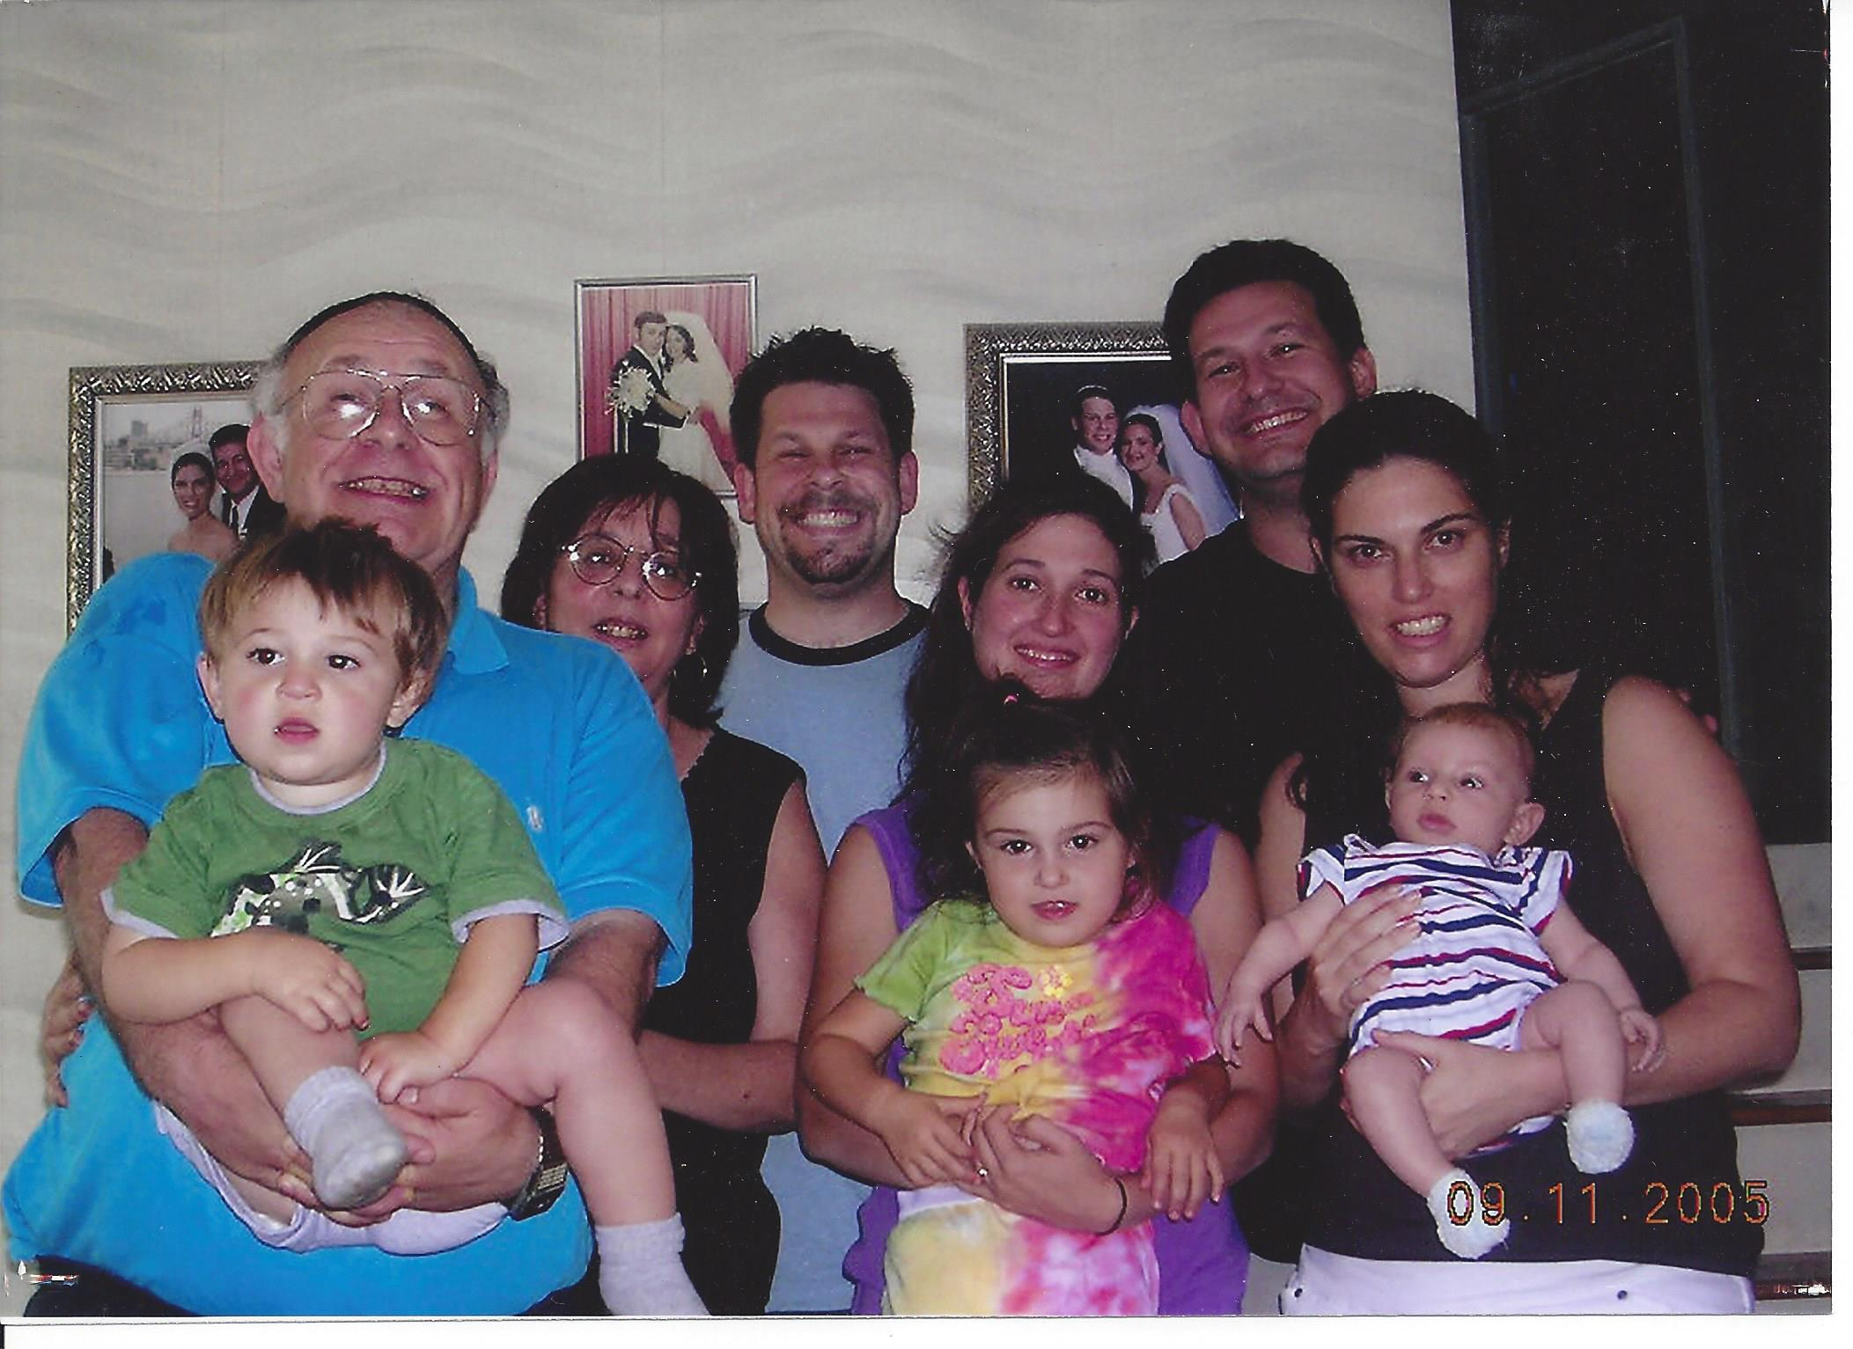
Five of my seven great-grandchildren in 2007: Katie Corbett 4, Emily Vayda 4, Eily Corbett 4, Nathan Corbett 22 mo, Andrew Vayda 4 