My Family

Thomas Figueras

(Note: I changed my name to Figueras from Nadelstecher when I was 28 years old.)

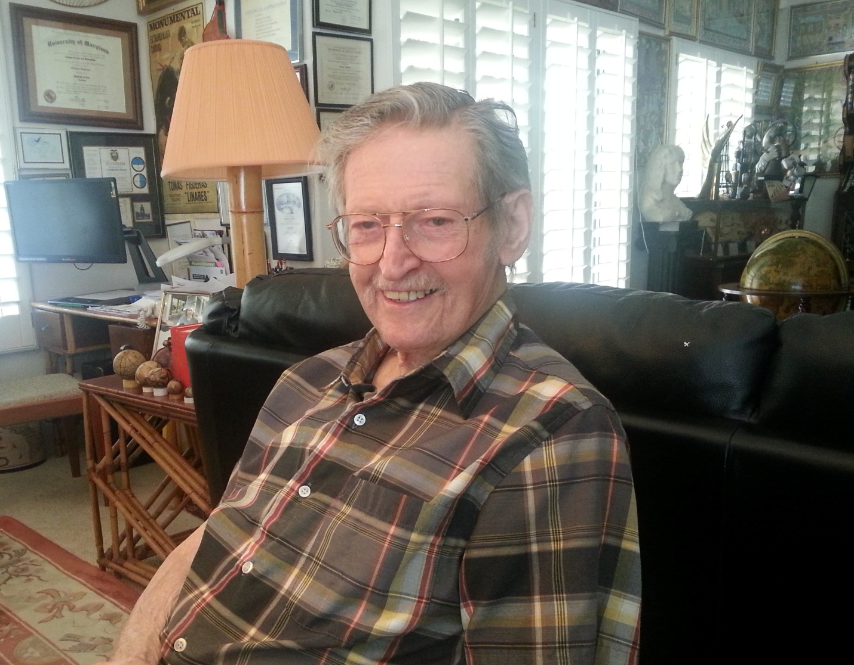

Tom Figueras in his Las Vegas home – November 10, 2014.

My brother was a child violin prodigy.

Ladislav (or Lazlo, though we called him Laci) Nadelstecher was born in 1921. He was the first of three boys born in our family. Our father played the violin, usually as part of a duo with a friend. He kept his violin atop his bureau. One day my brother tried to reach it so he was given a small violin to play and got some lessons from our father. Soon Laci surpassed him.

Our aunt was a violin teacher in Lemberg, Poland in Galicia. My brother was sent to study with her but her surpassed her, too, so he was sent to the music academy in Budapest. At that time we lived in Uzhorod, Czechoslovakia.

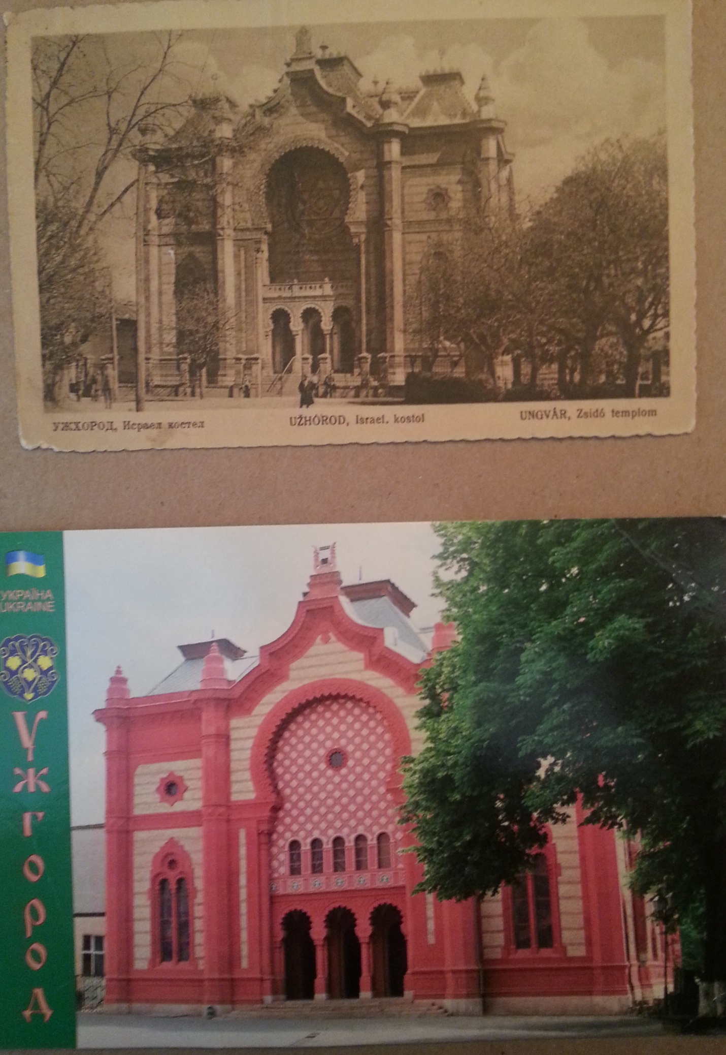

This was the synagogue in our town. This beautiful building was refurbished and is now a concert hall.

My brother had to have his appendix out and the surgeon who operated took a private performance of *Song of India* by Nikolai Rimsky-Korsakov as his fee for the surgery.

Laci was 14 when he met legendary musician [Bronisław Huberman](http://en.wikipedia.org/wiki/Bronis%C5%82aw_Huberman). Huberman said Laci was going to be one of the best violinists of the future. There were photos taken and stories written about this meeting.

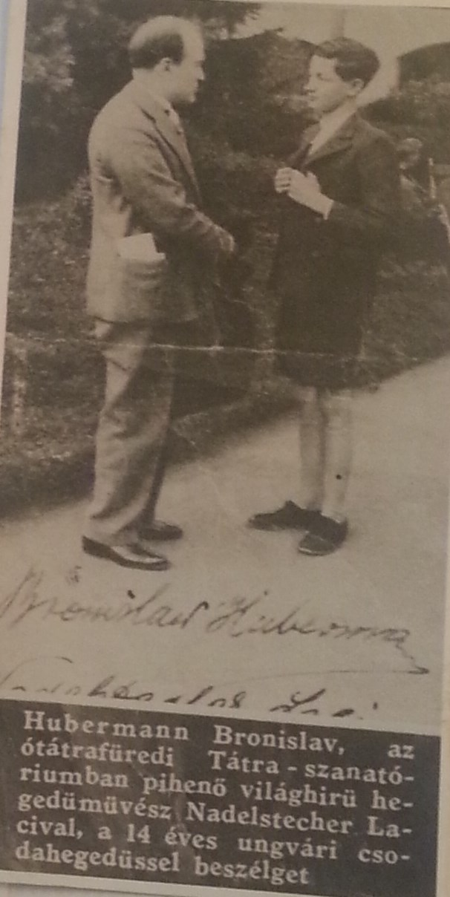

In May, 1944, Laci was sent to [Auschwitz](http://en.wikipedia.org/wiki/Auschwitz_concentration_camp)-Birkenau and then to [Buchenwald concentration camp](http://en.wikipedia.org/wiki/Buchenwald_concentration_camp). Buchenwald had an orchestra and he played in it. The SS used him to perform at parties so he was in a privileged situation.

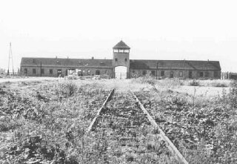 Auschwitz-Birkenau

There was an underground Communist party in Buchenwald. The Nazis found out who was the leader and executed him. The other party members had a memorial service for him and Laci was asked to play [*The Internationale,* the Communist anthem. Someone reported this to the Nazis and Laci was taken out of Buchenwald into Weimar for questioning. He was probably tortured. He was also thrown out of the orchestra so he became an ordinary prisoner. His status changed from Hungarian Jewish prisoner to political Hungarian Jewish prisoner and was sent to a sub-camp of Buchenwald (Wolfen).](http://en.wikipedia.org/wiki/The_Internationale)

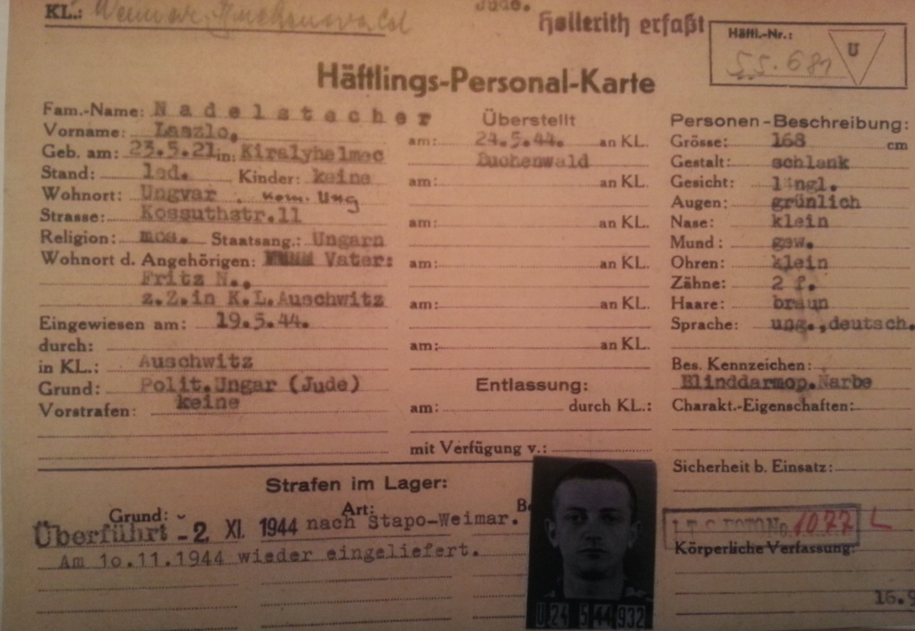

Prisoners Personal Card with my brother’s status as a political Hungarian Jewish prisoner.

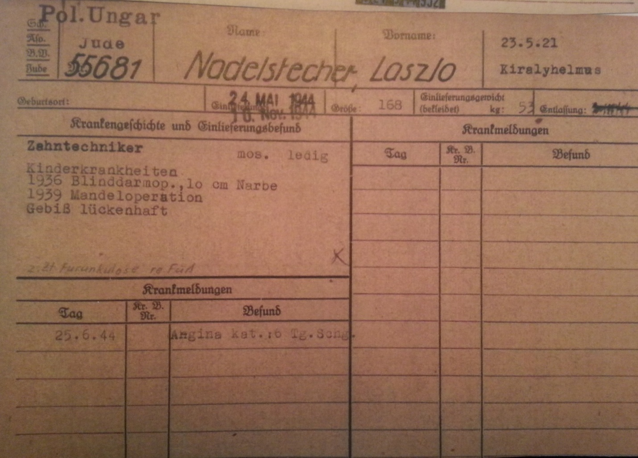

This card showed my brother’s childhood medical issues including his tonsillectomy.

Then Laci was sent to [Bergen Belsen](http://en.wikipedia.org/wiki/Bergen-Belsen_concentration_camp). There had been a [Death March](http://en.wikipedia.org/wiki/Death_marches_(Holocaust)). I don’t know if he died on the March or he might have died in Bergen-Belsen. The last information I got was about his transfer to Bergen-Belsen.

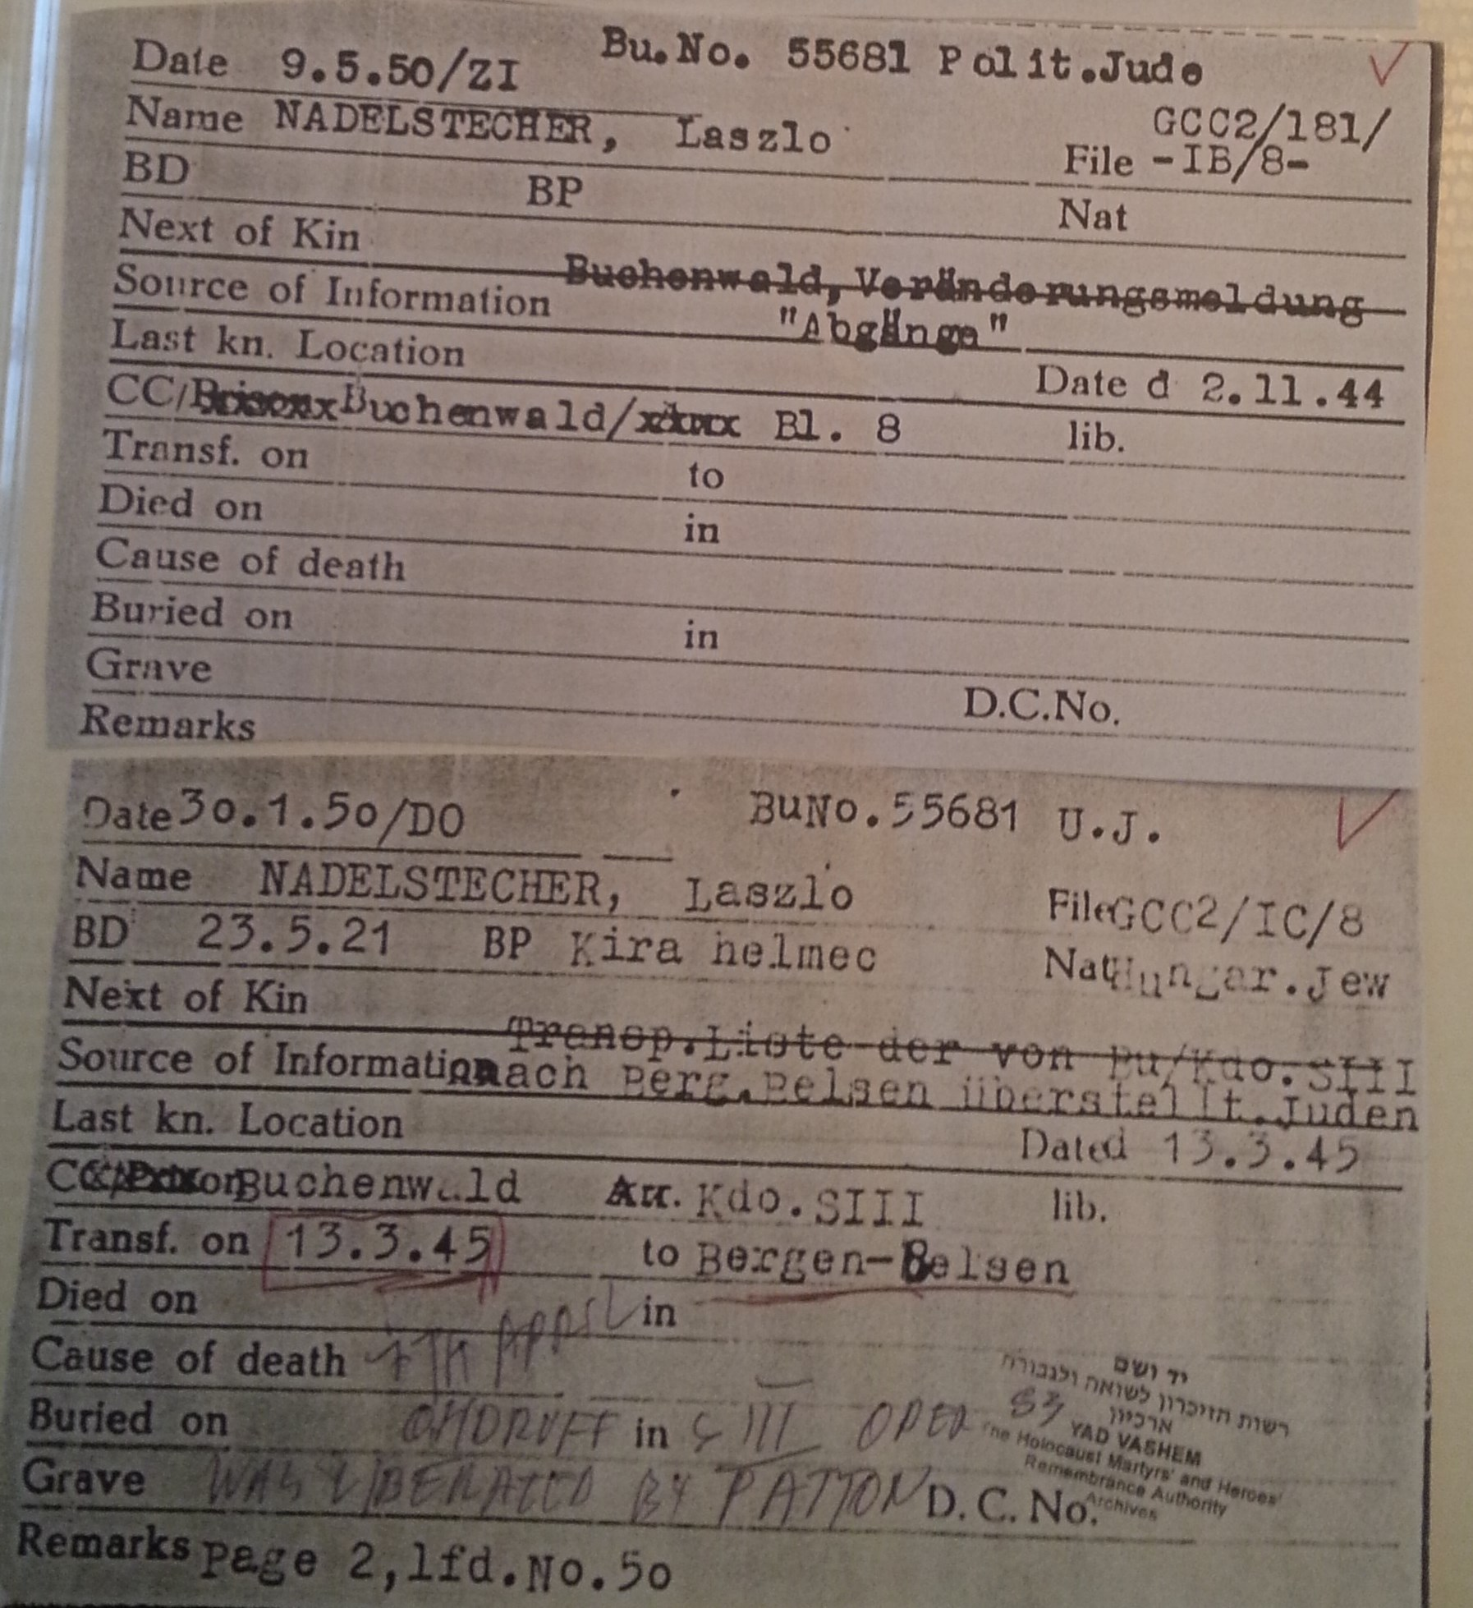

The last time I saw Laci was in Auschwitz-Birkenau. My brother Paul and I were together when we saw Laci and it looked like he was leading a group of men as if he were a Kapo. We ran to him and he put his hand in his pocket and gave us some sugar. That was an amazing thing in a concentration camp.

My brother Paul was a smoker and he gave away his bread for cigarettes. If not for this, he might still be alive…

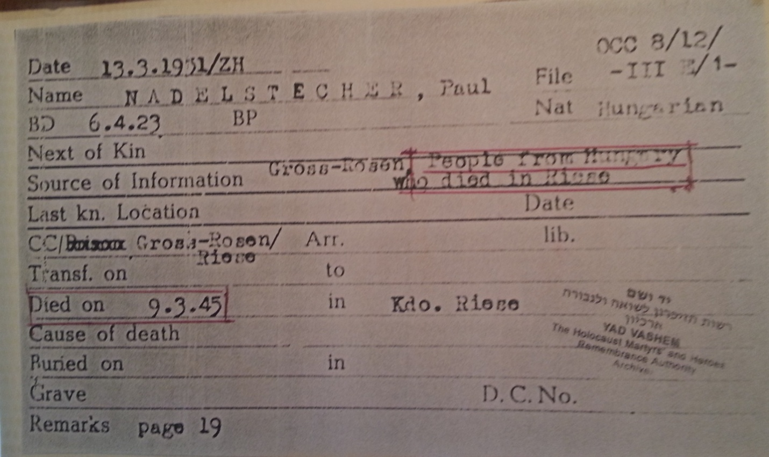

Record of my brother Paul’s death in March of 1945

Our father was a dentist. When we arrived in Birkenau, Dr. [Josef Mengele](http://en.wikipedia.org/wiki/Josef_Mengele) asked all the dentists to step forward. My father naively thought he would be able to practive dentistry. Instead he had to remove gold teeth from Jewish victims…

My mother was carrying a bag with sausages on the cattle car en route to Birkenau. We ate some on the train but she wanted to save some for our destination. That shows how little we knew about Birkenau.

I had an uncle who was a big, husky guy. My mother told him to take good care of her son. He had a hernia bag and that got the attention of the guards. /they saw the bag and decided he could not do heavy work so they marched him naked to the gas chamber.

My mother did not survive and there are no records on her.

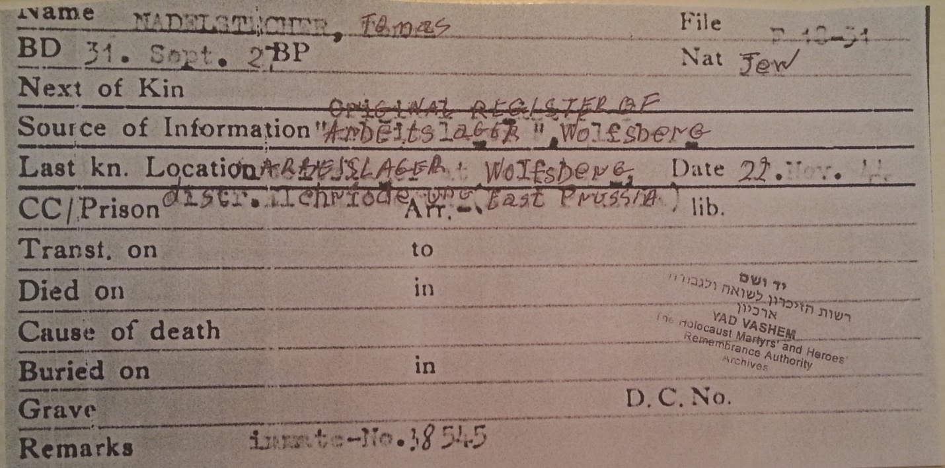

A copy of an identity card with my wartime information.

Immediately after liberation I was in the hospital in Bergen-Belsen. The Swedish Red Cross asked if I wanted to recuperate in Sweden. I asked if they had sardines. Yes, by the ton! So I went.

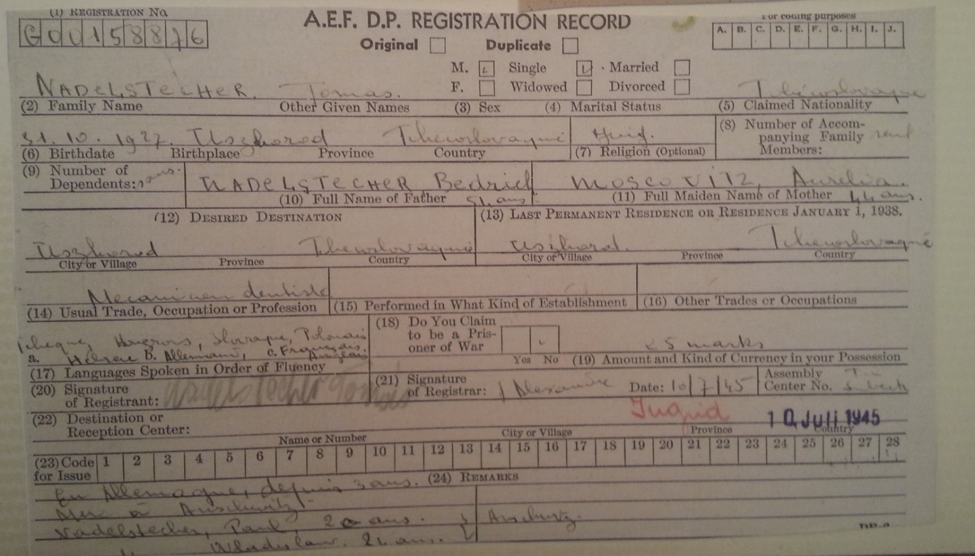

My Displaced Person (DP) registration record.

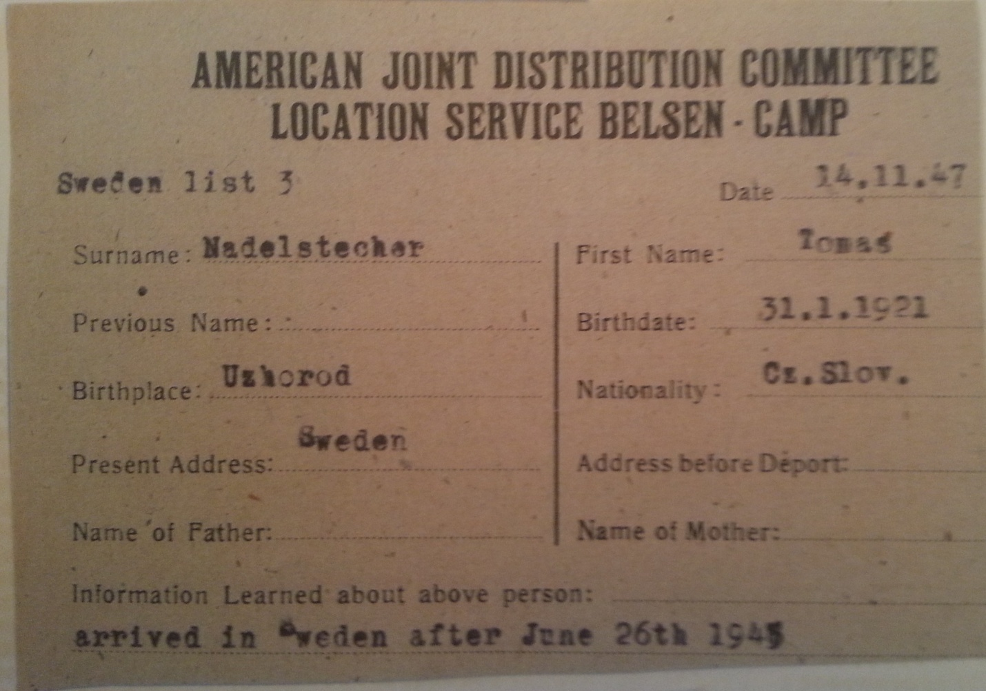

I was taken by train to the German port of Lubeck and then via boat to Sweden. After some time in quarantine (some of the prisoners had TB and were sent to a sanatorium), we were given good food for six months. Then I went to Stockholm and looked for a job. I found a job that did not require me to speak the language: I delivered flowers for a shop.

Then I worked as a sailor. My first stop in the Americas was Venezuela. I took a bus to the town square and ran into someone I knew from my home in Europe and he encouraged me to jump ship and stay with him. I got a job with a Swedish company called Astra. Today that company is known as AstraZeneca.

I wanted to return to the sea as an officer so I learned to be a radio operator.

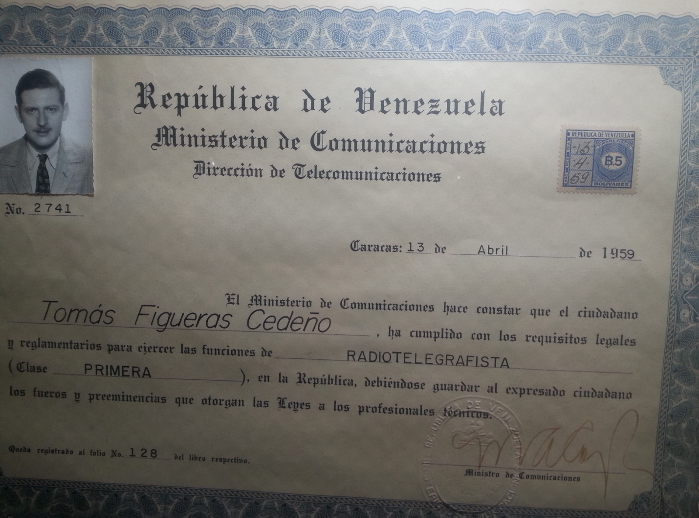

I came to the US in 1960. I wanted to leave Venezuela because there had been a coup d’état and I worried the country would become Communist.

I speak 11 languages: English, Hungarian, Czech, German, Yiddish, Swedish, Spanish, Portuguese, Russian, French and Italian. I understand Polish but do not speak that language. I have visited 175 countries. I was the international marketing manager for a telecommunication equipment company.