CURRICULUM VITAE (1944-1945)

I was born March 20, 1938, in Budapest, Hungary. The month and the day are important. Why? I will explain immediately. My sixth birthday, March 20, 1944 was a Monday and my parents wanted a big celebration, so they invited our relatives to come the day before, on Sunday. And Sunday, March 19, 1944 my birthday present was the Nazi occupation of Hungary. Early that morning German troops occupied our homeland. My relatives arrived pale and nervous. They gave me a few toys and hurried back to their homes. They said “It’s a deadly day, the Nazis are here!”

In two weeks all the Jews had to wear the yellow Star of David on their clothes, including the children. 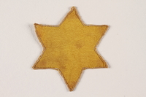

The next Nazi order: we had to leave our home and move into a ‘Star of David House’ (also known as a yellow-star house) where we lived with three families of strangers (one family to one room). I developed a nervous tic because I couldn’t even bring my toys with me.
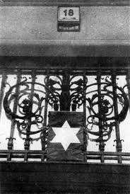 A yellow star house in Budapest (Yad Vashem)

My parents could not work because the fascist government rule, the numerus nullus, forbade highly educated Jews from holding certain jobs. My father was a dentist, my mother was an actress. Later I will explain why that job was life-saving for her.

Sometime in the summer I became sick. I had the infectious disease scarlet-fever and had to stay in a dark cellar, without windows, under quarantine. In the fall of 1944 a Hungarian fascist gang, the Arrow-Cross group, occupied our house and carried off the men and women between 16-60 years old. I remained with my elderly grandmother.

My father got the opportunity to escape from the fascist gangs. He ran back for us to the Star of David house and we went into the Wallenberg organized ghetto (officially it was the International Ghetto, or a Saved ghetto).

An old brickworks building was the assembly place for other Jews and several thousand people were crowded together. That was where my mother was sent. A young Arrow-Cross man pushed her into a hole full with feces and urine and guffawed. After a few days they started walking. They walked for several days on what has become known as a Death March. If somebody couldn’t walk the fascists shot him/her.

The distance between Budapest and the Hungarian-Austrian border approximately was 171 kilometers (103 miles). When the tortured Jewish group arrived to the Hungarian border city of Hegyeshalom, an elegant gendarme captain stopped my mother. “You are Manci Kalman, true?” My mother’s stage name was Manci. Early in her career (1921) she acted in a city, Debrecen, and that gendarme studied in the local university at that time. So after 23 years he recognized my mom because, when he was a student, he was one of her fans. The gendarme said: “When I will call your name you can step out from the group and I will send you back to Budapest”. This was the first miracle for us in the brutal war. All the other Jews there were transported to Auschwitz-Birkenau. (After the war we were informed that man was a cruel captain.)

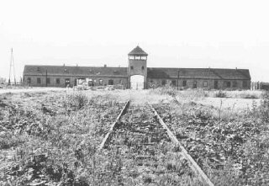 Birkenau

My mother also came to the safe house and we were together again. There were about 20-25 people in one room and we slept on the floor. In December we saw that some of the neighboring houses became empty. We heard shooting every night, but it was “normal” because there was a war and the Soviet army bombed Budapest.

One night an unusually polite arrowhead group came to our house. They commanded us to go to the foyer. My mother asked one of the men: “I have to dress up my boy in warm clothes?” The young Hungarian fascist smiled: “No, no, we will go just a short distance”. The house was one block from the Danube River but we didn’t know the Arrow-Cross group shot the Jewish people, including the children, into the icy Danube every night.

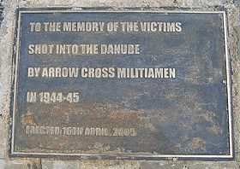
Plaque at the memorial in Budapest to the Jews murdered at the Danube River

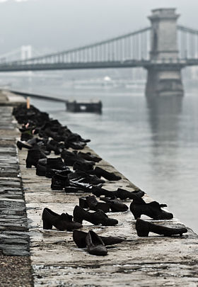
Shoe memorial at the banks of the Danube River where Jews were murdered in Budapest.

While we gathered in the foyer, another group of armed and uniformed men arrived. I don’t know who they were – maybe Zionist disguised as Arrow-Cross men, or honest police. The members of the two groups started to talk and our rescuers drove away the fascist gangsters. This was the second miracle for us in the brutal war.

The rescuers told to us: “At this time the big ghetto is safer than these international ‘safe- buildings’ near the river, so tomorrow morning we will go with you to the big one”. They gave us escort to the gate of the big ghetto, but drunken fascists waited for us inside the gate. They started to hit us with truncheons. My mother tried to save me with her body so a fascist repeatedly hit her arm. Her arm swelled up. Afterwards we had to stand in a row and one fascist commanded: “Take out one stinking Jew and I will shoot him!” I clasped my father’s hand and trembled. They picked out a man and shot him immediately. A few people tried to escape and started to run and the gangsters shot after them, but they were very drunk and the fugitives got away.

We went into a house in the ghetto. All the rooms were very full. I started to cry and said: “Please, try to look for another room!” My father became angry, but there wasn’t another option so we went into a kitchen. The next day a bomb hit the very packed room which we left the day before. Everybody died there. This was the third miracle for us in the brutal war.

During the last days of the siege of Budapest we stayed in the air-raid shelter day and night. We didn’t have food or water. My mother was terribly hungry and weak and she fainted.

On January 18, 1945 nervous German soldiers came into the shelter and asked us if we knew another exit from the cellar. Nobody answered them and the Germans hurriedly went out. A short time later, Soviet soldiers forced their way into our place and said: “You are liberated!” They tore off the yellow star from our clothes and one soldier gave me a slice of bread. We went out to the battle-scarred street.

On the main square of the ghetto we had to climb through a big hill of corpses. That didn’t disturb me. I was used to corpses by then. When we arrived at our house, our apartment was smoldering. One of the last bombs of the fight hit two of our rooms and our furniture was in flames. That didn’t disturb my parents - after all we survived the unbelievable ten months.

Yes, we were alive! Yes, we were free!

And since 1945, January 18 is my second birthday….
Tamás Földes

