Samuel Newman

I was born in Maków Mazowiecki in the Warsaw region of Poland on February 10, 1934. When the war broke out I was 5 years old.

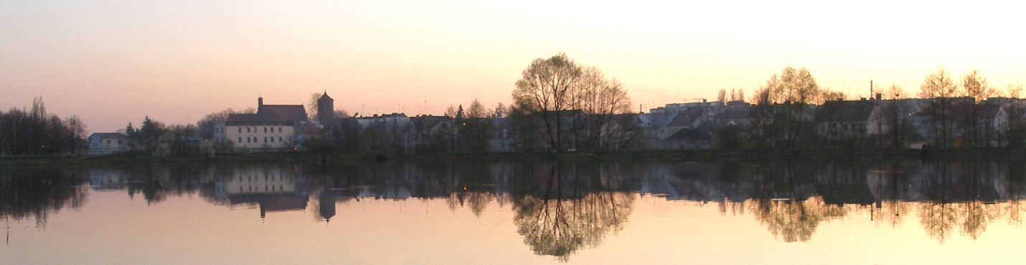
Makow Mazowiecki

My father was taken as a slave laborer by the Nazis but he escaped. Our family then ran away but I don’t remember exactly where because I was so young. I remember we had a horse carriage when we left Poland and went to Russia.
We were four children and our parents. My father’s name was Moshe and my mother was Rivka Leah. Our family name was originally Neiman (alternate spelling Najman). My siblings were two sister, Zivia, Chava, and my younger brother Anchel. He was 4 at the time.

One day in Russia my brother and I went to pick sunflowers in the fields near where my father was working. We had to cross railroad tracks. I crossed safely but Anchel fell on the track in front of a train and most of his arm was cut off. That was in 1943.

Later my father was taken to the Russian Army and my mother remained with the 4 children. My mother gave us some of her food and therefore did not have enough to eat and I think she died of hunger.

My oldest sister, Zivia, was taken in by a Jewish family. The rest of us were taken to different orphanages. I went to Kirgistan. I was there from 1943- 1946.

They did not feed us well so we went to farmers to steal food from their cold storage places on the farms. Children were sent to pick up heavy loaves of bread from the bakery. I stole one and buried it in the snow. I went back later and ate the whole loaf.

I was in touch with Zivia and she told me our father came back after the war. I showed her letter to the people at the orphanage and got a pass to travel to see him.

Zivia was working at a sewing factory. I arrived at 10:00 at night and the factory was already closed. I was 10 years old and alone. One Kirgiz family took me to their home and fed me. They gave me meat and that meal was so good I still remember it.

The next morning they took me back to the factory and my sister brought me to our father. I did not recognize the man in a uniform. He took me out and bought me a roll. It was so good – I had never had one before.

In 1946 we assembled as a family – except for Anchel, my younger brother. We could not find him. We left for Poland and had to leave Anchel in Russia. On the train my father met a woman. They later married.

Back in Poland, Zivia joined an organization that was helping Jews get to Palestine. My other sister and I were put into a Jewish orphanage: Legnica in the region of Wrocław. I was there until 1951. I was treated well and the JOINT (American Jewish Joint Distribution Committee and Refugee ... ) supported us.

I attended Jewish school and studied over the summer so I could skip a grade and catch up on my education.

In 1951 I left to study in Breslau (also known as Wrocław ) in Poland. It wasn’t until I went back to Poland that I started to hear about what happened to Jews who remained there during the war.

I learned graphic arts until 1955 and then applied to college but was rejected because I didn’t belong to the Communist party. Instead of college I had to go to the army. I served one year.

My father applied for papers to go to Israel and when they came, I was kicked out of the army.

In 1957, we went to Israel and started working with a printing company doing commercial slides that were shown during movie intermissions. I had a big share of this market. In 1961 I left and started my own studio.

I served three months in the Israeli army. I had basic training because I also had served in Poland. I was trained as a medic in Israel but that work wasn’t for me.

Originally I met my wife in the orphanage in Poland. She was a little girl then. We met again in Israel in 1960 and got married in 1961 and had two children: a boy and a girl.

In 1968, we came to the US. I always dreamed of coming to the America. We settled in Queens, New York. I found a job at the Federation of Jewish Philanthropists as a graphic artist. After four months I left and started my own company. I developed a business for typesetting and digital imaging. I closed the operation in 1997 when personal computers ruined our business. I then worked as a stock broker and day trader. I am now retired and trading my own accounts and some others.

My father died in 1997 in Israel at the age of 91.

My wife and I came to Las Vegas in 2004.

