Jacques Ribons

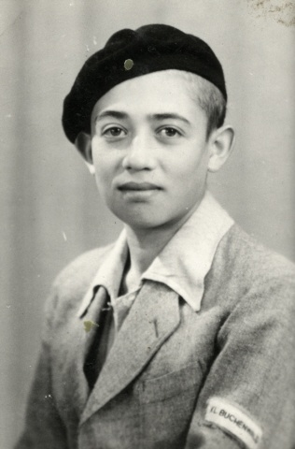 Jacques Ribons in 1945

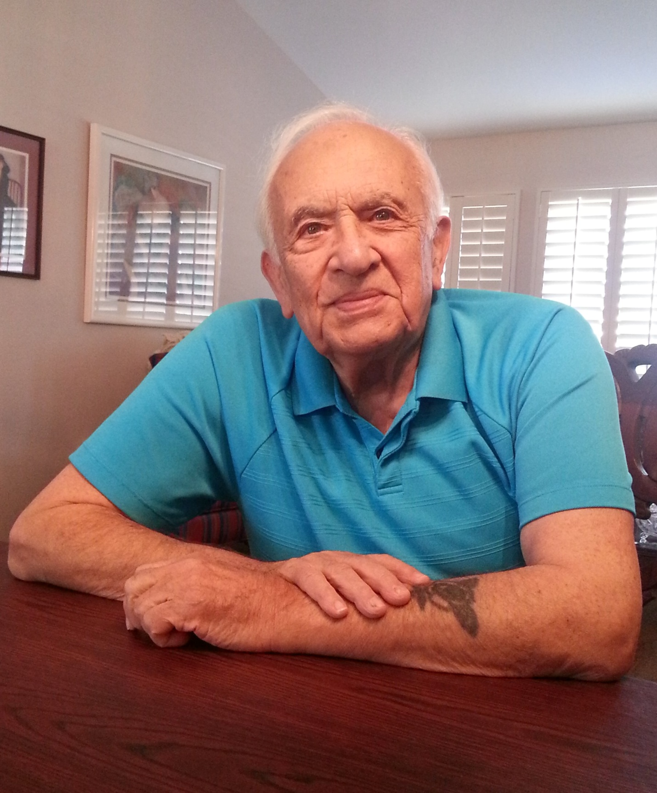
Jacques Ribons in 2014

I was born in Strzemieszyce, Poland, on August 15, 1927. This area is near the German border and there were lots of Hasidic (Orthodox) Jews in our town. We were not particularly religious; my mother more religious than my father. My grandfather had been a teacher and my father, Paul Rybsztajn, was a merchant. My mother, Bella, took care of us. We were three kids and I grew up with a brother, Bernard, and a sister, Esther.

Before World War II broke out there were some Jewish refugees who came from Czechoslovakia so we had an idea that the Nazis were not good to our people. When the Nazis invaded Poland on September 1, 1939 I was only 12 years old. The brutality of the Germans as they came into Poland was unconscionable. They took educated people, Poles and Jews, and we never heard from them again.

Our town was not bombed very much. The Nazis came in and rounded up people. The Germans did not know who was a Jew but the Poles pointed them out.

My father had been ordered to sign up for the Polish army and was told where to report. He went but the draft board kept moving as the Germans advanced so my father was never able to sign up. Somehow the Germans got him and marched him through the street in some town en route to a grave site. He had a pocket watch with him and one of the German’s saw it. The German said he would let my father go for the watch. That is how he got away.

My father came home after being gone for 3 – 4 months. He later went to work for the Judische Gemeinde (Jewish community organization). My father spoke German perfectly and his job was to be a go-between representing the Jewish community to the German authorities.

About a year after the Nazi invasion we were rounded up and sent to the ghetto. Poles had to move out of the designated area and the Jews moved in. There was a phony Jewish police. They had no power and could only push Jews around.
Our rations were a loaf of bread, some saccharine and flour and a few more things. Jews distributed the rations from the food given by the Germans. I was about 14 years old when I went into the ghetto.

I was forced to work for a German contractor doing electrical work and mixing cement. My brother was younger so he was left alone. Later I worked in a wheelbarrow factory where I was a welder. I did that until the liquidation of the ghetto. I had been in the ghetto for about a year or more.

We had a neighbor who had 2 daughters and a son. They had a bakery in town. It was decided that when the ghetto was liquidated me, mother and my siblings and some others would go into hiding into the home of a Christian friend. One of the neighbor’s daughters was dating this Christian man. The Christian changed his mind because it was too dangerous. He would have been risking his life to help us.
Everyone asked me what we should do. I was the oldest child there but still only a child. I saw the ghetto was going to be liquidated and thought if the Germans would catch us they would shoot us all. We decided to turn ourselves in to the Germans.

As the Jews from surrounding areas were being collected, all the men were taken out and the Germans put us up against a wall and started shooting. Two women were also shot with their husbands at that time. Then for some reason they decided to stop shooting.

A few days later the SS came and took us to Będzin. We were put in a couple of rooms in a convent or hospital. I was the oldest boy there so was assigned to clean the toilets with my hands. I had to do that for a few hours.

From there we were taken to Sosnowiec to a prison. We were sorted out (passed through a selection). My mother, sister, grandmother and other relatives were there. My brother and I had already been selected to work. We knew the Germans were killing Jews but we did not know about gas chambers. Still my mother would not leave her daughter and her mother so she went with them. My father was already gone and we did not know what happened to him. He and his sister were gone and we never found out where they were.

My brother and I were then sent to Blechhammer. There were other people from our town and from Katowice, Sosnoviec, Bedzin and other areas. When in prison, my brother and I did construction work: carried cement, dug ditches and other things. I was there about two years (1943-1945). At first we wore civilian clothing with a Star of David front and back. After the first year there we were given different clothes and became part of the Auschwitz camp network. I was tattooed with the number 178313.

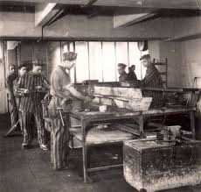 Prisoners at work in Blechammer

When the Russians advanced we were close enough to hear rifle shots. My brother and I were sent on a two week Death March to Gross-Rosen concentration camp. From there we were sent via freight trains to Buchenwald in the Weimar area of German. The train stopped in Weimar because the Allied forces bombed the trains. When we got to the camp were had a shower, were disinfected and put in the children’s barrack.

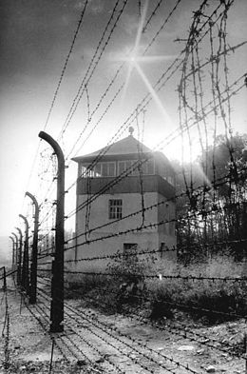 Buchenwald

There were hundreds of children in this barrack.

Prior to that we didn’t get much food; we got 2 slices of bread daily. I got sick with dysentery. I was in so much pain I wanted to be taken medical help. There was a tent set up with lots of bunks but it was dangerous to be there. Every day some people were taken out and given lethal injections. There was one man, a Czech doctor, who went around the tent collecting the ill. He asked how old I was. I was a teenager so he wanted to save me. He arranged for me to go to the camp hospital in Buchenwald. This hospital was for non-Jews and Germans. I was taken there via wheelbarrow. I was given a shot and fed some cream of wheat. Someone told my brother where I was so he could visit. I shared some of my food with him. He gave me a whole loaf of bread he had saved for me. He had saved my rations for me!

I got better and was returned to the children’s barrack- Block 66. I was liberated on April 11, 1945 at the age of 18.

I was feeling better and did not have to be sent anywhere special to convalesce. My brother and I survived, as did a cousin. My mother’s sister, her husband and two children survived in Belgium. One of their sons was killed in the Belgian army.

After the war I went to France, brought there by the OSE. I was there from 1945 – 1947. I got some schooling and was with Elie Wiesel. He is a few years older and was a close friend of someone from my home town. I was able to get some schooling in France.
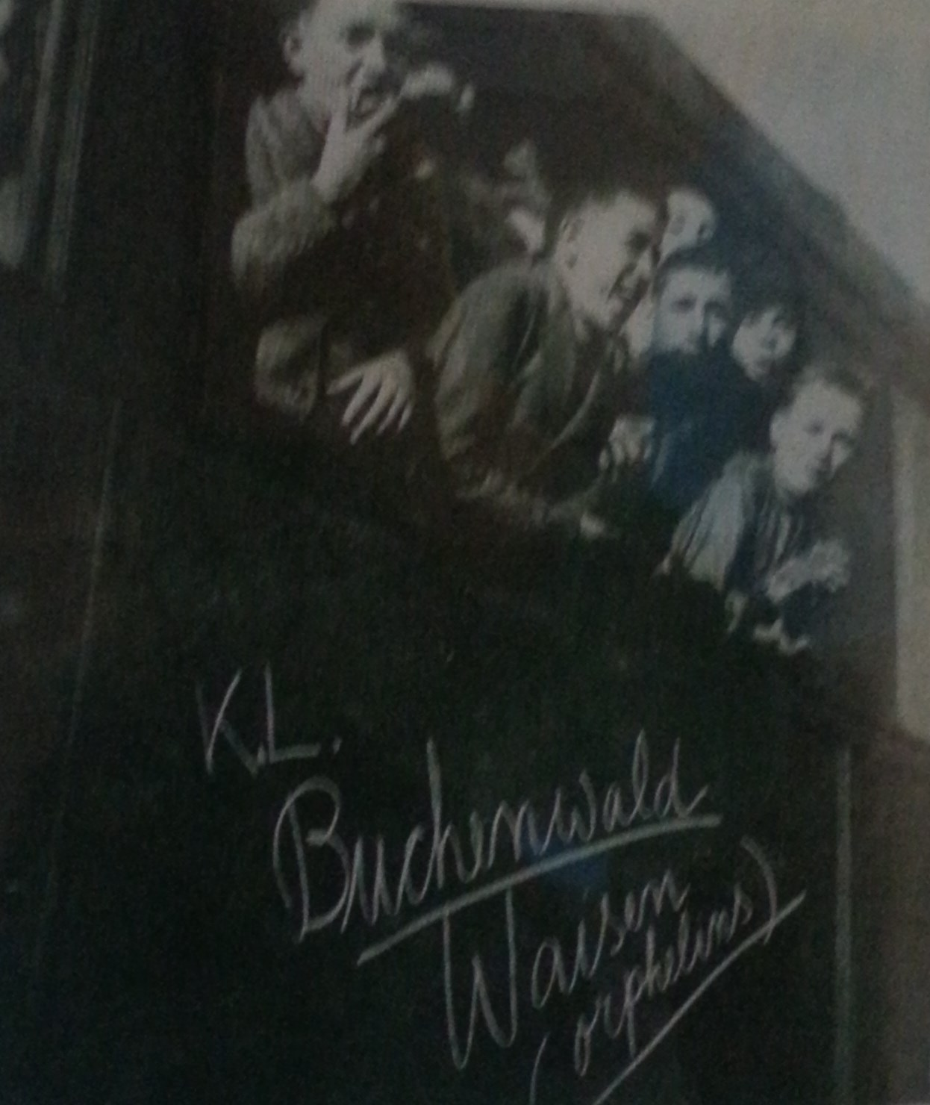
Photo of some of the Buchenwald boys after the war.
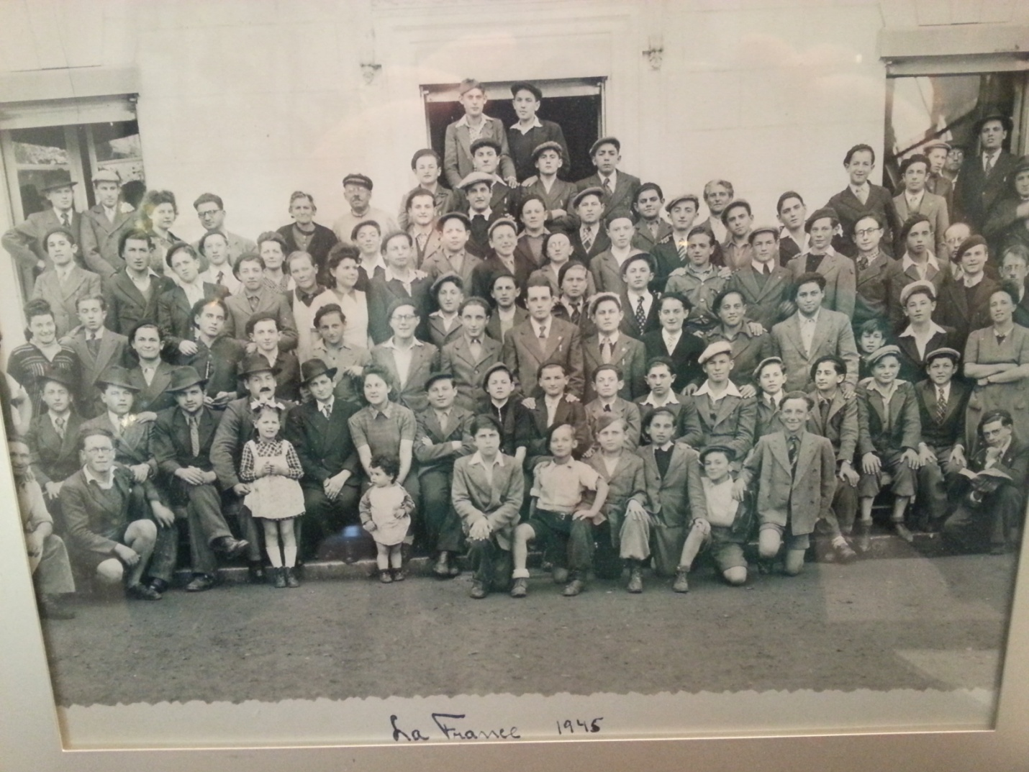
This is a photo taken of our group of children in France after the war. I am the 3rd person behind the little girl in the front row in the white dress and bow in her hair. I was wearing a light colored jacket. Elie Wiesel was in the row in front of me on the left with his head slightly tilted to the side.

I had no preference where to go. May Jews wanted to go to Palestine. I had an uncle in the US so I was sent here. I arrived in America in 1947 and settled in Patterson, NJ.

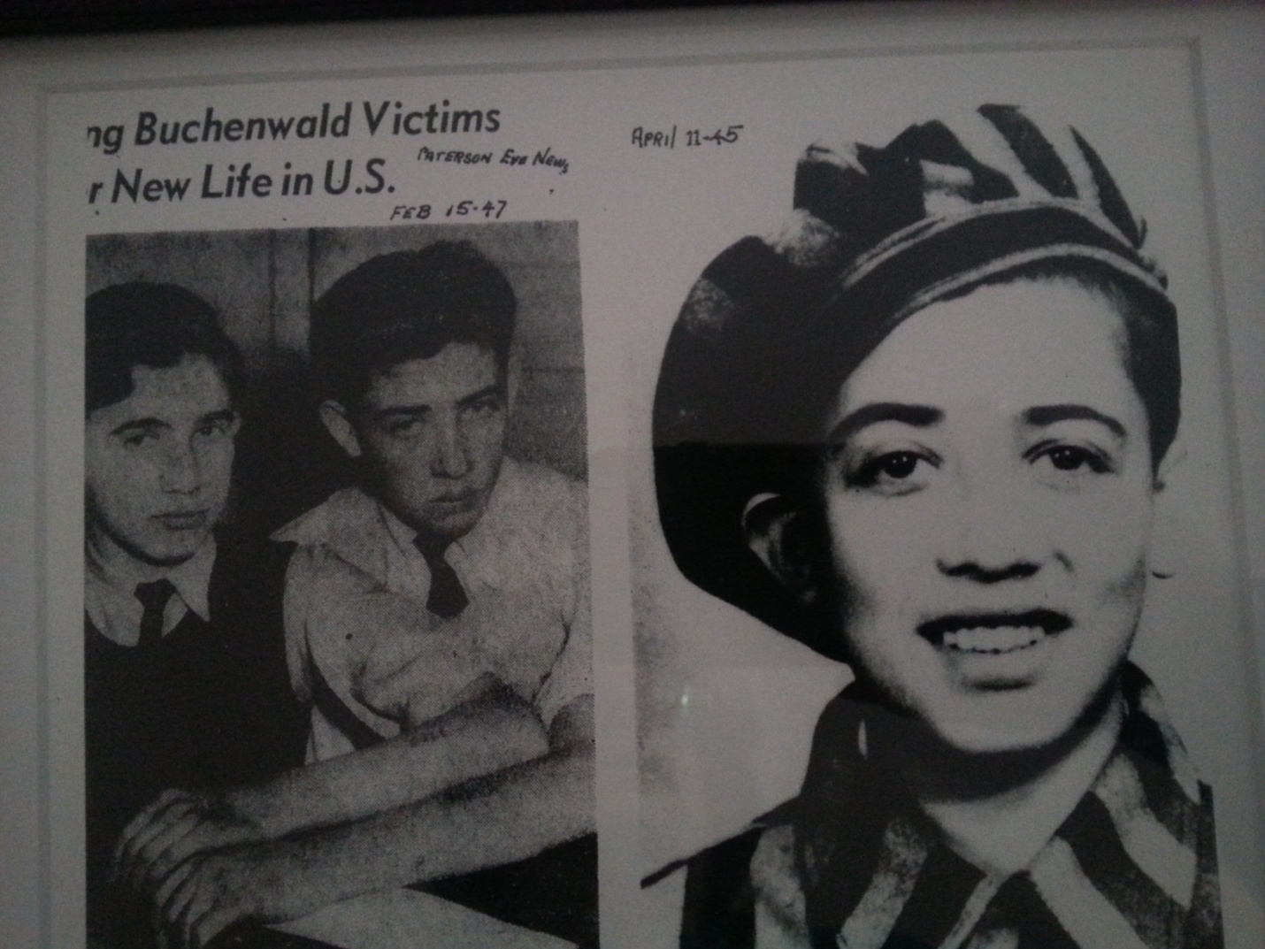

My brother and I were photographed for a newspaper in New Jersey in February 1947. Particular attention was given our tattoos.

I was drafted and given a choice: if I did not serve it might be difficult to become an American citizen or I could serve and get my citizenship automatically. It wasn’t automatic or immediate but I got my citizenship. I served in the artillery in Korea and was then shipped to Okinawa.

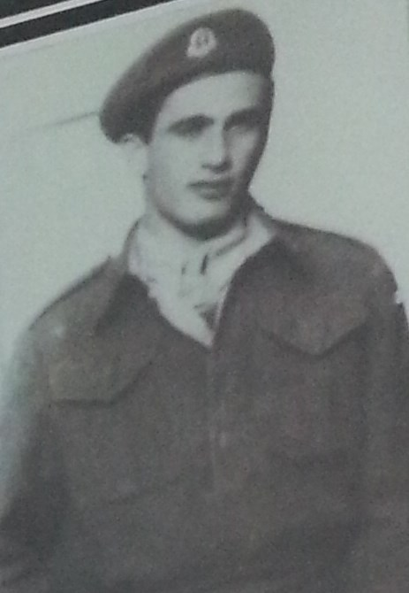
This is my brother, Bernard Ribons, while he was serving in the Israeli army. At the same time I was serving in the American Army.

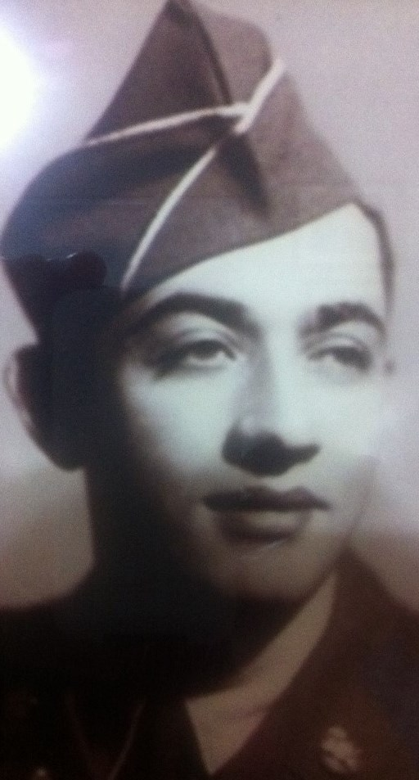
Before going overseas, I had a rose tattooed over my Auschwitz number. I was fearful, if captured, there would be too many questions.

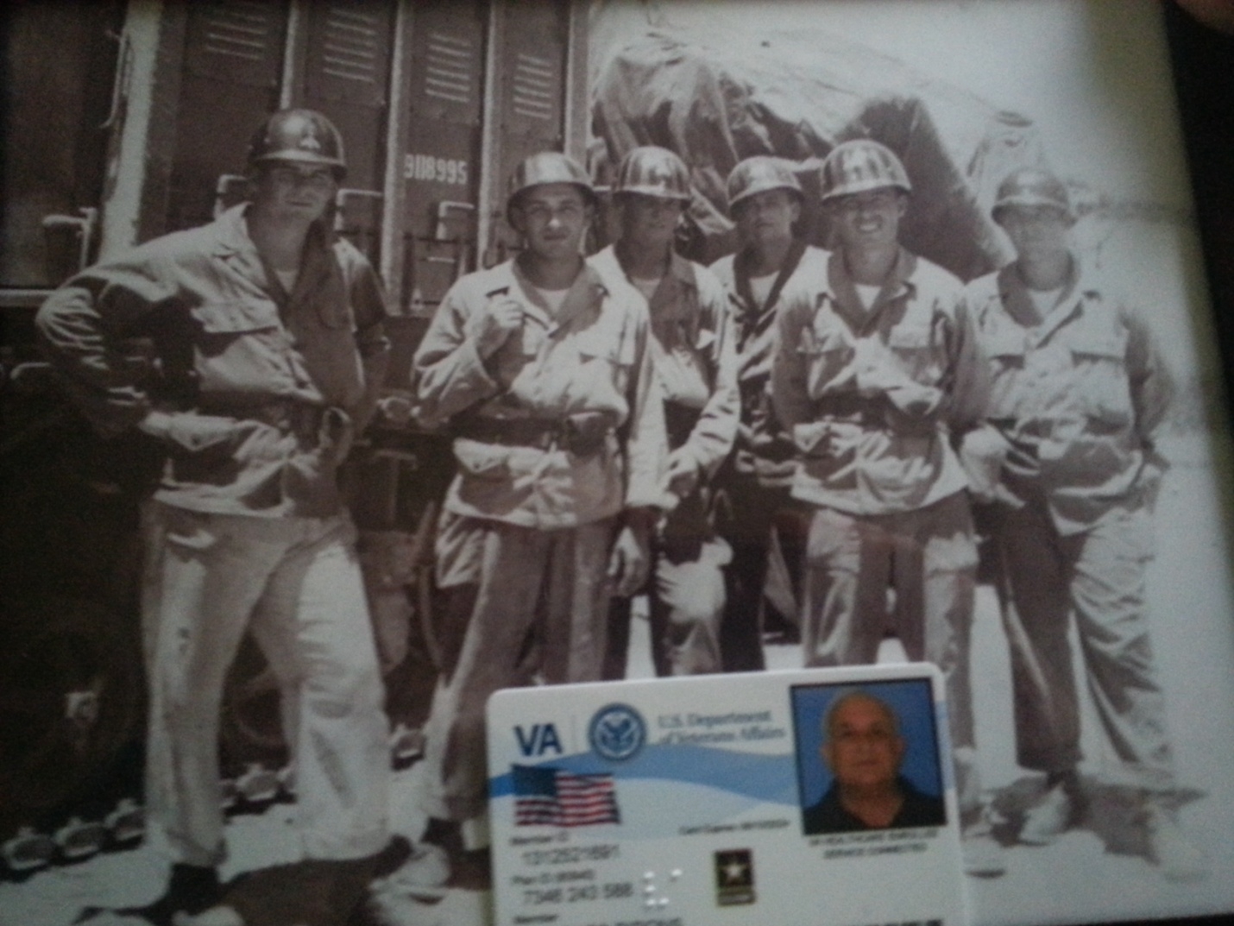
I am standing second to the left. This was taken in Okinawa.

In the US I was able to continue my education. After the service I went to college and studied history and economics. I moved to Los Angeles and went to school on the GI bill and worked. Ultimately I became an interior decorator.

My brother came with me to America but left for Israel in 1949 and served in the army there. He later owned a liquor store in Los Angeles. He was killed a few years ago in a car accident.

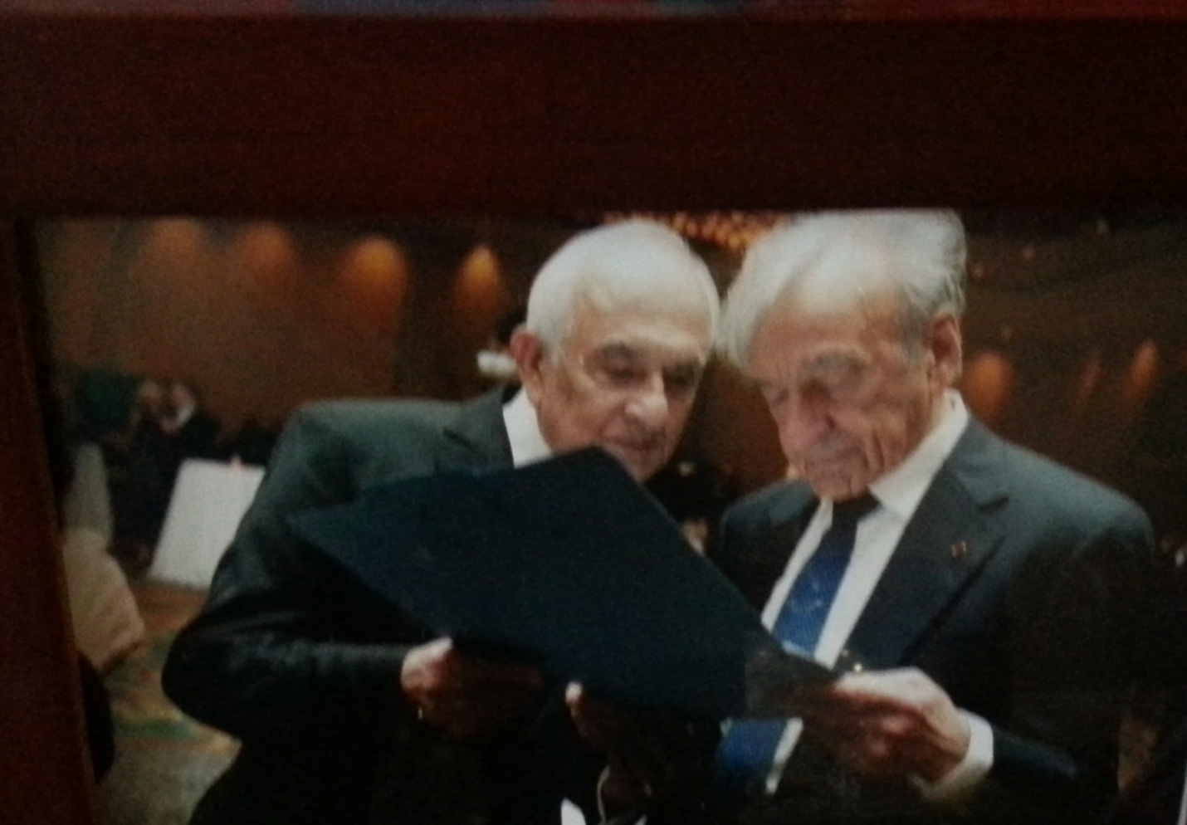
Here I am sharing the photo taken of us in France in 1945 with Elie Wiesel.
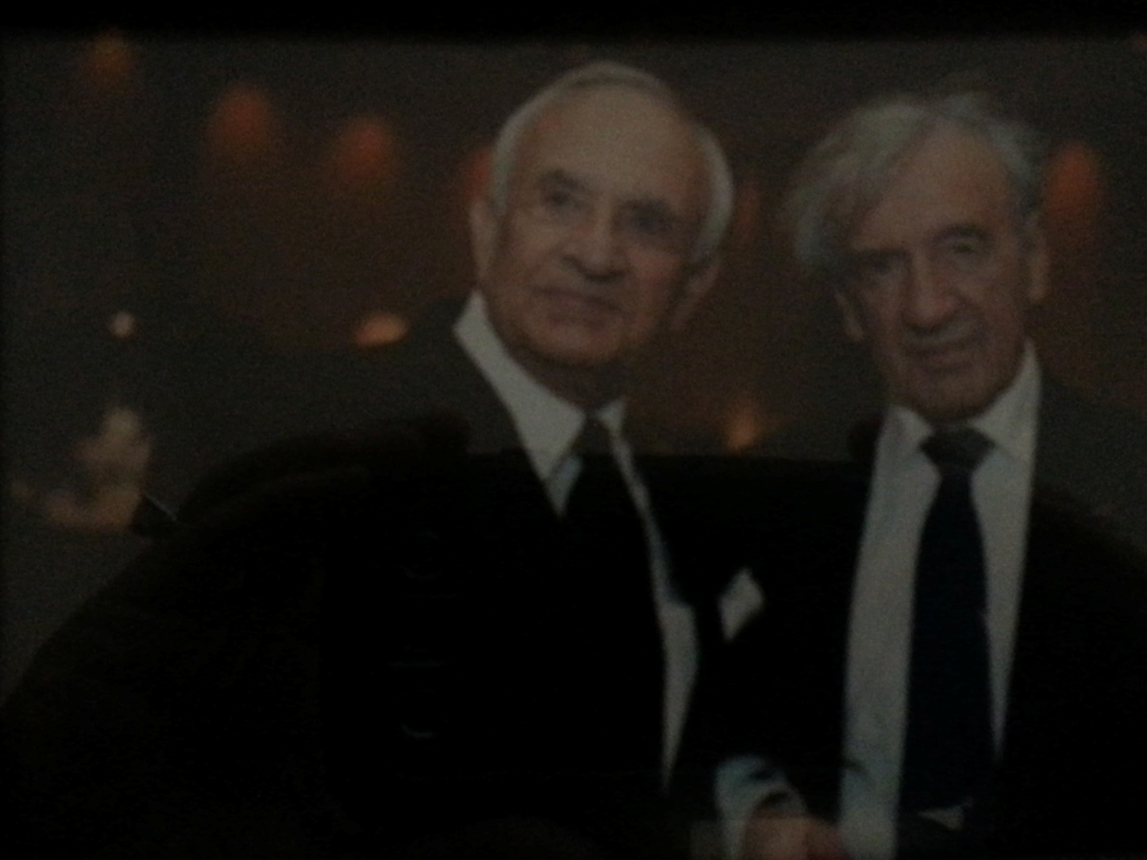
This photo of me with Elie Wiesel was taken in Las Vegas recently.

I have four children: three girls and a boy. One daughter is a pediatric radiologist. My son is an attorney, another daughter is a teacher and the other also works in the medical field.

There is more information about me at the US Holocaust Memorial Museum: Studio portrait of Jacques Rybsztajn, one of the Buchenwald Boys.

