Tamas Foldes Virtual Book

Tamas Foldes was born on March 20, 1938 in Budapest, Hungary.

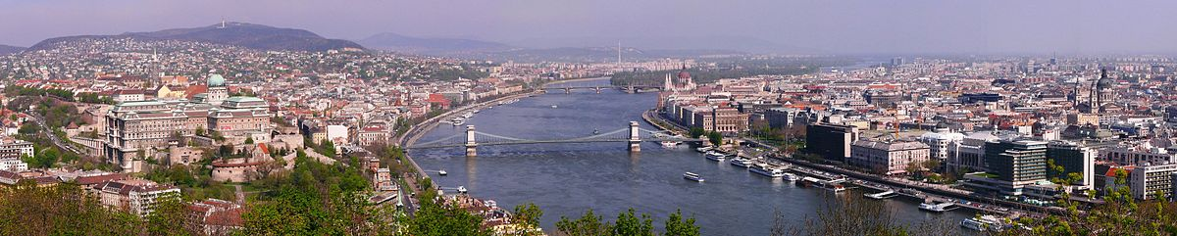

He remembers when the Nazis invaded because it happened as he was celebrating his 6th birthday in 1944.

His family had Shutzpasses (protective passports) issued by Spain.
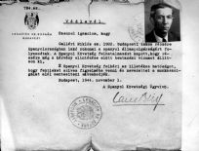These passes were not as secure as Swedish passes and sometimes Jews with such passes were still taken out, shot and their bodies dumped in the Danube River. His family was kicked out of their home and had to find shelter in dangerous circumstances. At one point they were living in the international ghetto, also known as the little ghetto. One night the Hungarian fascists came to round them up. The people in his building bribed someone to help them get to the big ghetto where they might be slightly safer than where they were living.

His mother, an actress, was taken to be sent away but she was saved by a guard who was one of her fans. Rather than transport her out of Hungary, he sent her home.

Budapest was taken over by the Soviet troops in January 18, 1945.

