Stephen Nasser Virtual Book

Stephen Nasser was born in Budapest, Hungary in 1931.

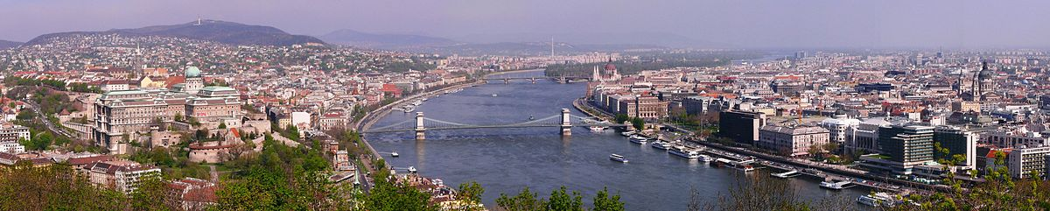
His family had a jewelry store and life was good with friendly neighbors. He did experience some anti-Semitism before the Nazis came in March, 1943. Things changed dramatically when they arrived: The laws changed and Jews lost their citizenship so they were no longer protected by the Hungarian government. Stephen and his brother got into fights with boys who tried to bully / intimidate them. His family was forced into a ghetto towards the end of 1943 or early ’44.

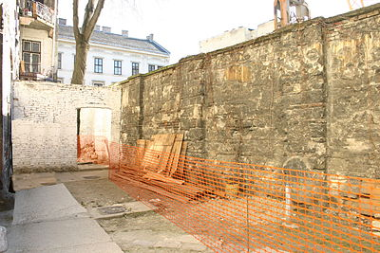

Stephen and his brother were only in the ghetto a few days. A Christian friend of the family took the brothers to work in his factory and they lived there, separated from family. They were deported in the spring of 1944 to an internment camp in a brick factory. His mother and some other relatives were there but soon they were transported in a cattle car to Auschwitz-Birkenau.

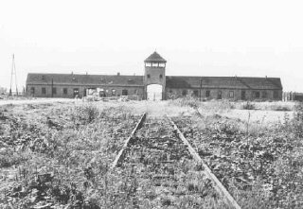

In Birkenau he saw some of his relatives murdered before his eyes. The brothers were in Birkenau for less than a week and then sent to Muhldorf, a subcamp of Dachau in Germany.

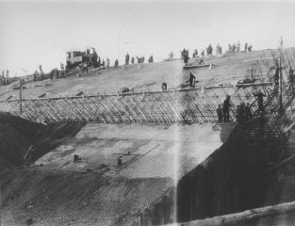
They built a bomb-proof munitions factory. Stephen was there until liberation on April 30, 1945. He was liberated from a Death Train by General Patton’s 3rd Army.

