Stan Rubens Virtual Book

Stan Rubens was born in Holland in 1932. His parents ran a retail store and he had an older sister. The Nazis invaded on May 5, 1940.

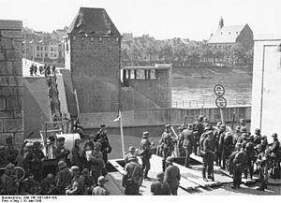

By 1941 his father took the family into hiding in Amsterdam. They were first aided and then betrayed by a woman named Mrs. Eusman. In 1942 the Nazis came to arrest them.

Because his father had once lived in Germany and spoke the language well, he was able to talk to one of the Germans and get help with an escape from deportation. Stan was in a holding area with his sister and other children. She found an opening and just walked away making her escape. Stan tried to break away from a captor but was caught and returned to the holding area. At that time he was not yet 10 years old and was separated from his family. His father was able to intercede so Stan could escape through the same opening his sister used. His parents bribed someone to help them escape from a transport truck. The whole family knew where they would find a safe haven. They memorized the address of a member of the underground who would shelter them and there they were reunited.

They were in this shelter for about a week and after that there were a variety of hiding places and the members of the family were sometimes dispersed. By the end of the war Stan was hiding on a farm in the countryside. His family survived.

