Meta Doran Virtual Book

Meta Doran was born in Hamburg, Germany on February 1, 1926.

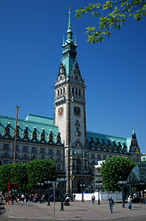

Her father ran a successful import/export business and she was an only child. Because her father had Polish citizenship, the Nazis deported her family to Poland in 1938. She ended up in the Pabiance ghetto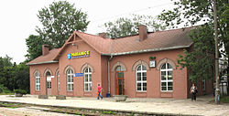

and then the Lodz ghetto where her father died of starvation. She spent four years in the Lodz ghetto.

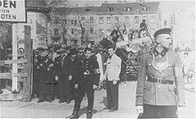

Meta was deported to Auschwitz-Birkenau in the summer of 1944.
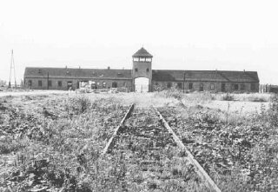

Her mother was gassed there. Meta was there for about 5 or 6 months and was then deported to Bergen-Belsen where she slept on the ground.

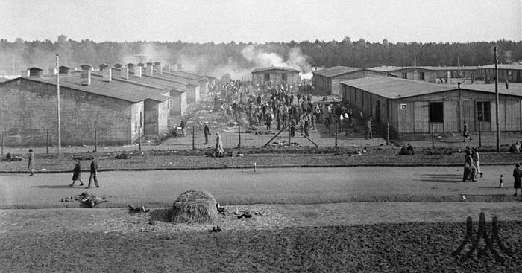

Because she spoke German and Polish well she was forced to collect information from incoming prisoners for the Nazis. From Bergen-Belsen she was sent to Salzwedel where there were munitions factories. She was lucky enough to be assigned to work in the kitchen.

She was liberated by the Americans on April 14, 1945.

