Martin Kohn Virtual Book

Martin Kohn was born in a small Hungarian farm village in 1929. His family had to give up farming during the Depression. His father moved to Satmar (Satu Mare), Romania

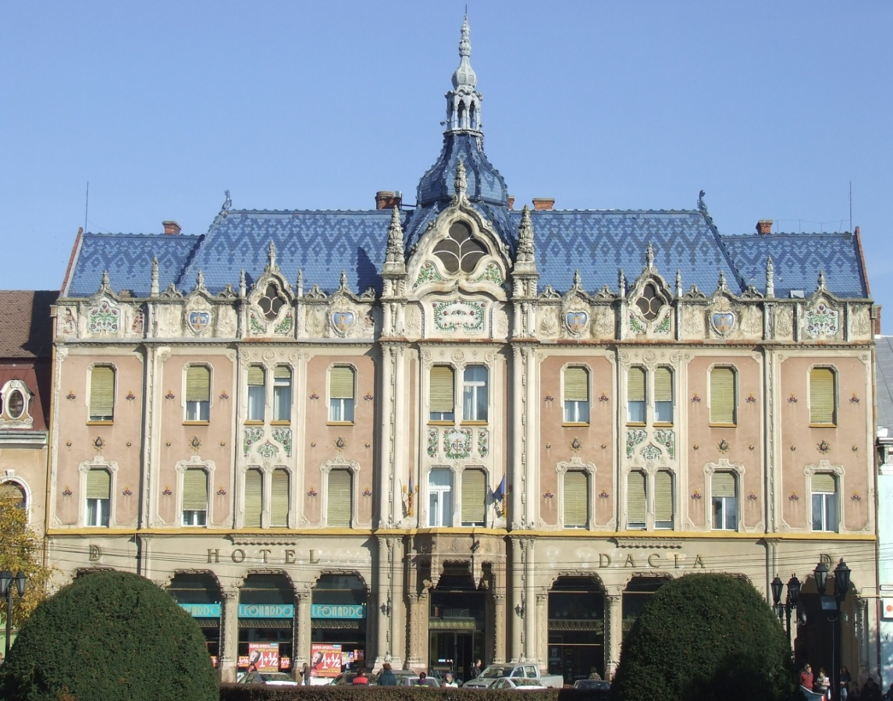

and established a factory that produced sportswear. Martin grew up in a family of 7 children.

They had some idea that the Jews in Poland were being abused after the Nazi invasion. Jewish refugees passed through the area.

The Hungarians were allies of the Nazis. Hungarian fascists rounded up the Jews for deportation to concentration camps in Poland. The Jews were temporarily put into a ghetto before they were shipped to Auschwitz-Birkenau in May 1944.

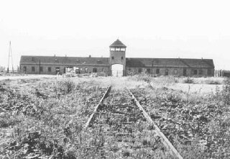

He was only in Birkenau for a week before he was shipped to the Plaszow concentration camp.

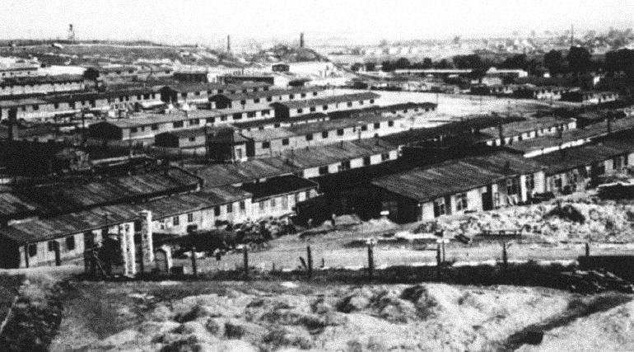

He was there until around September when he was shipped to Gross-Rosen and Balkenhain where he did hard physical labor.

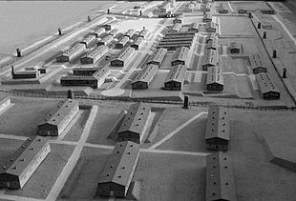 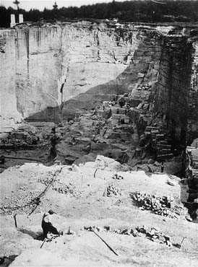

Gross Rosen camp Infamous stone quarry at Gross Rosen

As the Soviet troops approached the prisoners were forced on a Death March to Hirshberg and then to Dernau in Germany. The Nazi guards fled days before the Soviet army came through on May 8, 1945.