Margot Goodman Virtual Book

Margot was born in 1928 in Germany.

Her father was in the scrap business. He was wounded in WWI and was disabled. He was taken away by the Nazis and murdered in 1934. Her mother may have been involved in a resistance movement. Margot was placed in an orphanage after her father was killed. Her sister was sent away and her brother was shipped to their grandparents in Italy. Margot remained in the orphanage until Kristallnacht in 1938. 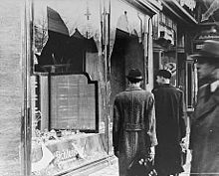

She went to find her mother because the situation in Germany had become very dangerous after Kristallnacht. Her mother arranged to have her brother sent from Italy to Germany to England on a Kindertransport. She made her own arrangements to leave Germany and told Margot they would see each other in a few weeks in America. She left Margot with a passport and some money. The person entrusted with Margot’s care stole these and abandoned her. Margot ended up in various hiding places from 1938 until 1941.

Somehow she was put on a train to Berlin and sat next to a Nazi. He may have been part of the underground because he offered her food and did not harm her. In Berlin another Nazi approached her, realized she was alone and took her to safety. He retrieved her passport and made arrangements for her to leave Germany to go to the US. She does not remember his name but he helped saved other Jews, too.

Margot arrived in New York in July 1941 while the war still raged in Europe.
