Magda Nissanov Virtual Book

Magda (Hebrew name Malka) Nissanov was born in Hungary in 1924 in a small town with only about 60,000 people. 5,000 were Jews. By 1940 Polish and Czech refugees made their way to Hungary and told stories about what the Nazis were doing including tales about the existence of the Theresienstadt / Terezin ghetto,

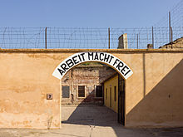

which opened in 1941. At first her family could not believe the terrible stories. Only one person in the area had a radio so the community could not learn much about what was happening elsewhere.

The Nazis came to her area in 1944 and a ghetto was formed in her neighborhood so her family had to have other families move into their small home. During her time in the ghetto she was injured when a pillar fell on her and she sustained a concussion. She has limited memory of that time as a result.

The Jews in her area were deported and ultimately shipped to Auschwitz –Birkenau in a cattle car.

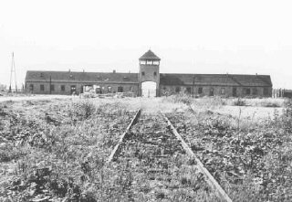

She arrived there in May, 1944 and had to go through a selection process conducted by Dr. Mengele. She and her sister were separated from the rest of the family. They were deported to a work camp in Bavaria, Germany. Ultimately she was in several camps where she did jobs ranging from moving earth to nursing. At the end of the war she was in Dachau

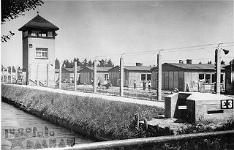

and liberated by the Americans in April, 1945. By that time she was very ill after contracting typhus and living under the extreme conditions in the concentration camps.

