Lydia Lebovic Virtual Book

Lydia Lebovic was born in 1928 in Czechoslovakia but later moved to Hungary where she grew up. She was one of 4 children. Her family had heard stories of Nazi atrocities from refugees even before the German invasion of her region. The Nazis reached her area in March, 1944 and she was forced into a ghetto the next month. She stayed in the ghetto for 5 weeks and was then shipped in a cattle car to Auschwitz-Birkenau.

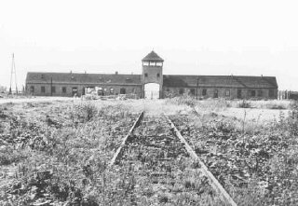

Upon arriving in Birkenau there was a selection and Lydia found herself alone. Her mother and younger sister went immediately to the gas chamber and she did not know where her other siblings were. She was in Birkenau for 6 weeks and was then transferred to a work camp in Hamburg, Germany which she describes as a good camp: they had food, clothing and shelter and the prisoners were not overly abused, though they did work hard. She was in this camp until February 1945.

She was then transported to the concentration camp Bergen-Belsen.

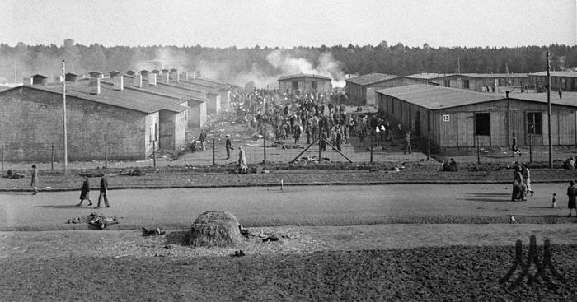

The conditions were horrific but she found her older sister there. She brought food for her and when the British liberated the camp and opened the gates on April 15, 1945, she was able to find her brother, too.

Interview note to Brett: Lydia mis-identified Deborah Lipstadt and referred to Helen Epstein in her interview.