Henry Kronberg for Virtual Book

Henry Kronberg was born in April 1920 in Breslau, Germany
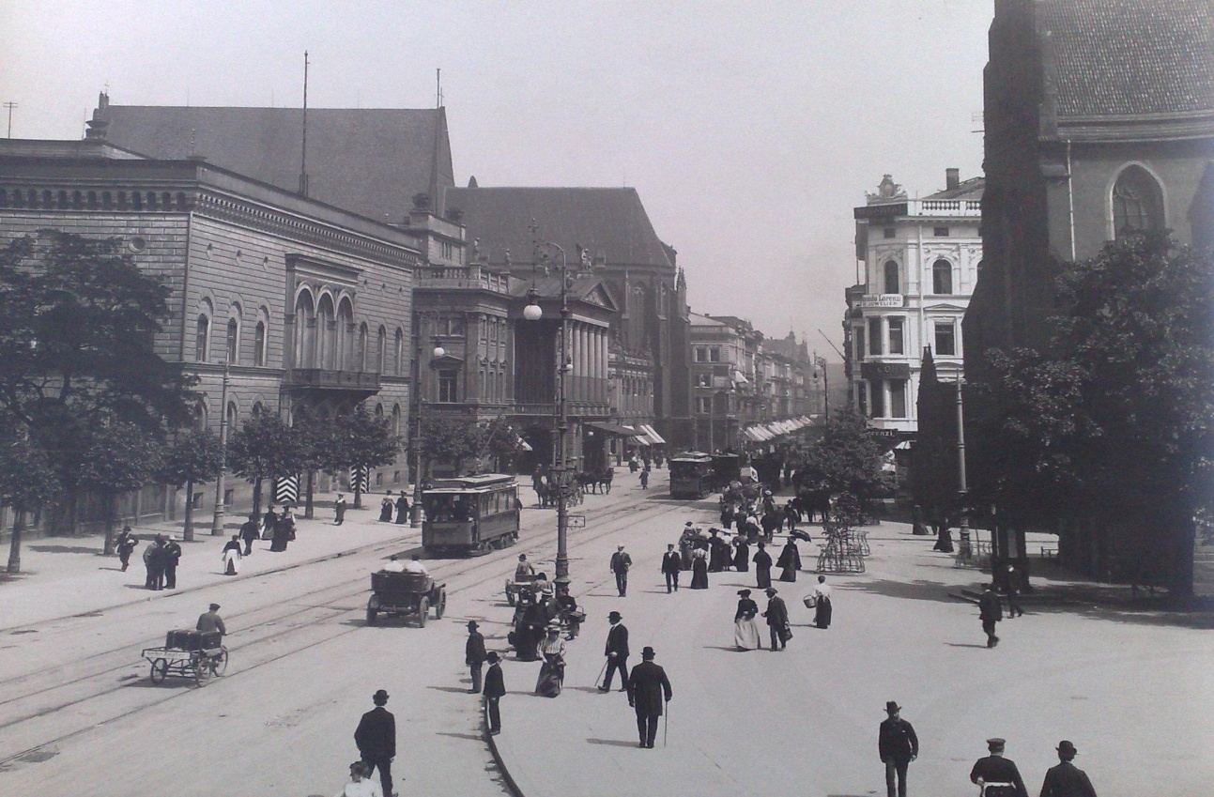

but he grew up in Katowice, Poland.
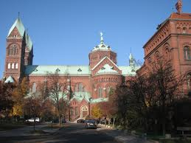

As a young man he was an apprentice in a material goods store.

He was 19 when the Nazis invaded Poland. He left Katowice and went to Krakow
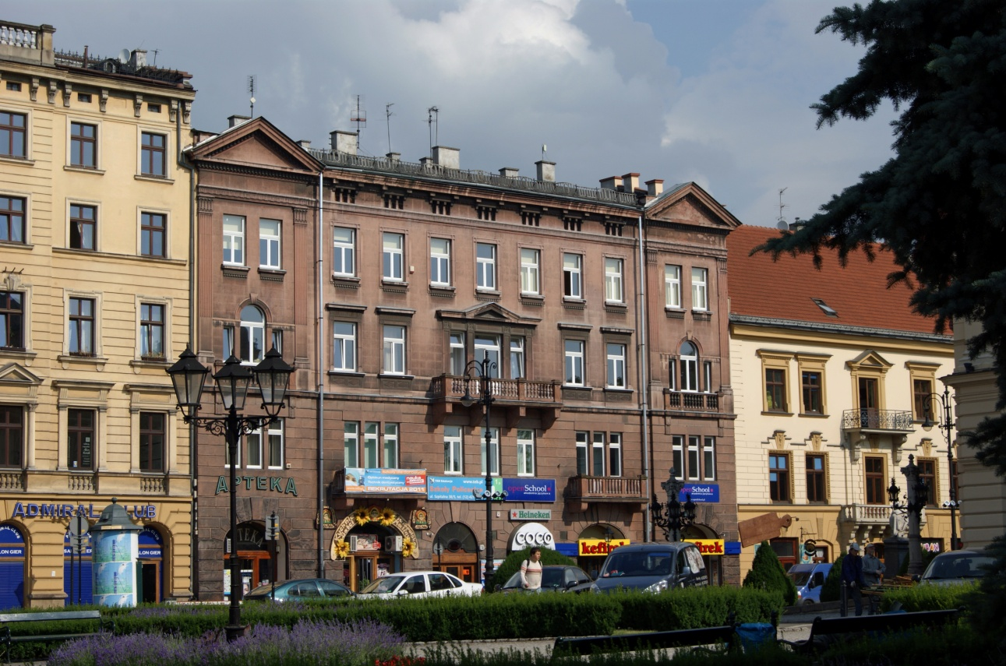
and was there when the ghetto was formed. The Jews were forced into the ghetto but his sister and mother had fled to the east and escaped the ghetto. He and his father were supposed to join them but never made it out.

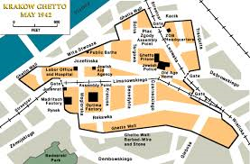

He endured forced labor while in the ghetto. He managed to get himself assigned to work in the Gestapo headquarters doing odd jobs. Eventually he became the foreman of the painters. People were interrogated and tortured in this building. His job included scraping blood off the walls and repainting.
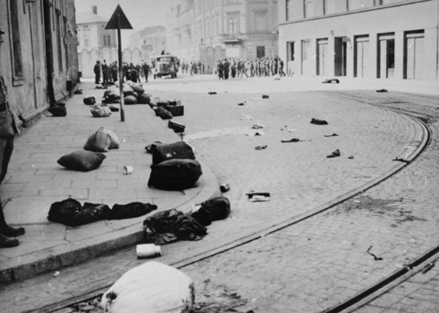
(Bundles abandoned by Jewish deportees from Krakow Ghetto, March 1943 - Wikipedia)

When the ghetto was liquidated Henry and the other Jews who worked in Gestapo headquarters were housed in a prison and then in a convent that was converted to a prison. He worked in Gestapo headquarters for about 2.5 years.

In January, 1945 the Soviet army approached the area so the prison was liquidated and Henry was sent to 3 different concentration camps. He was liberated by American troops near the Bergen-Belsen camp.
