Evelyn Goldstein Virtual Book

Evelyn Goldstein was born in Berlin, Germany in 1936. 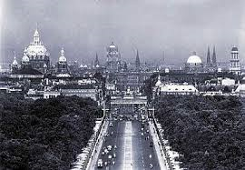

Her father was a doctor and he knew someone who worked on a cruise ship. Through this connection he was able to get his family out of Germany in 1939 when she was three years old.

The family went to Shanghai, China. No visas or entry permits were required to go there so some 20,000 Jews from Europe found refuge in that area. When Evelyn first arrived, her family was put into a camp but later they found a one-room living space that also had to serve as an office for her father’s medical practice. She has no memory of hearing anything about the treatment of the Jews left behind in Germany.

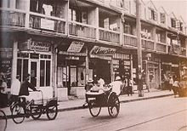 (Shanghai Ghetto)

After Japan entered the war her family was moved to a ghetto and they stayed there until 1946. Conditions were crowded and primitive. She remembers witnessing a US bombing off in the distance.

She spent ten years in China: from 1939 – 1949 and she is still in touch with some of the Jewish refugees she met there.

