Celia Strauss
nee Korolczuk

I was born in Ostrow-Maz, (Ostrów Mazowiecka ) Poland on June 9, 1930.

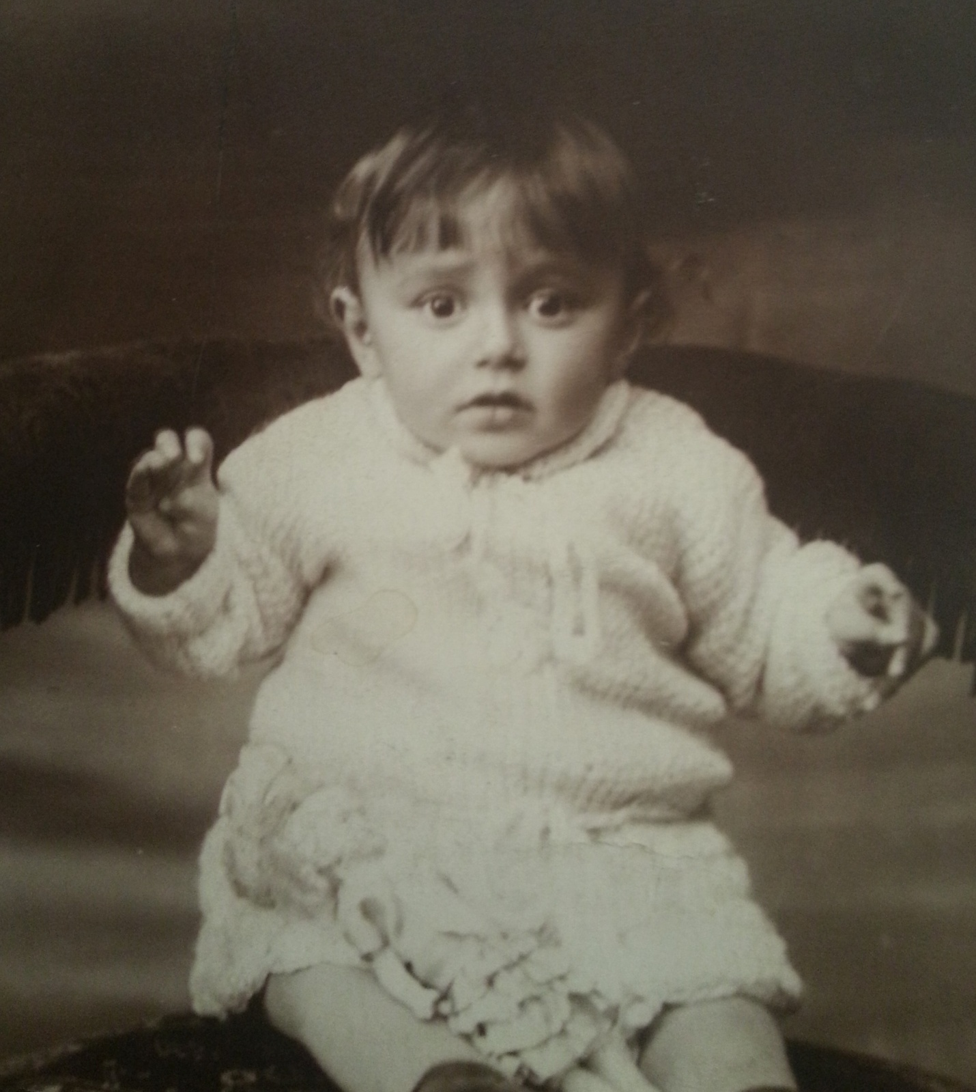

My family had a yard goods business and my father traveled to London for material. I have one sister.

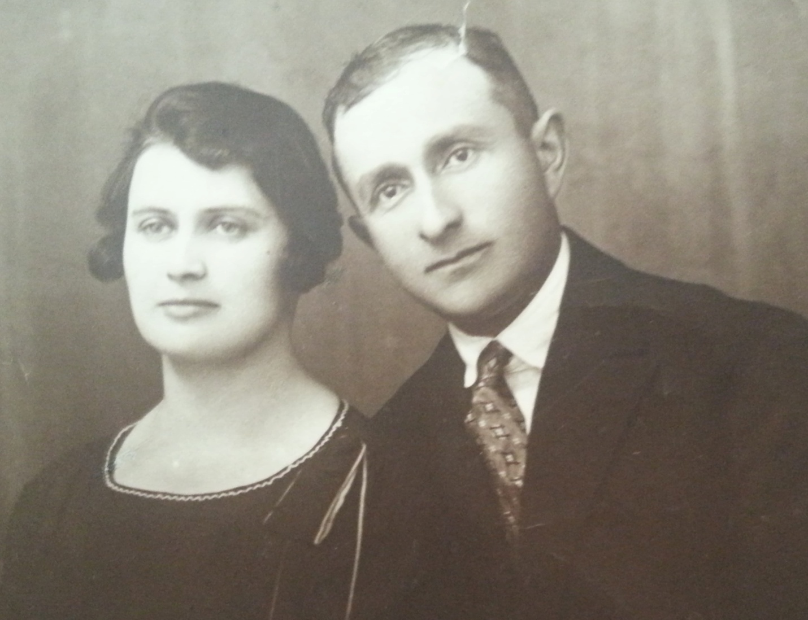
My parents Leah and Menachem Korolczuk

After the Nazis invaded Poland in 1939 Jewish men were ordered to report to the grounds outside City Hall. There they received orders from the SS but I don’t know what the orders were. Afterwards the SS men stood on both sides of the street. On one side of the street the SS said “stop” and on the other side the SS said “run”. No matter what the Jews did it was wrong and the SS shot at them. Many men were killed. It was a game to the SS.

Our town was under German occupation but the next town, Zambrów, was under Russian occupation. Many Jewish families crossed over to the Russian side. There was a forest in between these towns. I, with my mother and sister, crossed safely but my father was caught crossing through the forest. He was beaten and forced to dig his own grave. Then the Nazis shot into the grave. People who saw this happening came and told us.

In Zambrow we found my uncle who was a doctor. He was able to get us a room but most other refugees were sitting out on the street with their belongings with no place to go. When people told my mother what happened to my father, she cried all night. She was left with two little girls. I was 9 and my sister was only 3.

The next morning we heard screaming from the street. Opening the window we saw my father coming. People were cheering and hugging him. The Nazis thought it was too easy a death for a Jew just to shoot him and wanted to torture him more. He managed to escape running zigzag in the woods. He was wounded but alive. I ran to him and he picked me up and carried me upstairs. After that I became his shadow and did not let him out of my sight.

My uncle came with bread and milk. He had gotten in touch with my grandparents in another city and told them that their son, my father, was killed. My grandparents were expecting their daughter-in-law with the two children to come to be with them of course they were delighted to see their son alive and well.

We had been together with my grandparents and the rest of the family for a couple of months when we heard threats against my grandfather. A relative of ours found out that our family was listed as a bourgeois family on the list by the NKVD (Soviet secret police) to be sent to Siberia. Knowing that we were in danger, we decided to flee. We left in the middle of the night.
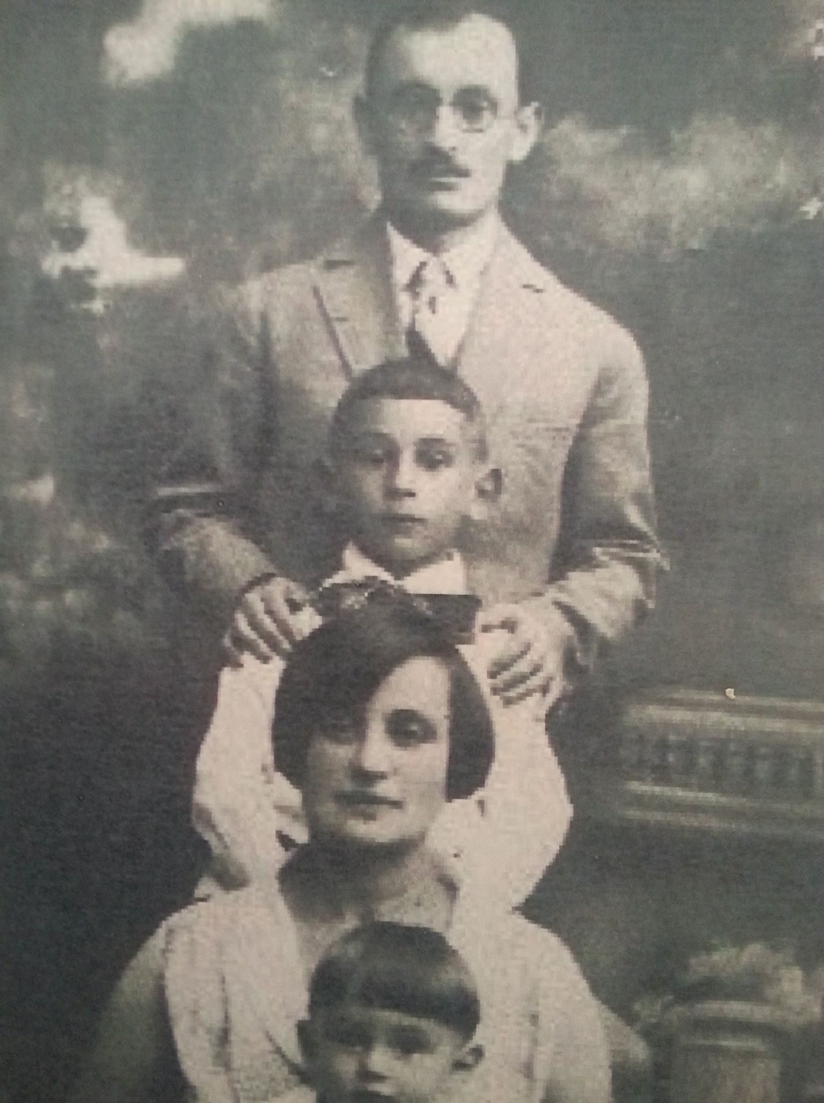
My uncle Dr. Josef Friedman, his son Isaac, his wife Rosa little Eliezer.

This was a very big mistake. Had we stayed we would have been arrested and sent to Siberia, our family could have survived.

We traveled a long way and came to the city of Baranowicz (also known as Baranovichi). We had family there. The city also had a large Jewish population. My family met to discuss where they should go and hide since they were on a “wanted” list. On a map they found an out of the way small town Snow, in Belarus.

We rented a place to live in the outskirts of Snow. One of the local Communist officials got suspicious of our family and started looking into the registry to find information about us. He found information about who we were in the City Hall. He said “we don’t want people like you here” so we prepared to be arrested. The children were told to sleep in layers of clothes so if we were arrested in the middle of the night we would have clothes for Siberia.

Just at that time the Germans attacked Russia (June, 1941). Had this happened a little later our family would have already been arrested and safely in Siberia. As bad as conditions might be in Siberia, it was better than being under the Nazis. Again our timing was bad.

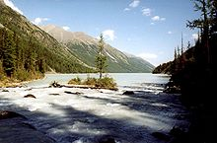 Siberia

Our landlord became mayor of the city during the German occupation. That was helpful to us later. We were taken out of the apartment and put into the ghetto. We were sent to live with a man who had his own house in the ghetto. He was a merchant and he had a double wall constructed to create a private, secretive space for storage. It became our hiding place that saved our lives.

We heard Jews were being killed and ghettos burned. One day Ukrainian and Lithuanian troops (Nazi collaborators) came to our town singing loudly about killing the Jews. There was a ravine in our area and these men came to round up the Jews, take them to the ravine and shoot them.

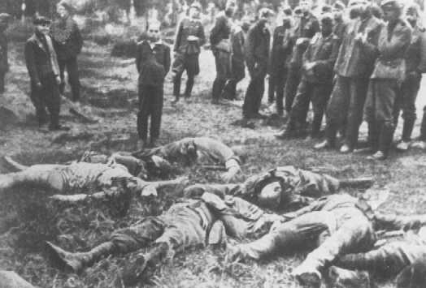

When we heard the shouting and screaming all around us my father opened all the doors and windows to give the impression we had fled but we, the four of us in my family plus my aunt, and the merchant’s family, were hiding behind the double wall. We were not discovered.

There were bushes on the outskirts of the city. Our group hid there for a while after the roundup and then fled to a distant cornfield. We ran at night so we would not be seen. We had no food or water with us.

The others in our group decided to go to another city where there was still a ghetto and they invited my father to join them but children were not welcome. My mother said to my father you have a chance to save yourself, go with them. My father replied without my wife and children I don't want to live. We were left in the cornfield and were discovered by a German shepherd dog followed by his owner. He had a bayonet with him but no gun. I think if he had a gun he would have killed all of us. He told us he would bring bread and water for us and would return shortly. My father did not trust him, suspecting the man would go to the police, which we found out later he did. We fled and heard shootings.

My paternal grandparents, uncle, aunt and two little cousins (ages 5 and 1½) were hiding somewhere else. They were in the attic of the building they lived in. They avoided the first roundup but when the police came back to check again they heard the baby cry and the family was caught. The baby, little Shulamit, was a delightful, lovable little girl with big dark eyes and blond curly hair. They would not waste a bullet on her and killed her by throwing her, like a ball, against the building. After seeing everyone else in the family there killed, my aunt was taken to the police station. There she was raped for a week. She begged the police to shoot her which they finally did.

We were running away. My sister was crying from thirst. My father said to us we will look for an isolated house and I will ask them for water for my child. A man was just coming out of his house onto the porch. My father approached and asked him for water for his child. The man recognized my father. My father had been a teacher and this man, who was also a teacher, had seen my father at a previous teacher conference. He brought bread and milk for all of us and took us to his barn to hide us. This man's name was Mr. Rutkowski.

The Nazis spread word that Jews who had survived the roundups should come out of hiding and there would be another ghetto set up for them. My mother was willing to go to the ghetto but my father did not trust the Nazis. Mr. Rudkowsky and my father both knew the mayor. My father decided to write a letter to the mayor and ask what he thought about this offer from the Nazis. Mr. Rudkowsky took the letter to the mayor. The mayor wrote to my father that he doesn't trust the Nazis, and said he should to go into the forest and find than join the partisans. The mayor also told my father what happened to his parents and the rest of the family who had hidden in the attic.

Mr. Rudkowsky offered to take my sister. My sister’s name was changed from Debora to Tanya.

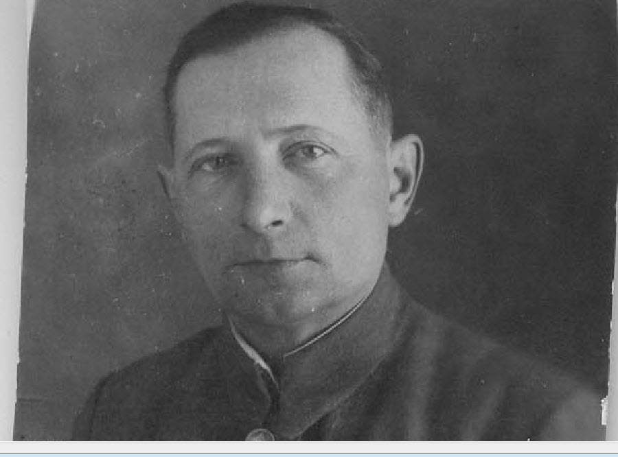
Ivan Rudkovsky

My father tried to find a broken-down house somewhere where we could hide in exchange for jewelry. We found such a place and my mother gave the owner a diamond ring. After one night the owner came to say she had a nightmare that she was caught hiding Jews and they were going to kill her and her family. We were told to leave.

The woman pointed us to another house where she thought we might find shelter. She pointed to a house in the far distance but we went to the wrong house. My father knocked on the door. The house belonged to a police man and his sister answered the knock. Not knowing this was the wrong house, my father said to her,
“we were sent to you”. The sister was very shaken and thought the partisans sent us to test her to see if she would hide us or send us to the police. She took us to the attic of their barn and treated us well. She kept us there for a few weeks.

One day she told us she thought her brother suspected something so we had to leave. We left and this time found the right house, the one we were supposed to have gone to before. The man in this house had been a criminal who spent years in prison but he hid us in his barn. There was a shed next to the barn that you could only get into through the barn. We were hidden behind straw in there. We had heard this criminal saved a Jewish Russian prisoner of war. This POW left to join the partisans.

One night there was a commotion. We heard men's voices and a horse and wagon came into the barn. They were partisans! They had blown up a train transporting soldiers to the front. They were hiding through the day in the barn, only traveled through the night. The partisans let us go with them, as we got closer to the forest we realized the Germans were attacking the partisans. The partisans left us to join the fight and we got stranded alone in the cold. We didn’t know where to go or what to do.

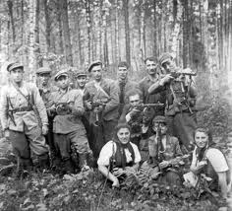

I can’t remember how we came across another partisan group. They accepted us and my father joined the fighting groups and earned several medals. Partisans were attacked often and we had to flee. Sometime we went through swamps. There were times when the swamps were so deep I sunk in over my head and my father pulled me out by my hair. He had to be careful to hold his gun high over his head to keep it dry so he could not carry me. When we got out I was soaking wet.

One time the Germans attacked us and we had to flee. My mother lost the sole of her shoe and could not run. I pulled her and prayed for my father to find us but he was away with a fighting unit. There was shooting and screaming around us. Eventually my father found us.

We were with the partisans for three years: 1942, 43 and 44. In 1944 we heard heavy artillery coming closer and closer. The partisans came out of the forest to welcome the Soviet troops. The first Russians arrived on horseback.

After the Soviets arrived my father left to find my sister. My sister did not recognize him after three years. My father, who had worn nice clothes, wore a Russian outfit. My sister did remember Hanukkah so that was one memory she had.

After the end of the war we registered to return to Poland, from there through many difficulties we arrived to Germany to a displaced camp Foehrenwald.

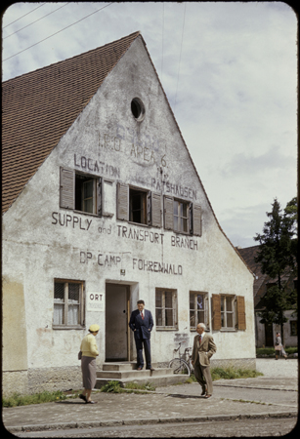

My mother had a large family in the US and they offered to bring us here. We came to New York in 1947.
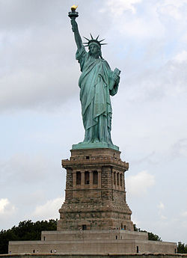
My father never got over the war. Right before his death he was in a coma. He sat us and said “they are killing Jewish children” and a few hours later he died.

It was only after the war that my father told my mother about Shulamit and the others who had hidden in the attic. My sister overheard the conversation and that is how we know the story.

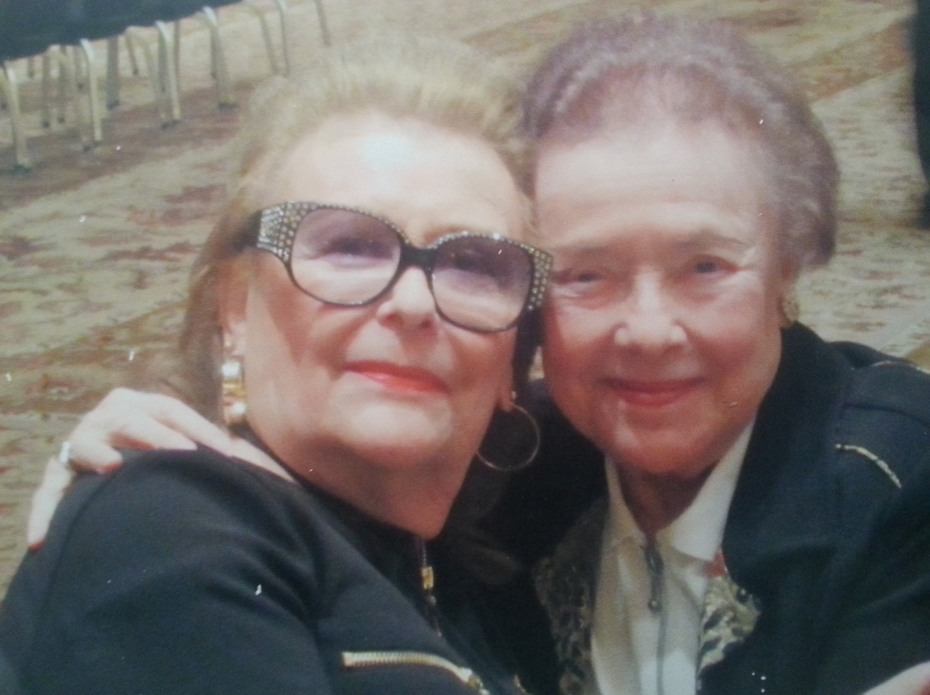
Celia and Debora

My husband Janos and I moved to Las Vegas in July, 1994. A second marriage for both of us, we honeymooned here and decided to come to Summerlin to retire.

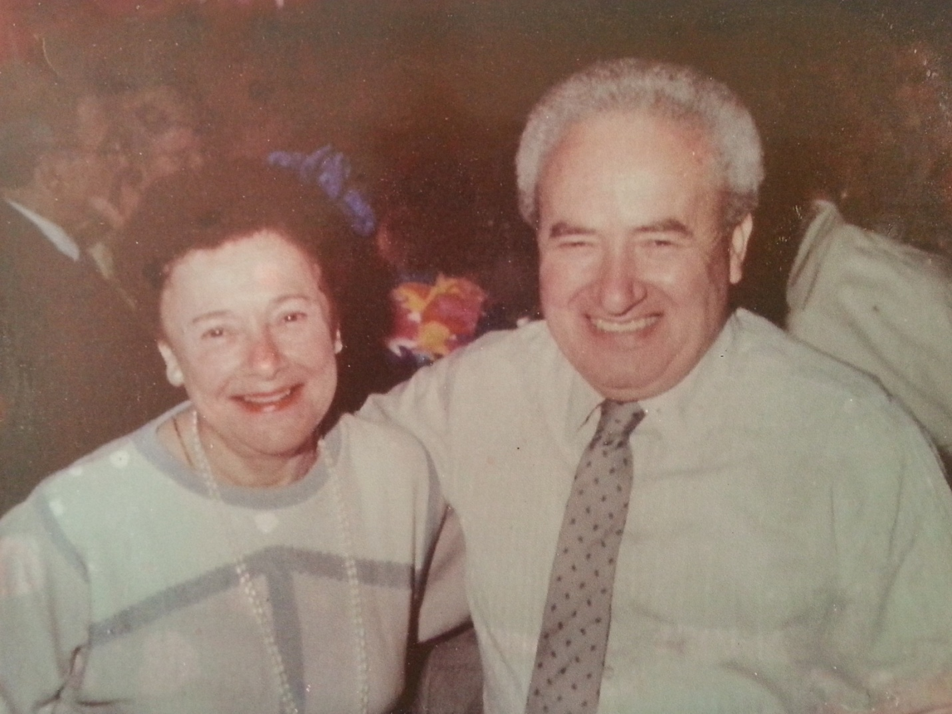

Mr. Rudkowsky has been honored for saving my sister’s life and his name is in Yad Vashem, the Holocaust memorial in Jerusalem, Israel. He is honored as one of the Righteous Among the Nations.

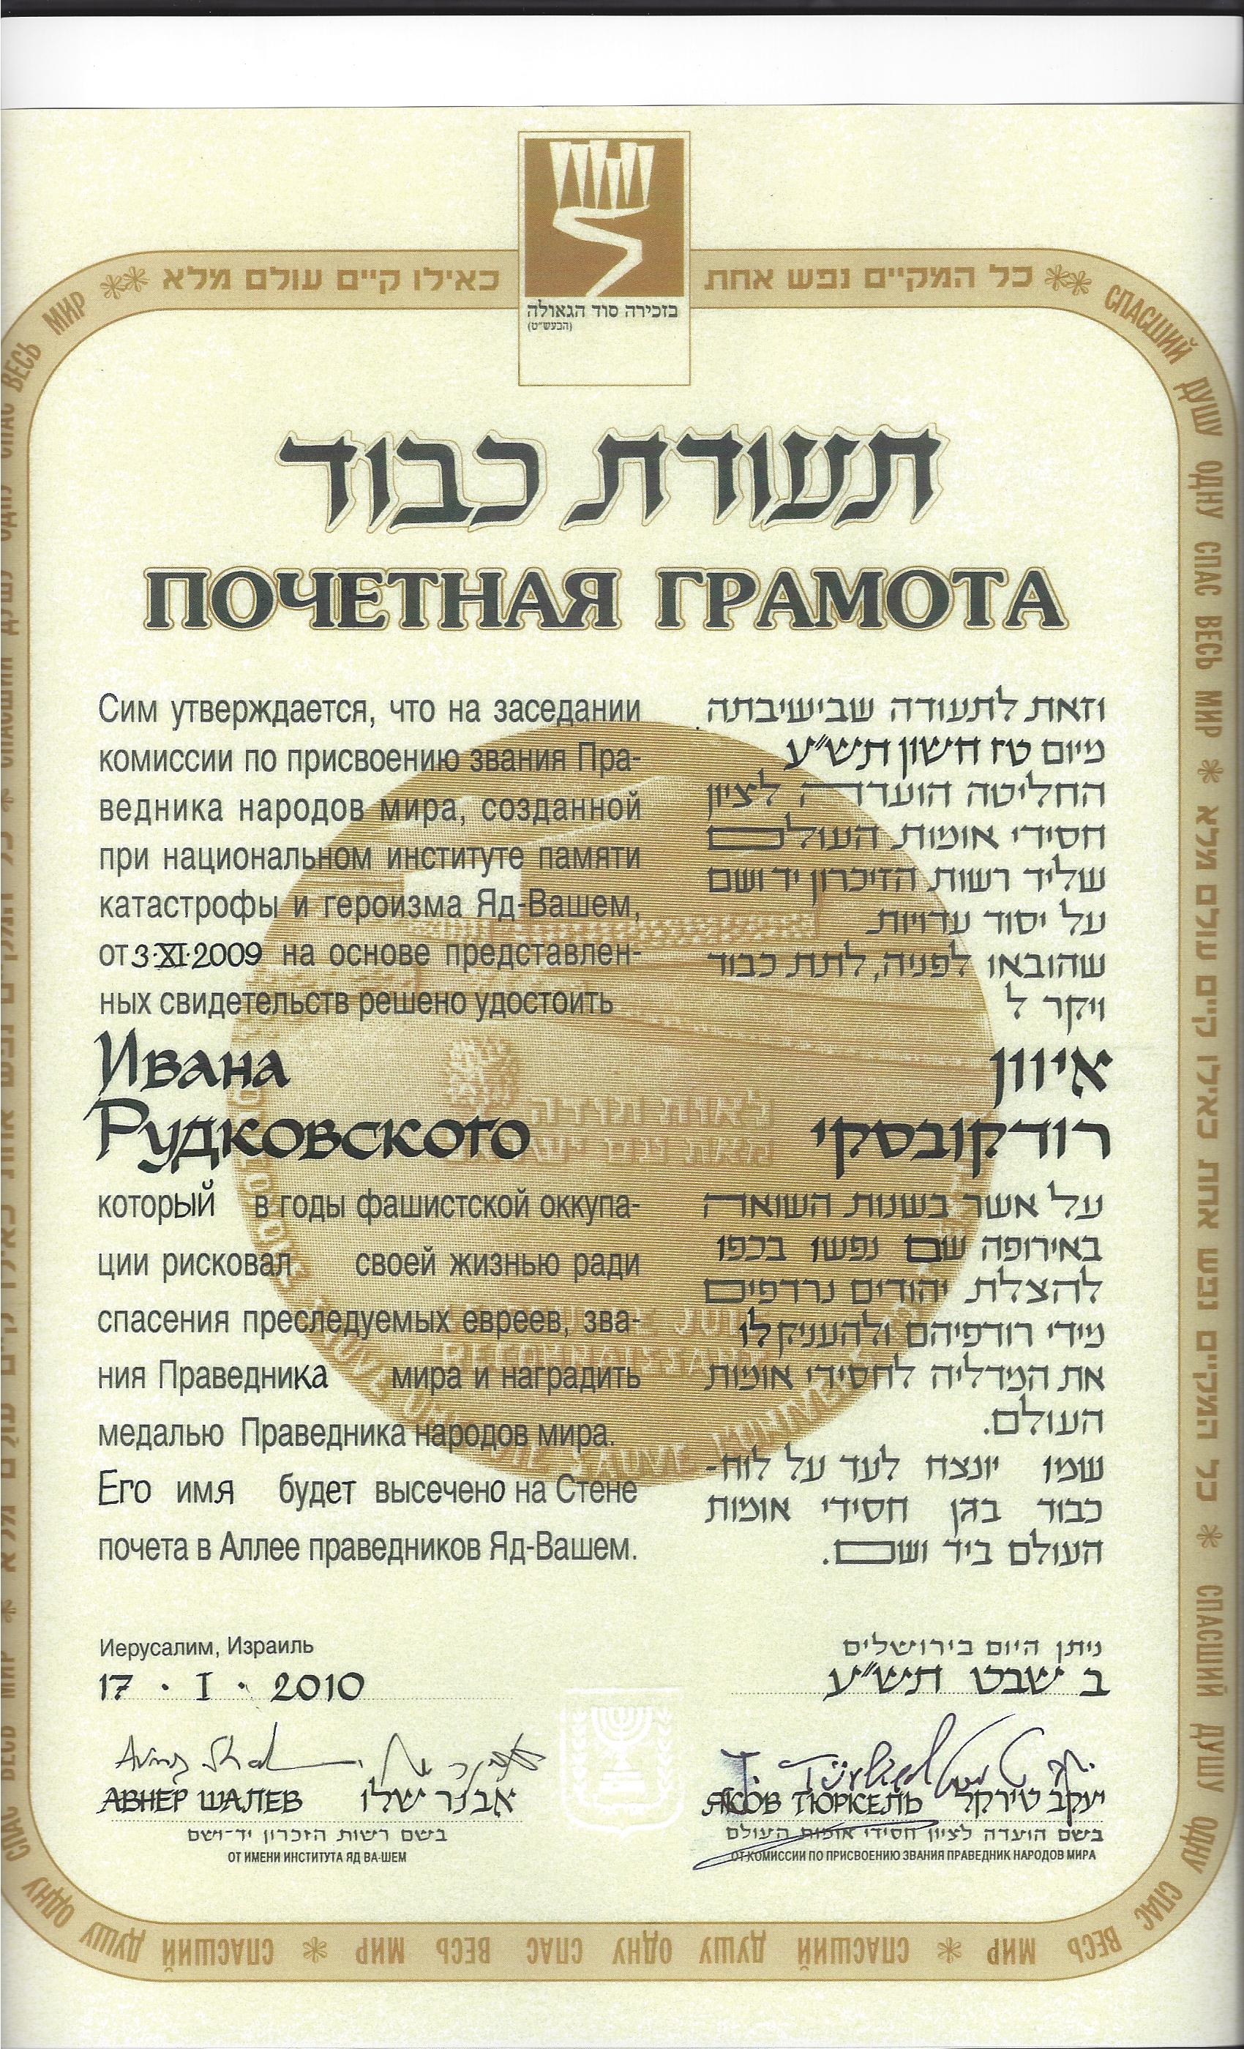
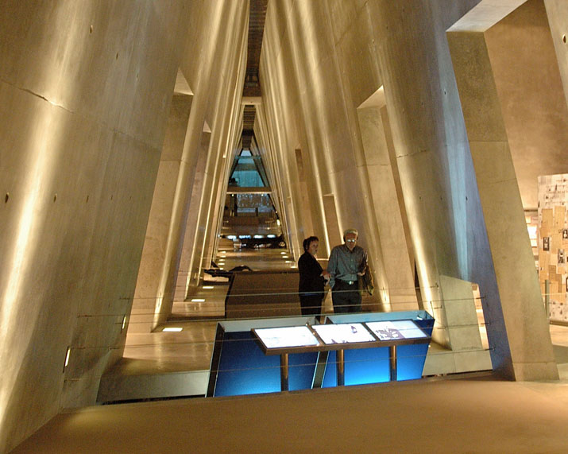

Yad Vashem, the Holocaust memorial in Jerusalem, Israel

Photo with Menachem Begin taken in the US shortly before he became Israel’s Prime Minister
