Ann Jenner Virtual Book

Ann Jenner was born on August 16, 1935 in The Hague in Holland
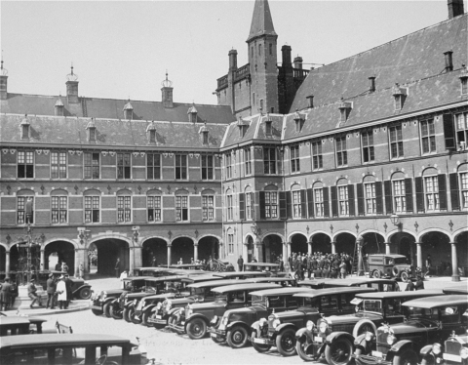

but grew up in Voorburg. 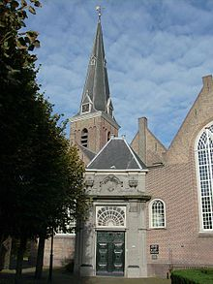

Her father was a butcher and bought livestock for the Queen. Before the war she had 2 brothers. A sister was born during the war.

The Nazis came in 1940

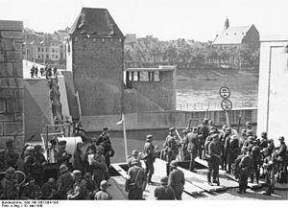

and things changed for her family: Jewish children were not allowed in the public school so she was briefly tutored at home but that ended because the tutor was Christian and prohibited from teaching Jewish students. A Jewish school was opened in a big city but Jews could not ride on streetcars and it was an hour walk. Nonetheless, she and her brothers attended briefly until the Nazis started rounding up children from the school. The Nazis decreed the Star of David with the word Jew on it had to be sewn onto clothing.

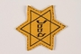

Her family was thrown out of their home in 1942. Her family was ordered to report to a camp but her mother was pregnant so they got a temporary reprieve.

The Dutch resistance helped the family and members of the underground hid them: the new baby was hidden by their former housekeeper and her oldest brother went into hiding with the housekeeper’s grandmother. Her other brother went to another couple. Ann went to a butcher who was friends with her father and her parents went into hiding, too. Later both her parents and one of her brothers were also forced to hide with the butcher. Her parents’ hiding place had been discovered and her brother was physically abused by his rescuers.

The family survived and after the war other children were born to the family.

