Shirley Weiss

My name was Shari Soloman and I was born in Kyvjazd, Czechoslovakia on July 7, 1929. My childhood was hard because my father, Martin, was an abusive alcoholic who beat my mother, Genny. Martin was her second husband and she had a daughter, Edith, from her first marriage. Edith was ten years older than I and went to the US in 1938. I also had other siblings who were younger than I: Zelda, Rose, Perla and Ludwig. My father did not make a living and we survived thanks to relatives who sent us money.

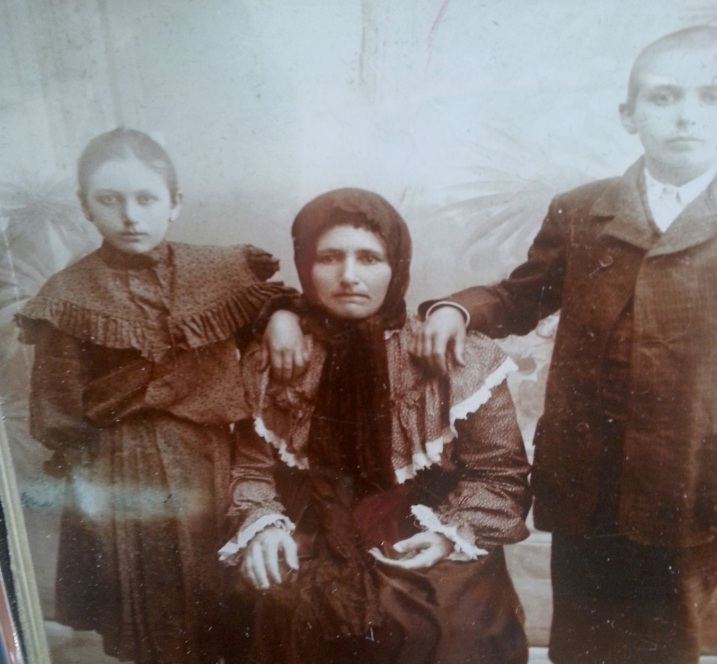
My mother Genny as a young girl with her mother, Rosa and her brother Morris.

The Hungarians, who were allied with Hitler’s Germany, came to our area in 1940 and life became miserable. Jews were not allowed to go to school and there were other restrictions. We had to start selling my grandmother’s belongings in order to get food. Things got worse when the Jews were put into a ghetto in 1943. Jews from the surrounding area were forced into the ghetto in Beregjzaz (also known as Berehove). Food was rationed and we were housed in army barracks.

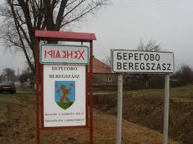

By 1944 the ghetto was liquidated. My father was gone. He had joined the underground but I did not know that. He was just gone. My mother’s health, which had never been good, got worse and worse. When the ghetto was liquidated and we were forced to leave, my sister Zelda and I carried our mother to the cattle car. She was so weak! Our other siblings were with us in the cattle car and it was in that car that my mother died in my arms. We were sent to Auschwitz-Birkenau .

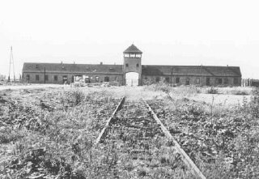 Entrance to Birkenau

When we arrived in Auschwitz-Birkenau and there were dead people on the ground and lots of other people running around. Soon I could not find my siblings anymore in all the commotion. It was terrible.

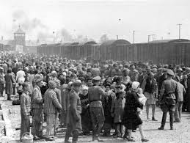
Selection at Birkenau ramp.

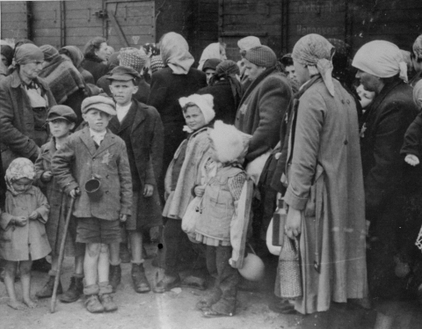
Jewish women and children from Subcarpathian Rus await selection on the ramp at Auschwitz-Birkenau. USHMM

I was sent to a children’s camp. I was shaved and given striped clothes. I did not work but had to stand in the roll call where prisoners were counted every day.
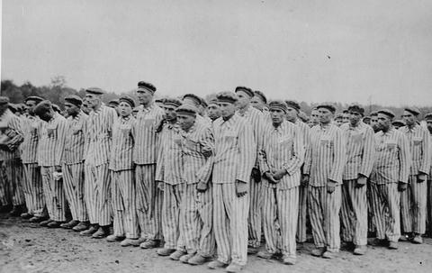

The kapo (prisoner in charge of the barrack) was a Polish woman who took a liking to me. She told me to go to another barrack where they were looking for workers. My barrack was going to be exterminated but I might survive if I left.

I went to the other barrack and was selected to work, given a shower and some better clothes and then loaded onto another cattle car. We were taken to a camp that was a bomb making factory in the Sudetenland. My job was to load boxes and I did not actually work in the factory.

One day I tried to steal a raw potato and eat it. I was caught and severely beaten. I still have pains in my back from that beating.

I was in this camp for several months until the Nazis retreated because the Russians were coming. We saw our guards beating male prisoners who passed us during their Death march out of Buchenwald. It was terrible to see how those men were beaten.

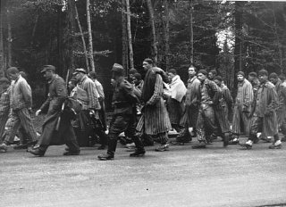Prisoners on a Death March

We were taken to Terezín in 1945 and liberated by the Soviet Russians. In the camp there were some children and elderly folks. We were confined there after liberation for fear of our spreading typhus. We were scared of the Russians. A lot of young girls were raped.

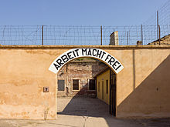 Terezin / Theresienstadt

I spent several months in Terezin. One day nuns came looking for Czech survivors. We were taken to an orphanage where we were cared for and sent to school. Then I found out from a friend that my father was alive in Prague. When I saw my father he asked what he could do for me. I told him there was nothing he could do—just leave me alone. I did not ever want to see him again.

From Prague I tried to go home to Hungary. The Hungarians gave me an ID card and I could use that to travel around Europe. In Hungary I heard people say, “Why did the Jews come back here?”

The Czech people were wonderful to us after the war. They tried to make good for us. I went to school in Prague and was almost finished with my studies when I got papers to come to the US. The papers came from my half sister, Edith. She had learned that I was alive and wanted me to come but I had to wait for my quota number.

In the meantime, the Soviet Russians started to come to my area and the nuns gave us money and put us on a plane to Sweden where we could safely wait for our quote numbers. The nuns were afraid the Russians would not let us leave. My number came up soon after I got to Sweden so I was not there long.

I came to the US on the MS Gripsholm from Sweden. I went to my sister in Brooklyn and then to an aunt in the Bronx. I went to night school to learn English. My aunt had a candy store where people liked to hang out. One day a handsome man came in and he was nice to me. He was the most beautiful man and we had a wonderful marriage for 50 years. His name was Theodore (Teddy) Weiss. His mother loved me and taught me how to cook and bake. During the war Teddy was a boxer entertaining the troops. He was born in the US to Hungarian parents.

We married in 1950 and had two sons, David and Steven. David was born in New York and later we moved to Los Angeles in 1956 and Steven was born there.
I have four grandchildren: Stacey, Ryan, Erik and Casey, and one great-grandchild named Teddy after my beloved husband.

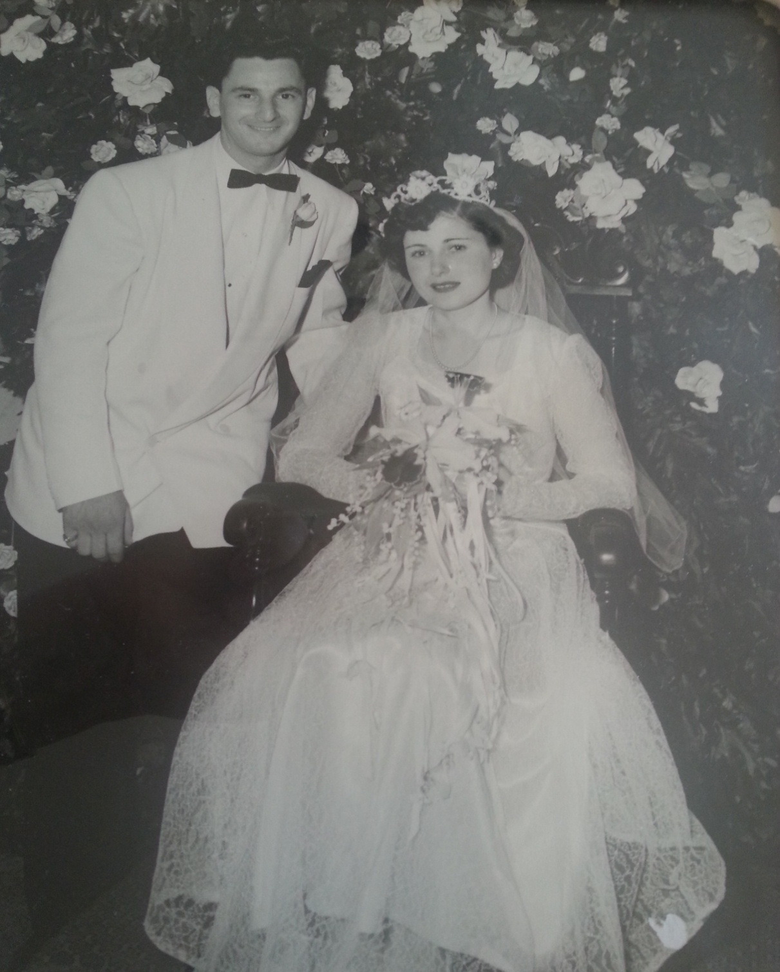

I worked for many years. First I worked for Ohrbach's department store part-time. My husband worked in the hardware store business. One of his partners stole from him. It made him sick and he had a stroke.

Later I worked for Robertson’s department store where I sold cosmetics for 12 years. We came to Las Vegas in 2002 and I continued to work for Robertson’s for a while until my husband became very ill and I had to take care of him.

After my husband died I got a call from Clinique with a job offer to work at Robertson’s again. That family-owned department story was bought out by Macy’s.

I had some good years with my husband and my children…

My message to the students who read my history: this really did happen. This should NEVER happen again to ANY human being.

