Rachel Stuczinska Taylor

My sister Tola and I about 1946. My pre-war nanny saved the hooded coat for me.
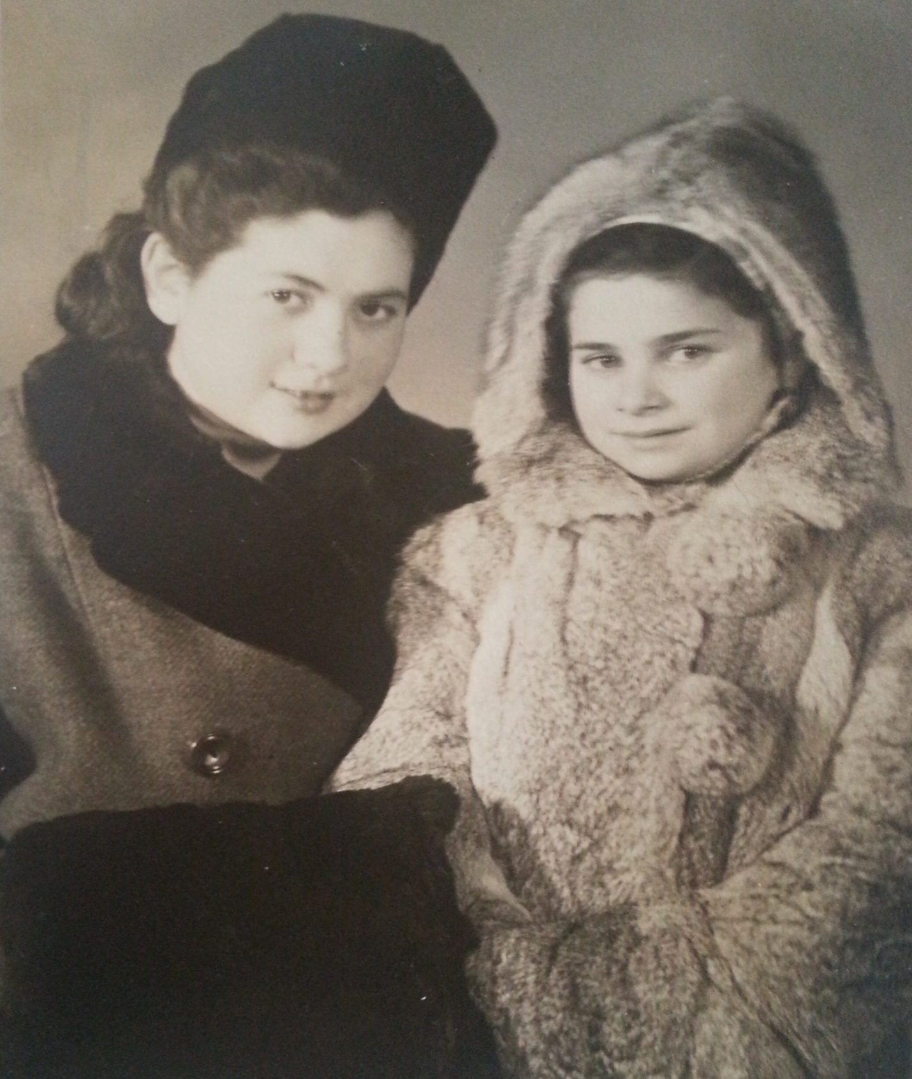

I was a baby when World War II began. I was born October 22, 1937 in Kutno, Poland near Lodz. The war began September 1, 1939. The youngest of five children, our family’s experiences were unusual as all of us survived the Holocaust.

My father, Mordechai Stuczinska, had a meat business and very fine butcher shop. My family also owned a large apartment building and got rental payments from tenants. My sister Tola (Tola was her Polish name and her Hebrew name was Yona), was the oldest child. Then came Sabina (Sarah in Hebrew), Ignaz (Shlomo), Yanka (Judy) and myself Lusia (Rachel).

Though I was very young, I remember the Nazi invasion. We lived in a one-family house. There were French doors in front. When we heard the airplanes my mother sat down in front of the door to barricade it. A bomb fell nearby and the force of the blast blew open our door and my mother went flying. I was not yet two years old and thought it was very funny.

My second memory: we went to our paternal grandparents. They lived in a large apartment building. On the main floor were stores and there were apartments above and below those stores. We were below and someone put me on their shoulders so I could see out the window. All I could see were marching boots.

My next memory: my mother came home and one of the maids put rags on her back. The Gestapo had beaten my mother demanding to know where my father was. My father was hiding because he stopped a German soldier from touching my older sister. Our neighbor had denounced us to the Nazis.

During World War I my grandmother saved the life of a German soldier in Poland. His name was Milka and she hid him. When World War II broke out he came to our town. This was very important for our family.

My older sister Tola was about 15 years old and in a French Lyceum (like a college). She brought a paper from someone in the underground (resistance) with excerpts from Hitler’s manifesto Mein Kampf (My Struggle).

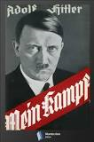

She talked about Hitler’s writings with my parents. My mother immediately started working on getting false papers for all five of us children. We were to be mixed Polish-German (not at all Jewish). What helped to save us was that we did not speak Yiddish so we could not accidentally give ourselves away as Jews. We spoke Polish.

My mother got the papers but we could not use them right away. When the Nazis created the ghetto we all had to go. We left our comfortable, warm home for the overcrowded Kutno ghetto.

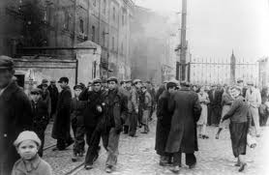Kutno Ghetto, 1940

Before the Germans liquidated this ghetto, Milka told my mother that all of us children should be transferred to the Gubin ghetto. She managed to get us all out but she could not get the rest of the extended family because they were not accepted as workers. It was hard for my father to leave his parents. Jews from our town were being sent to Majdanek and my parents knew they were being killed.
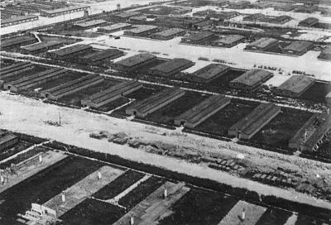 aerial photo of Majdanek, 1944

What saved our lives? My mother had been buying gold coins since she got married and had accumulated a bag of coins. She took some of the coins and hid the rest. She did not want to take all of them into the ghetto. She used some coins to get false papers for us and some other families that had children. She also used the money to bribe the guards in the ghetto.

The Gubin ghetto was a working ghetto. Even children worked: we moved stones to make cobblestone roads. At first my father was hidden in the ghetto beneath the floor of our place. A table stood over the opening to hide it and we would sit there to help hide the opening.

My sister Sabina broke her knee before the war and walked with a limp. We had to hide her or have her seated when the Germans were around or else she would have been sent to be exterminated. Crippled Jews were considered unproductive and could be shot on the spot.

Finally my father had to come up from beneath the floor because the Germans started searching for hiding places. Then both my parents were sent to Auschwitz -Birkenau.

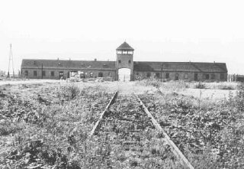 Birkenau

I was only about 5 years old at the time. I remember my father kissed us goodbye saying he was going on a “voyage”. Later my mother went on the same “voyage”. Sabina and Tola took care of us after our parents were gone.

My older sisters were interrogated (a routine beating that happened frequently in the ghetto) and that made it important for us to flee. I do not know the details of the arrangements. A Polish Priest, Father Stjansny, came with a nun and helped us escape. We were awakened in the night and told to leave everything and hidden in a cart with straw and smuggled out of the ghetto. We were taken to a farmer outside the village of Szeregowo. The farmer took all 5 of us and was well paid for this. He was an anti-Semite and did not know we were Jewish; he thought we were German – Polish mix. My sister Sabina worked for his family as their cook.

My brother was told NEVER to urinate outside so nobody would see he was circumcised. He did it anyway and other boys noticed and denounced us. The Gestapo came to our door. My brother had to run and hide in the barn. He left his shoes behind so I grabbed them and followed him. We hid all day until the farmer came to get us.

The Priest heard about this and arranged for us to move. We left and moved into an apartment in Szeregowo. Tola spoke three languages (Polish, German and French) and got a job translating for the town mayor and the Gestapo. Both offices were in the same building. She was a teenager at the time.

Tola was able to see telegrams that came into the office. One telegram said the young men in the area would be sent to the Russian front to dig anti-tank ditches. Tola got word to a friend in the Polish resistance and was able to warn the boys to hide. When the Nazis came to collect the boys, none were found.

Shortly thereafter Tola learned that all the able-bodied men, women and children were to be sent to dig ditches. She got another warning out so only the very old and very young were around when the Nazis came looking. There was nobody around who was able-bodied. This was the second time she saved people. She did things like this to help whenever she could.

One day a letter came to the Gestapo saying there were 5 Jewish children hiding. My brother had been denounced. My sister intercepted the letter and also told the resistance about the informant. Members of the resistance denounced the man and he ended up being sent to the Russian front and never returned.

A telegram came saying 5 mixed children were ordered to be sent to Auschwitz. Tola destroyed the telegram. A week later another telegram came asking why the children (us!) were not sent. We had to leave before any direct phone call could be made asking about us. The resistance told us to get together and take a walk that night. We were instructed to cross the nearby river and go in the direction of the Russian troops. People had listened to Radio Free Europe and knew a bit about how the war was going and knew the Russians were advancing.

On the other side of the river a member of the underground took us to a farm that was surrounded by the Wehrmacht (German army) – not the Gestapo. We were only there a few days but during that time my sister Judy was sick with a high fever. Tola had to cross the river to get her medicine.

We woke one morning to the sounds of screaming pigs. The Russians had come and were killing the pigs for food. Luckily there was a Jewish captain of these Russian troops. When he realized we were Jews he posted guards so my sisters would not be raped. We were able to collect our things and we waited for our mother to find us.

In the meantime, Tola’s name showed up in the mayor’s office so the Russians arrested her. The resistance got the whole city and nearby villages to come to her aid. A sea of people came and told the Russians that Tola saved them. She was released.

We went home and found other people living in our house. My father came back some time later. Then my mother came home. They both survived Auschwitz-Birkenau. My parents did not ever want to talk about what they went through there.

There were still a few coins left after the war. If not for those gold coins, we children would not have survived. My immediate family survived intact but we lost almost all our relatives.

I started studying dance while in a displaced persons (DP) camp after the war. I continued when we went to Palestine and eventually joined the Israeli ballet company as a performer. Soon I was a soloist. I met my American husband while visiting the Officer’s Club in Bitburg, Germany for Thanksgiving. We married in 1959. I danced until I had children and retired from the stage.

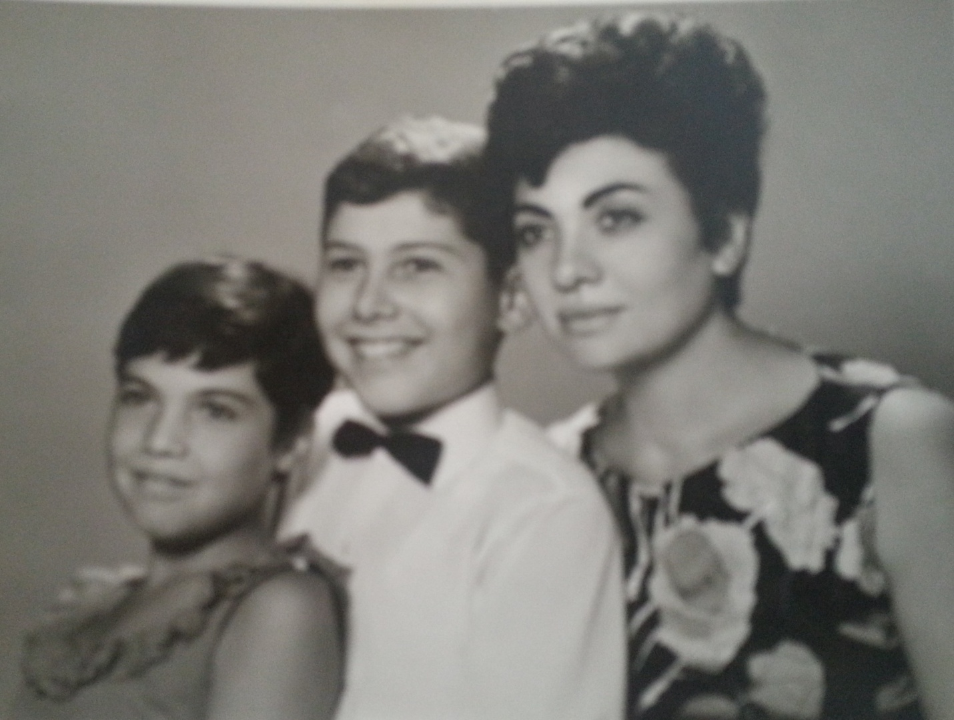
My niece Dalia, nephew Avi and sister Sabina.

I came to the US in 1961 and we traveled, like many military families. I came to Las Vegas in 2004. I have two children, Michael and Drorit. I have four grandchildren: Sivan, Shira, Hila and Davi.

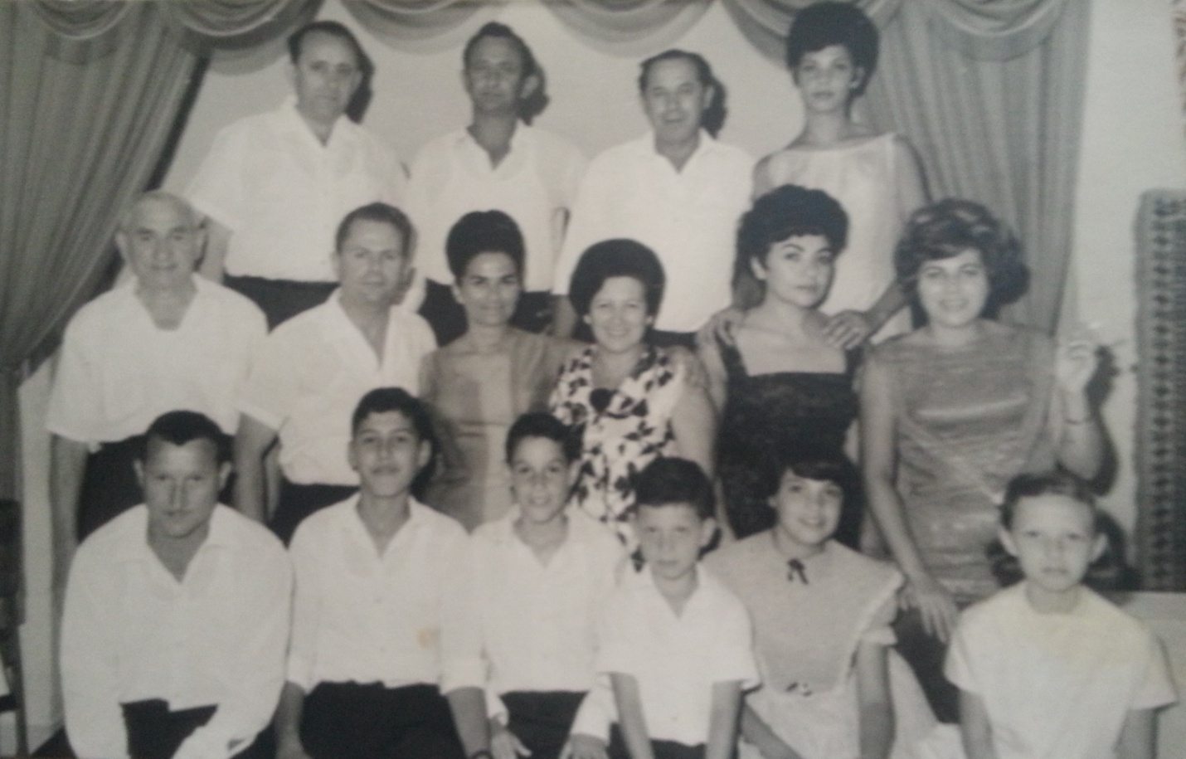
My family: back row left to right: Brother-in-law Avraham, Shlomo, Israel and Rachel; 2nd row: my father Mordechai, Shalom, me, Sarah, Sabina, Sila; 1st row: Yehuda, Avi, Doron, Shmuel, Dalia and Edna.

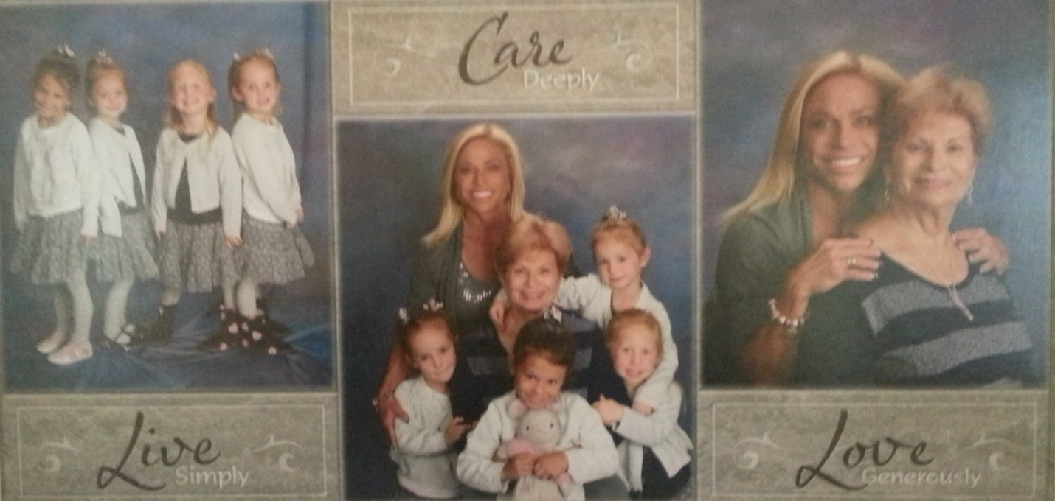
My grandchildren: Sivan, Hila, Shira and Davi. Also in the photos, my daughter Drorit and myself.

