Eva Peters*
*Pseudonym

I was born in Budapest, Hungary in 1928.

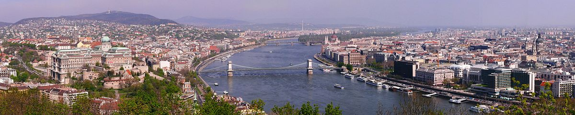

As a child I thought one day I’d be a dancer, maybe also a singer. I had trained as a dancer and was very talented. When I was little I enjoyed wearing a tutu and being in the limelight. Later I wanted to be a surgeon. We were an assimilated Jewish family with an Austro-Hungarian background. We spoke Hungarian and German. I also learned English. I was an only child and was bored in school. I hated it but even so I went through the primary grades and gymnasium (like high school) and even had two years of medical education. Before the war I went to a private Lutheran school and did not experience any anti-Semitism.

We were aware of the Nazis and some of the atrocities back in 1936 – 1937. By 1938 my grandfather started shipping some members of the family to the US but my mother did not want to go. I don’t know why she wanted to stay in Hungary. Grandfather was a genius to foresee there would be problems ahead.

Even before the Nazi invasion on March 19, 1944, there were Numerus clausus in Hungary (restrictions against Jews). My family knew a few days in advance of the German invasion that they were coming but by then there was no way out anymore.

When the Nazis invaded we could see them on the street but I was not allowed
outside. 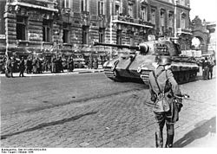

My father, who was 48 at the time, was called in for forced labor and made to dig ditches around the city as protection against a Russian invasion.

My family had to leave our home and move into a Jewish Yellow-star house. All our possessions were taken away. Dancing and schooling were interrupted. The house we lived in was a six story corner house and we had at least three families in our 6th floor apartment. We shared one bathroom. We only lived in that house for a few months before we were bombed out and had to move.

My mother, who didn’t look Jewish, and I had false papers saying we were Christian so we were able to move to shelters under another building. My false name was Magdalona Roys. My father, who looked Jewish, did not have false papers so we hid him in the deep bathtub. There was no water for baths.

We knew some Jews were taken away.
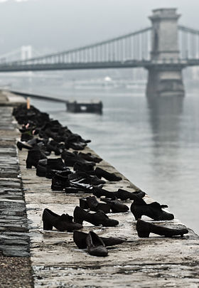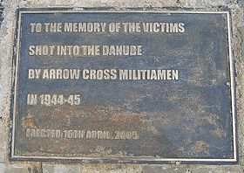

Jews outside of Budapest and those without friends or resources were more likely to get caught. We were lucky and not sent to a concentration camp.
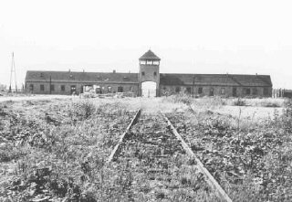 Auschwitz-Birkenau

Towards the end of the war all we had to eat was beans. The water was cut off so people sat with cups trying to catch drops falling off the faucet in the shelter. I don’t remember being hungry but I know my parents were hungry. We had some sugar and were able to trade it for food.

I remember fighting between the Russians and the Germans around Christmas, 1944. I do not recall when exactly the fighting stopped but when we were able to get out of the shelters we went to our former family home, where I grew up. It was destroyed – flattened. There was no food or clothing. We walked to a nearby town to a man who used to work for my father. He gave us food and shelter for a few months. He was a good Christian.

After the war my father started working again. He started building and rebuilt our apartment house and we moved back in. I returned to school after missing a whole year.

My immediate family survived intact but we did lose my paternal uncle and his wife. We re-established contact with our relatives in New York but my mother wanted to stay in Hungary.

Life in Hungary under the Communists was miserable. In 1950 I started my medical education but was only able to do two years before I was thrown out because my parents had once been wealthy. The fact that we lost everything in the war did not matter.

I stayed in Hungary until 1956. By then I was married. Years before my husband had worked as a chauffeur for Raoul Wallenberg. He was supposed to drive Wallenberg to a meeting with the Russians but he was removed from the job and there was another driver. My husband survived but Wallenberg was never seen again.
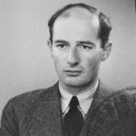 Raoul Wallenberg

When my husband and I left Hungary for Vienna, Austria all I had was what I was wearing. The Austrians gave us food, shelter and clothing. We were among the first 5,000 Freedom Fighters who escaped Communism so we were like celebrities. We only stayed briefly in Vienna and then came to the US.

When we arrived in America we were first sent to Camp Kilmer until my uncle from New York came and got us. Because I spoke English I was able to get a job at Macy’s and then got other jobs, too.

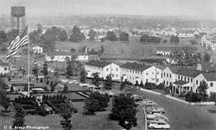 Camp Kilmer, NJ

We stayed in New York about a dozen years and then moved to California. We came to Las Vegas almost 20 years ago because my husband wanted to be here. He loved it here until he passed away.

I don’t like to talk about these things. My memories are painful. They won’t bring back my parents or what we had.

