Virtual Book
Claude Black

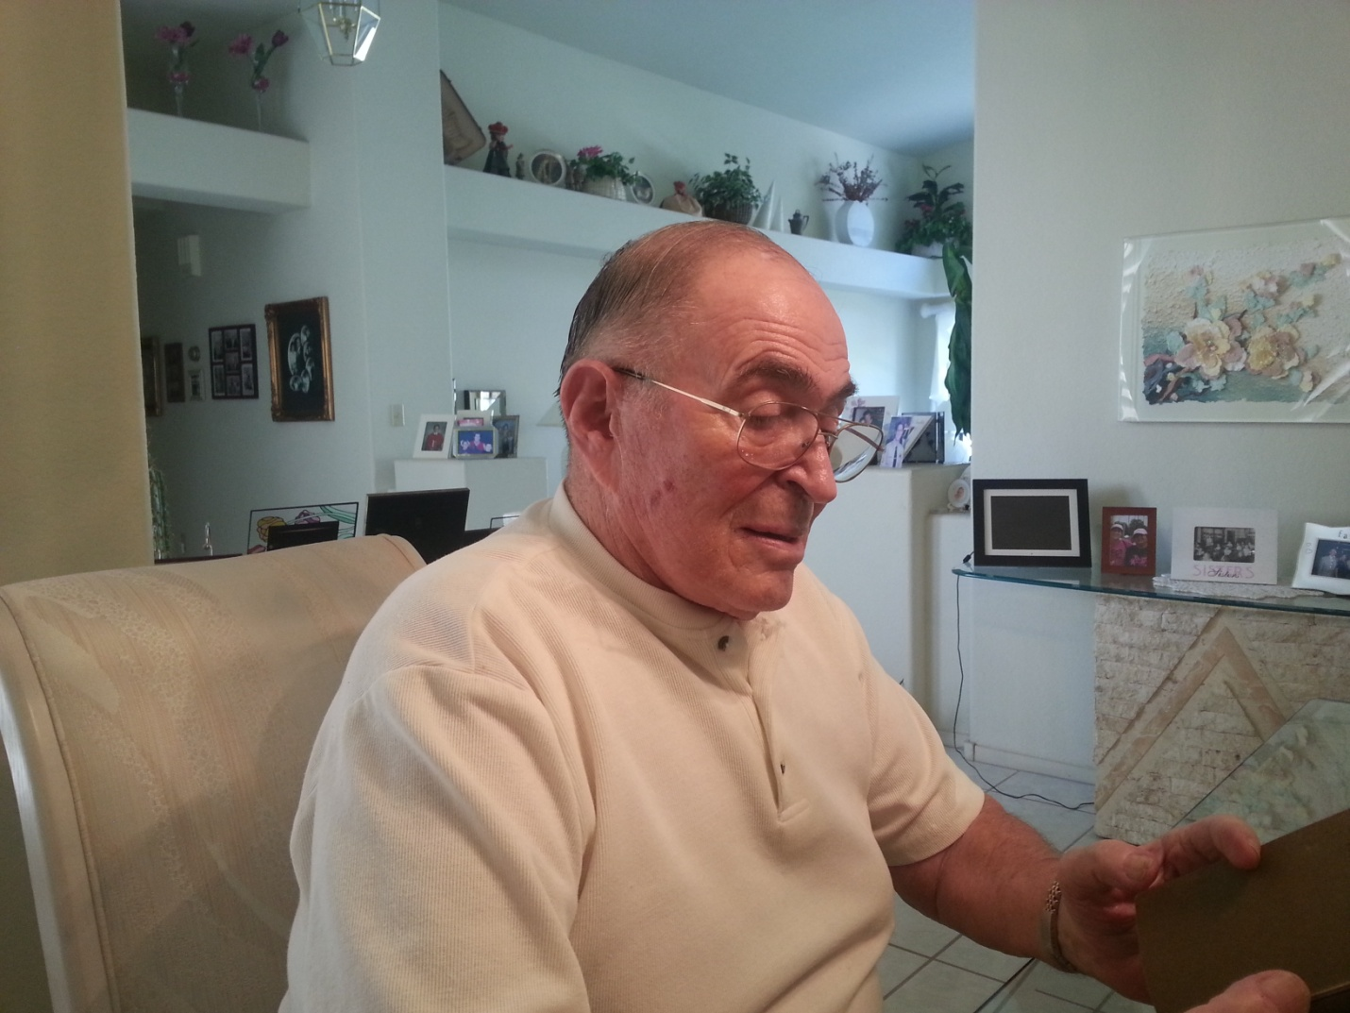
I was born May 17, 1931 in Offenbach am Main , Germany.

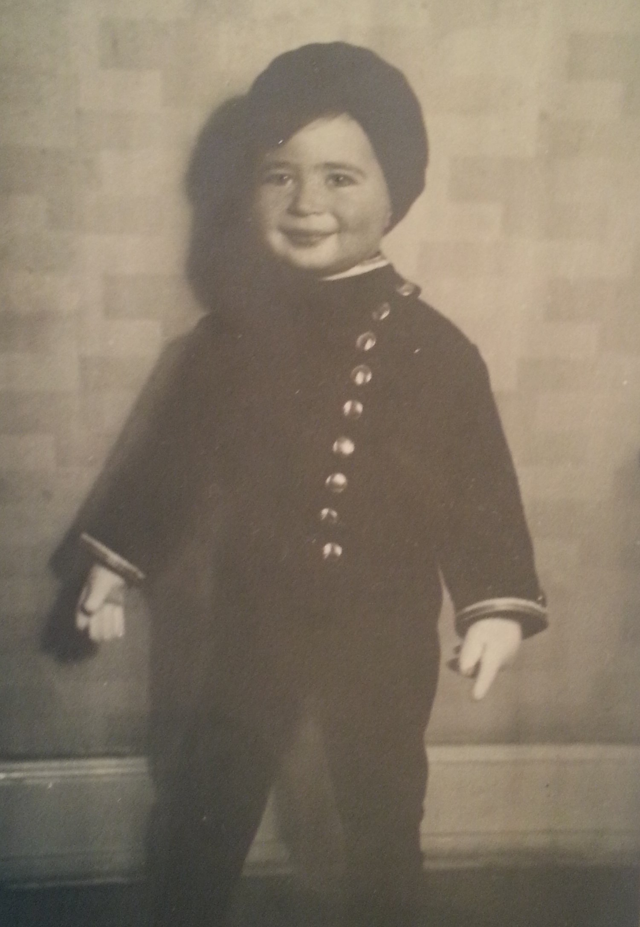
Me as a young boy in Germany.
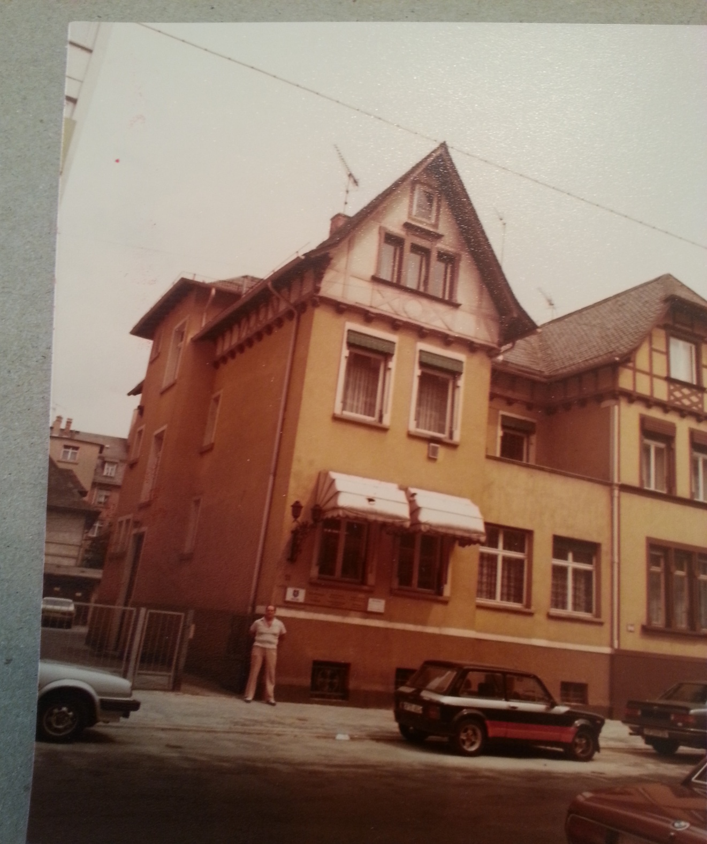
Photo of me in front of our former home taken in 1983: 11 Luisenstrasse in Offenach, Germany

My father, Leo Schwarzwaelder, was self-employed in a business that sold accessories for the manufacture of leather goods such as zippers, snaps and other items.

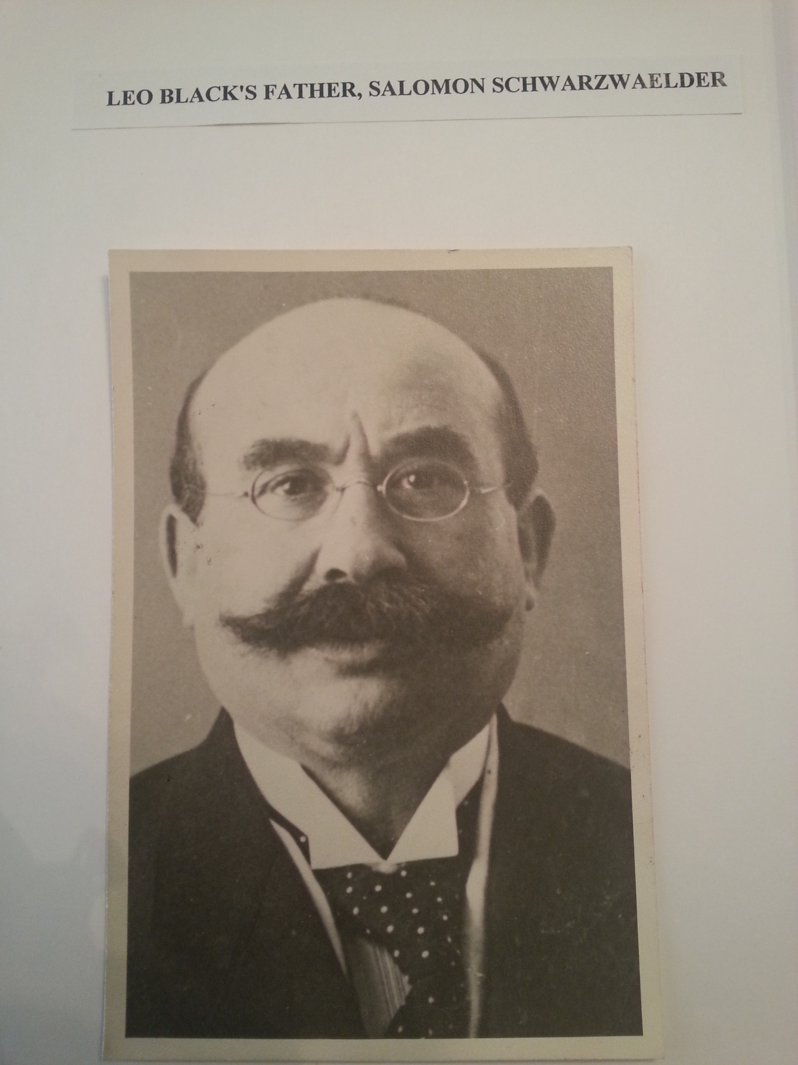
My father’s father.

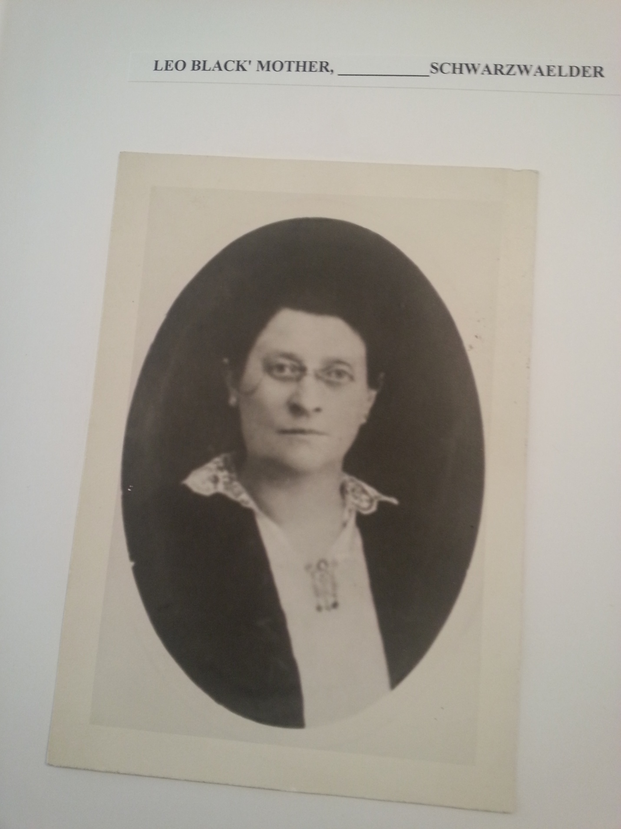
My father’s mother.
My mother’s name was Helena Herrscher Schwarzwaelder and she worked with my father in the family business. I was an only child.

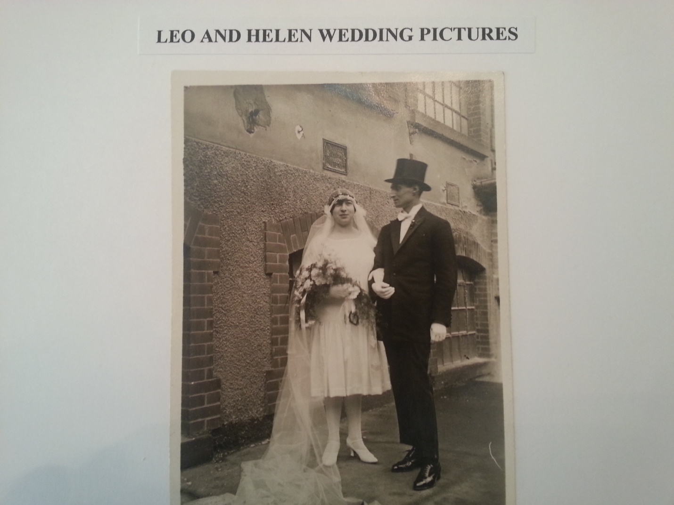
My parents at their wedding
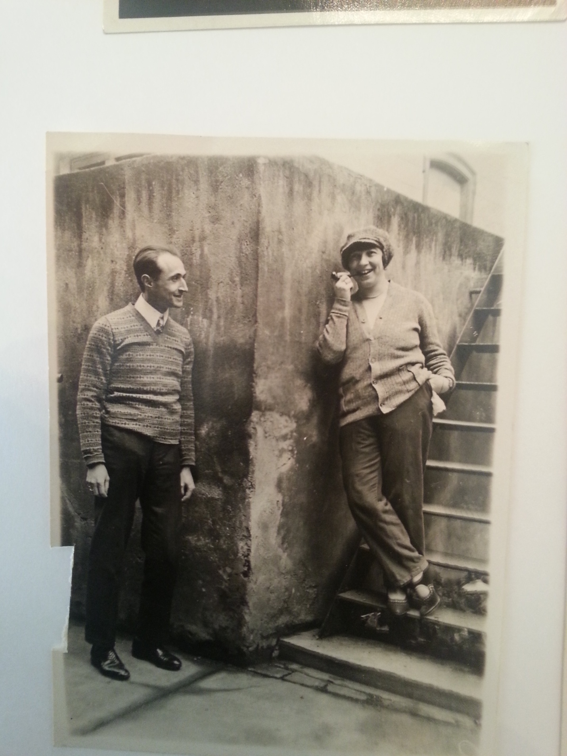
My parents on their honeymoon.
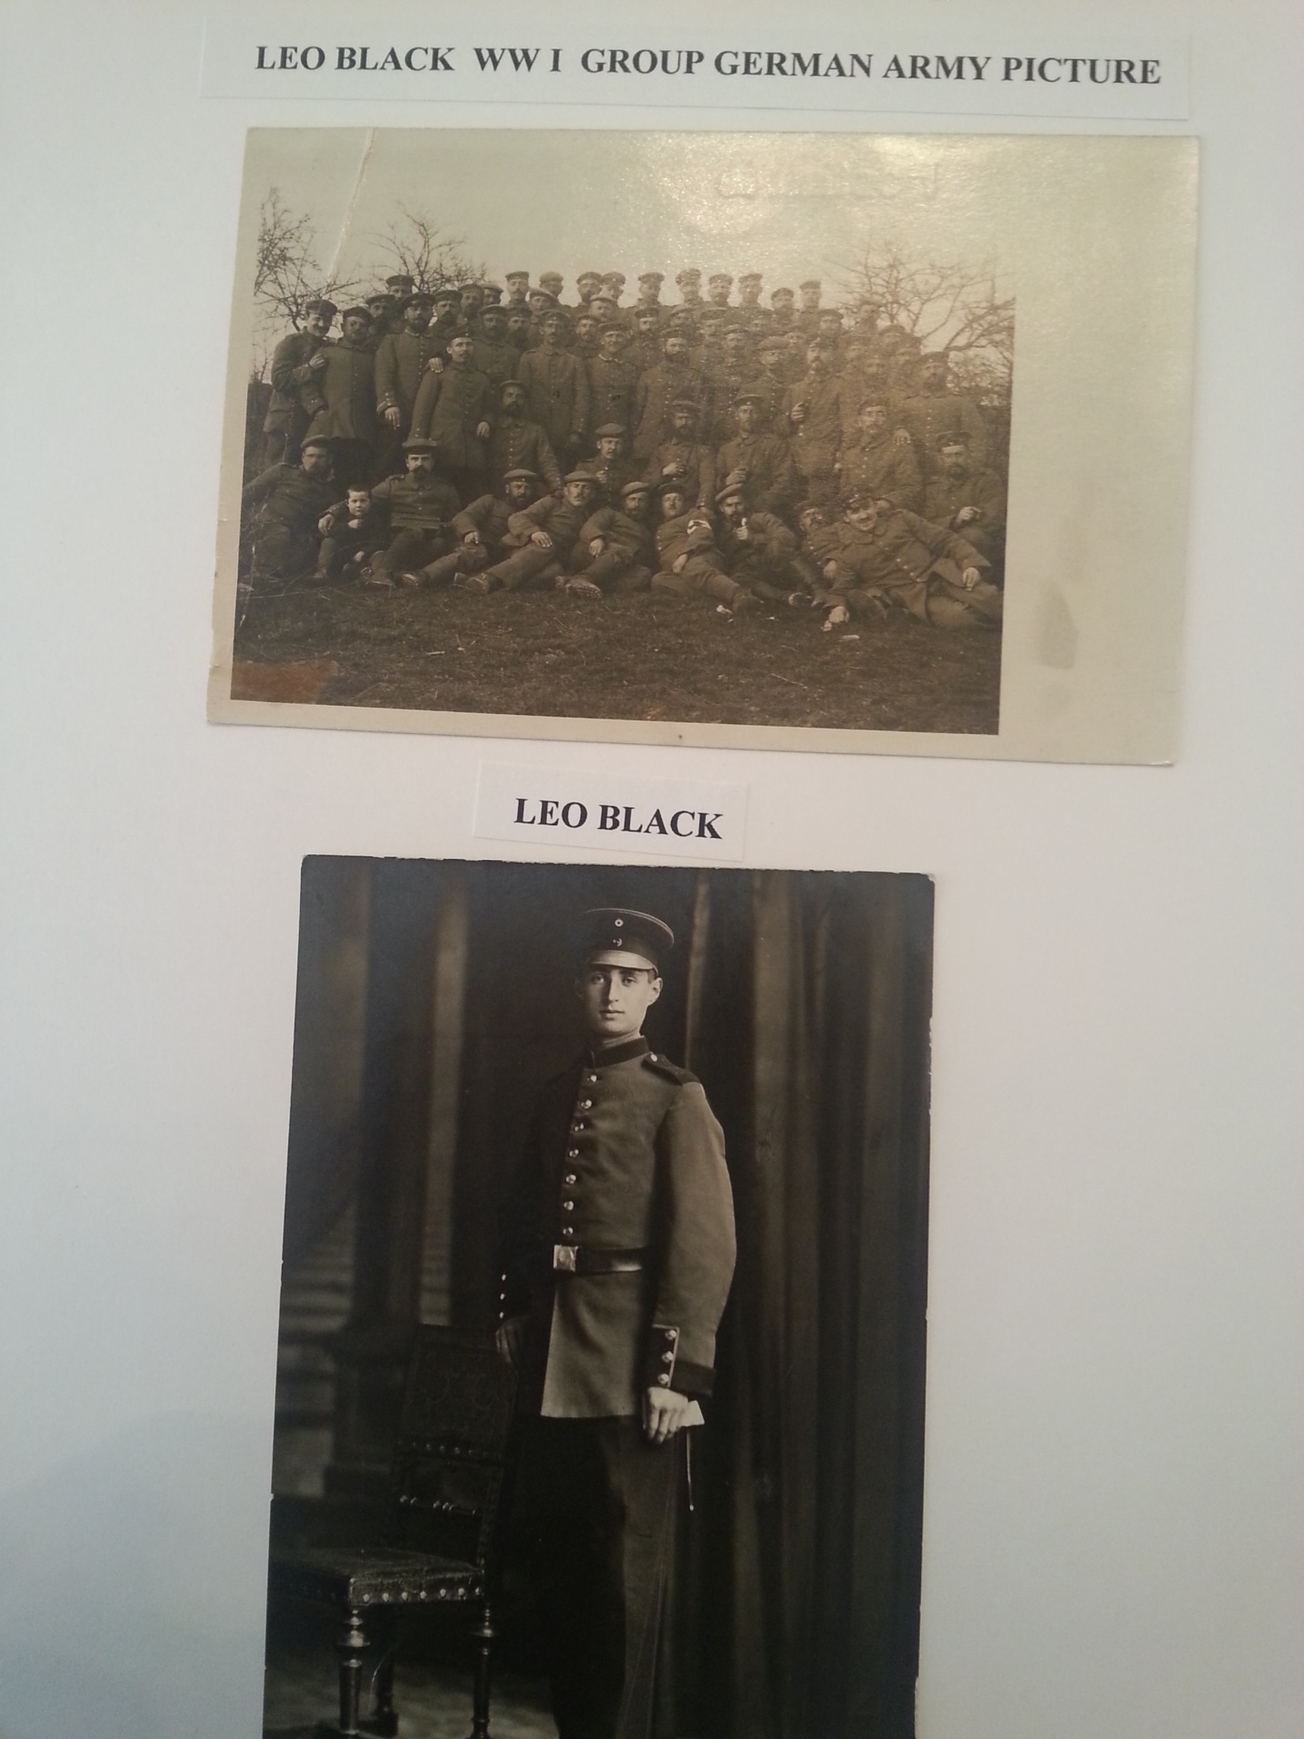
My father in his German uniform from World War I.

We left Germany on August 1, 1939.
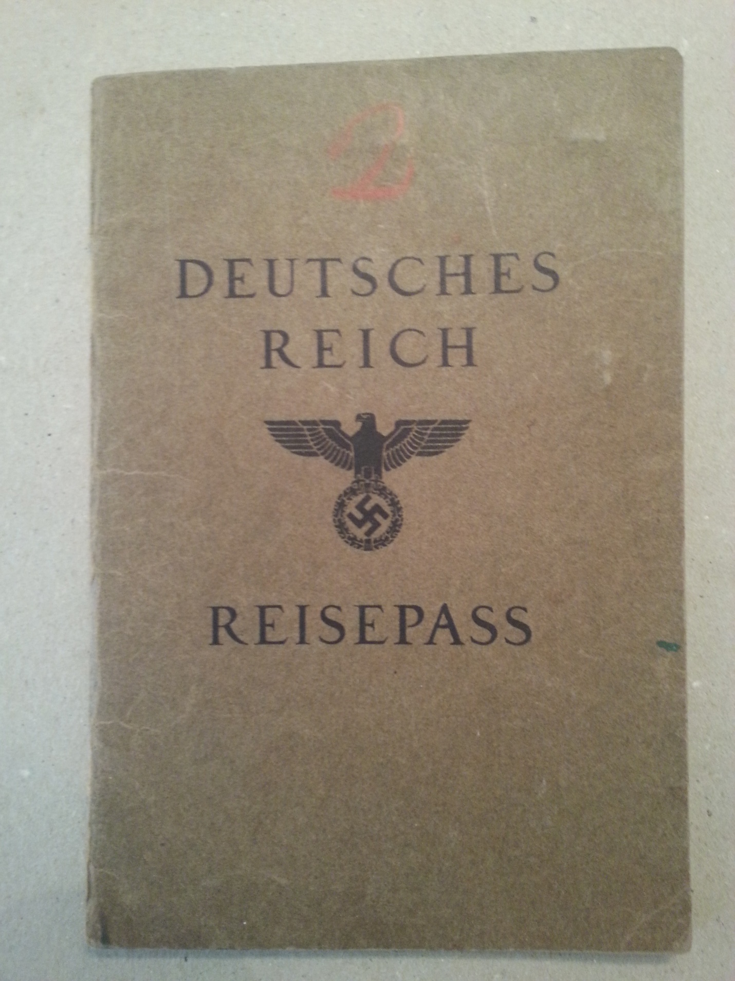
Passport issued by the Nazi Reich
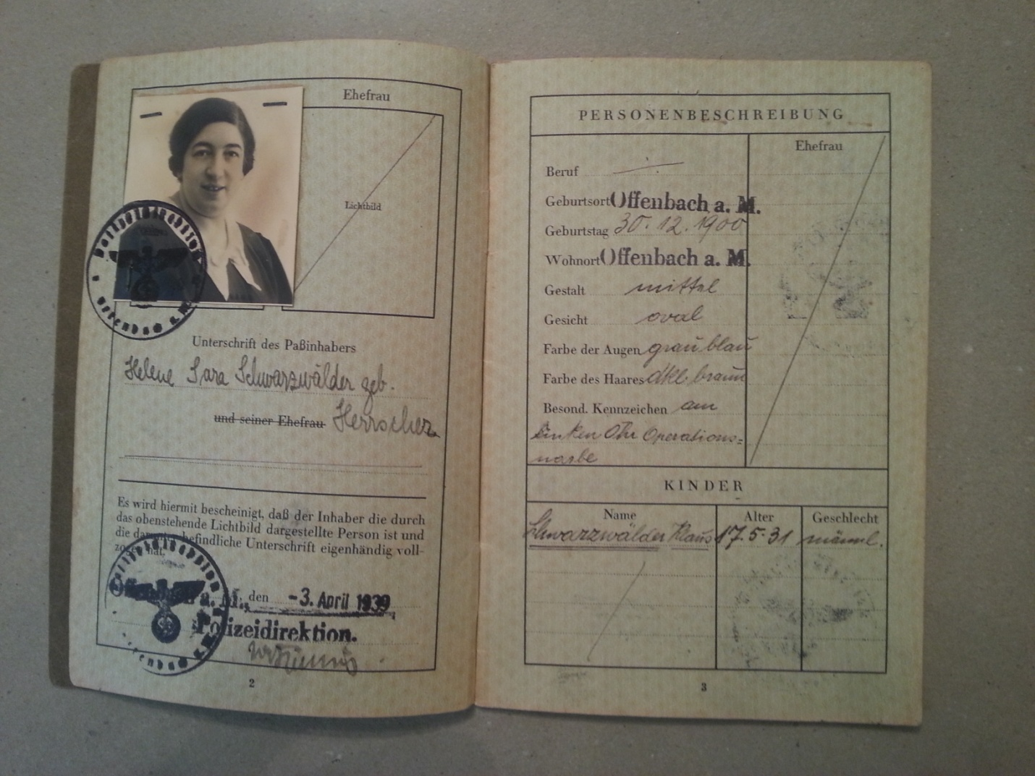
My mother’s passport had my name, too, under “kinder” (children). Note the middle name Sara was added to indicate she was Jewish.

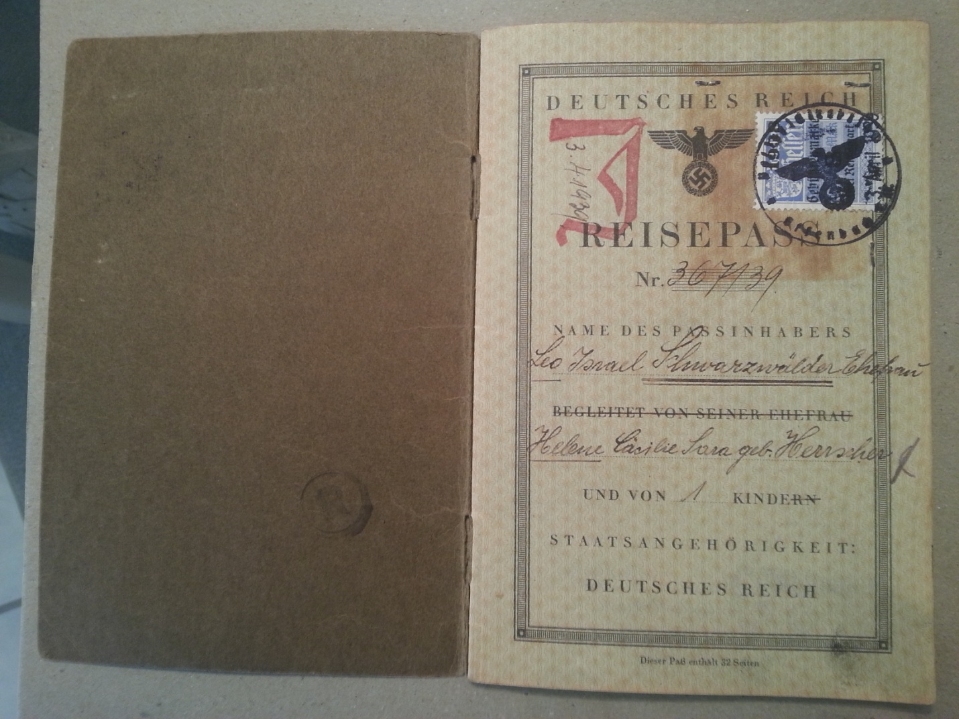
My father’s passport with the J in red and the middle name Israel added to indicate he was Jewish.

This was exactly one month before World War II began. We left because my father had been arrested during Kristallnacht (The "Night of Broken Glass") and sent to Dachau.

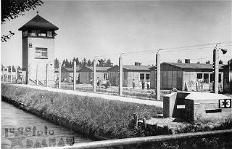 Dachau

My father never talked about what happened there. When he was released and came home he had a huge breakfast. My parents made plans to leave Germany.
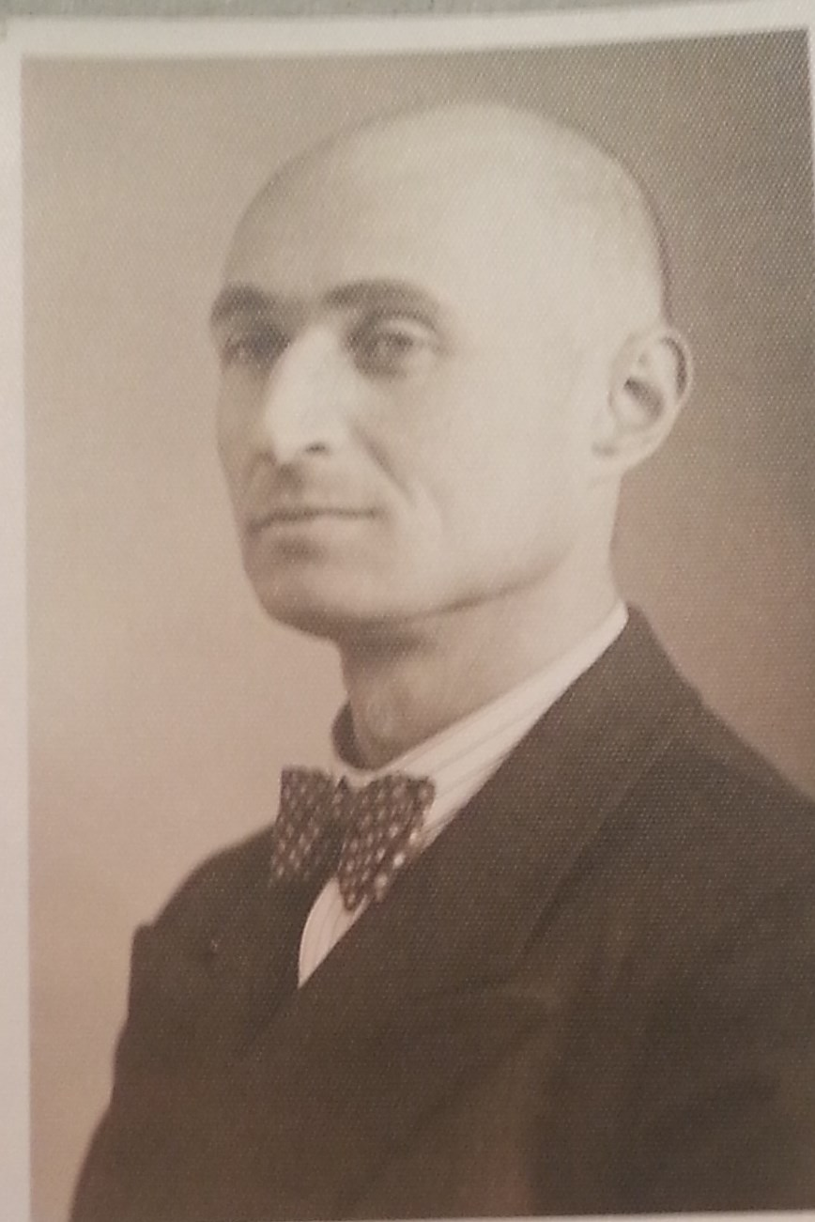
My father after he came home from Dachau circa 1938

Our belongings were packed up and we went to London, England for about six months. I don’t have many memories of that time but I have some souvenirs from the ship we took in January, 1940. Our belongings from Germany never arrived.

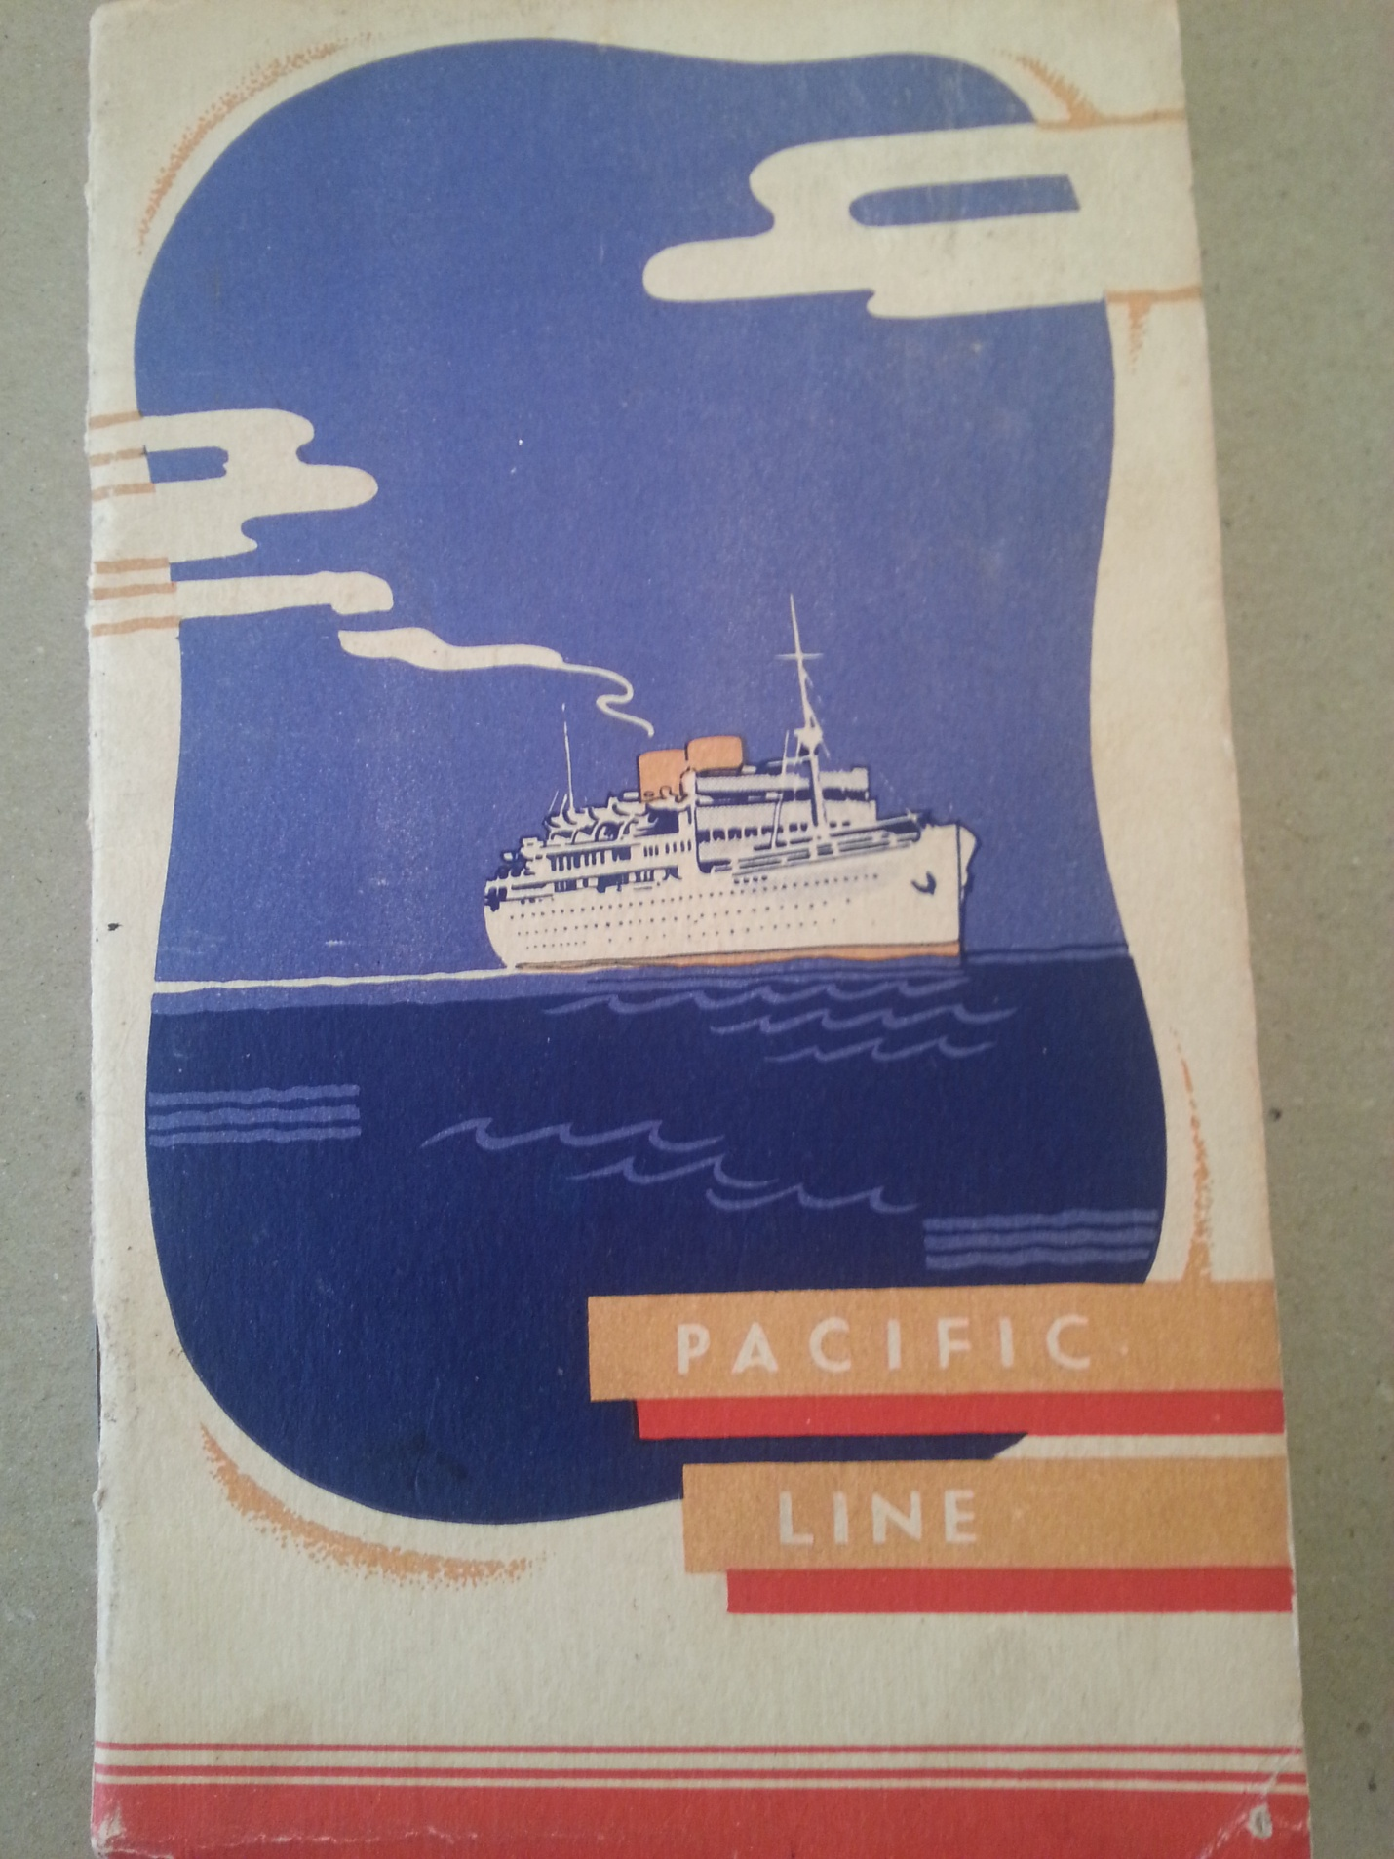

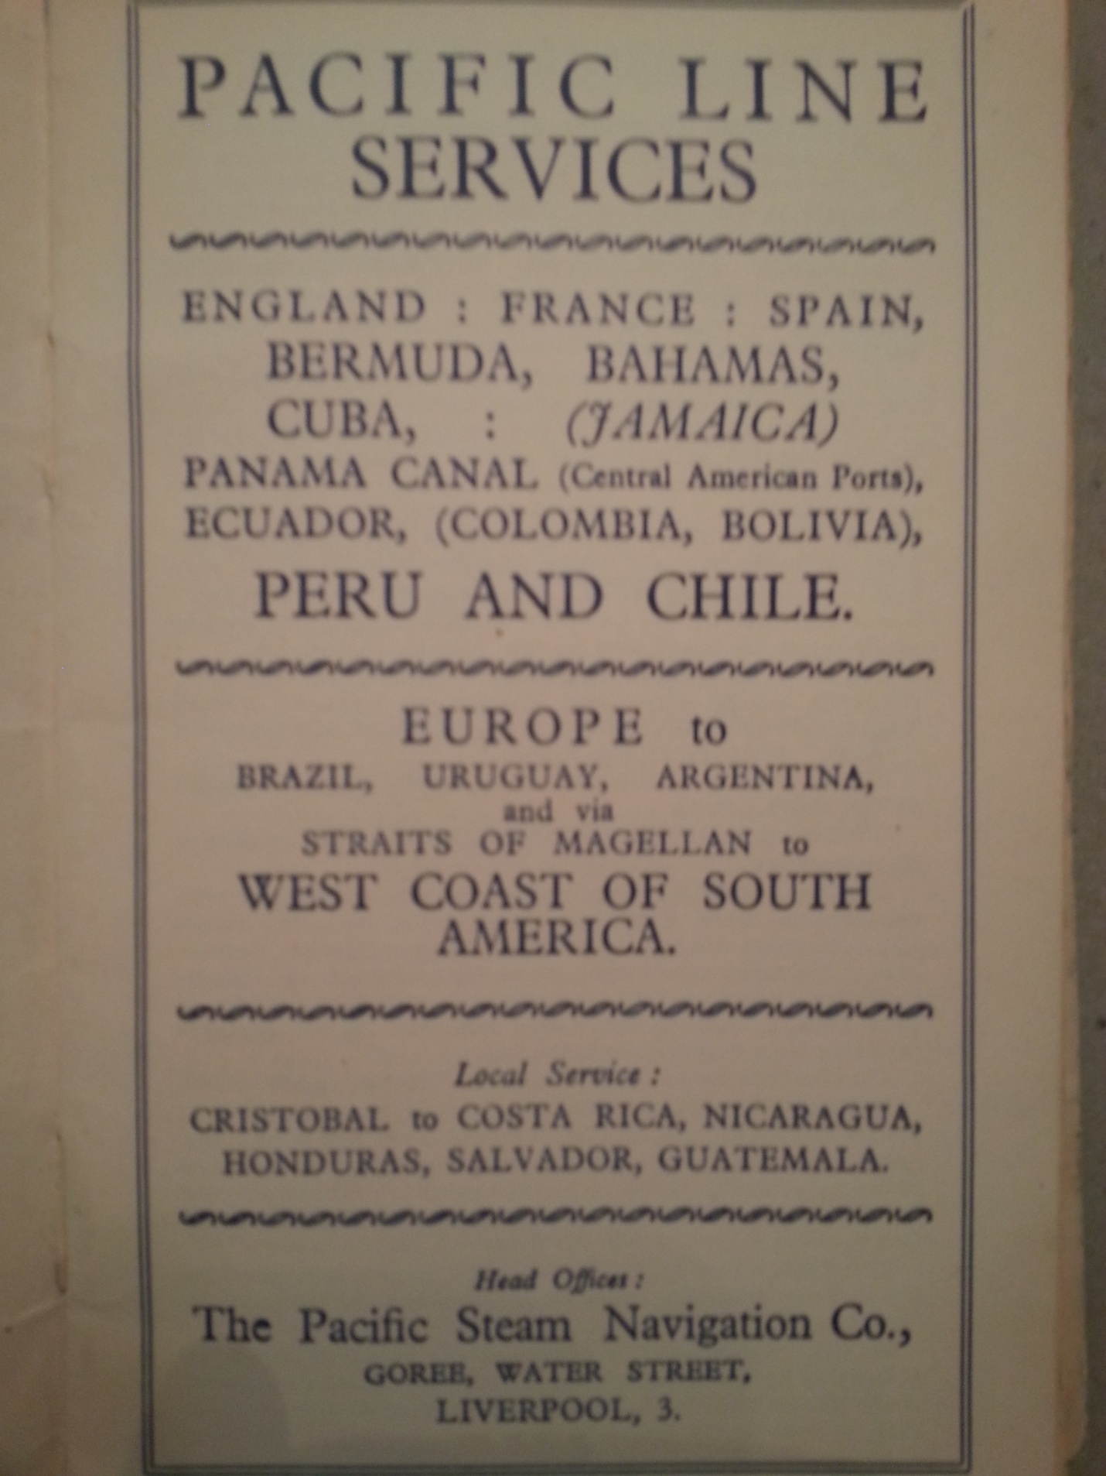

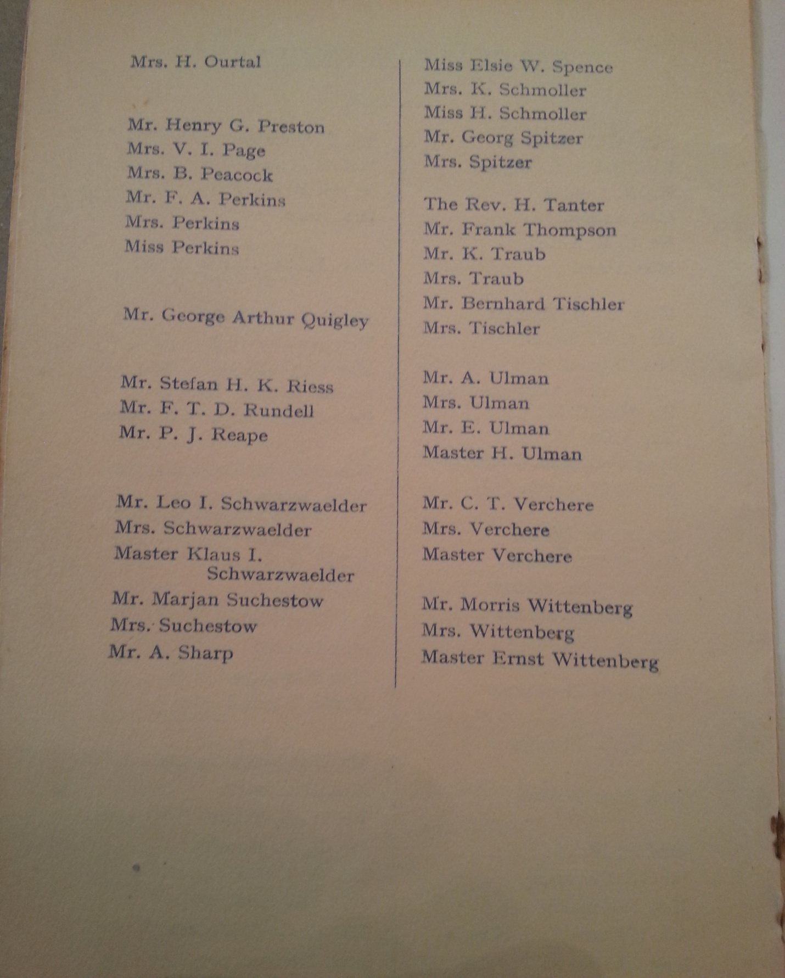
Our names on the passenger list.

My maternal grandparents stayed behind in Germany. My grandfather was ill. After the war we learned my grandmother was sent to the Terezin (Theresienstadt) concentration camp where she perished.

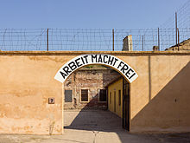 Terezin. Sign says: work makes you free.

After our months in London we went to Concepción, Chile but we arrived right after a big earthquake so our family decided to go to Santiago instead. We were there until December 1946. I went to elementary school in Santiago and did not notice any anti-Semitism. My parents opened a deli but the economy was not great. We decided to leave Chile and try again to go the US since the quota system was more open at that time. We went to the US when our quota number finally came up.
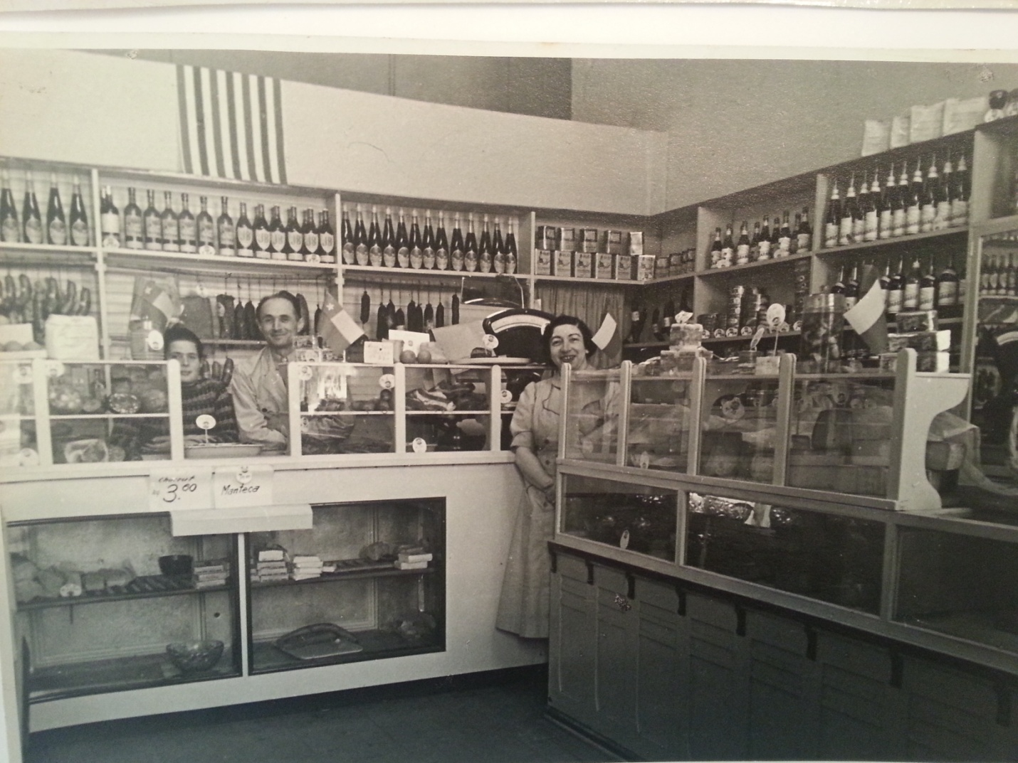
I was standing with my parents in our deli in Chile.

We were sponsored to come to the US by my mother’s cousin’s family in Chicago. I was 15 years old by the time I came to the US. We had taken a freighter to America and landed in Galveston, Texas. We then took a train to Chicago. We lived in the Hyde Park area near the University of Chicago. My mother worked as a bookkeeper for a clothing manufacturer and my father worked in a factory.

I didn’t know much English so it was recommended I go to elementary school for a while (rather than start in the middle of a semester) before I started high school. I had taken some English (as a foreign language) classes in Chile but it was not enough. I started high school at midterm.

There was a German-Jewish family there that ran a store and after the war they specialized in sending care packages to survivors in Europe. I got a job there for a while packaging these boxes. I later got a job working for a national grocery store chain as a stock boy. After finishing high school I went to Northern Illinois State Teacher’s College (now Northern Illinois University) on an industrial arts scholarship. Since I didn’t speak English fluently when I first arrived in the US I ended up taking industrial arts courses. In college I also studied the languages which I spoke (German and Spanish).

I was in high school from 1947 – 1951 and went to college from 1951 – 1955. I joined a US Marine Corp officers program in college and went on active duty after graduating in June 1955. I was offered a commission after graduation. I got married before I started active duty. My first tour of duty ran from 1955 – 1957 but I stayed in the reserves for many years and was called back to active duty when needed until 1985 when I retired as a Lieutenant Colonel. As an immigrant kid it meant a lot to me to serve my country as an officer. I was an intelligence officer and also a training officer and, because of my language skills, became a General’s aide for a short time.

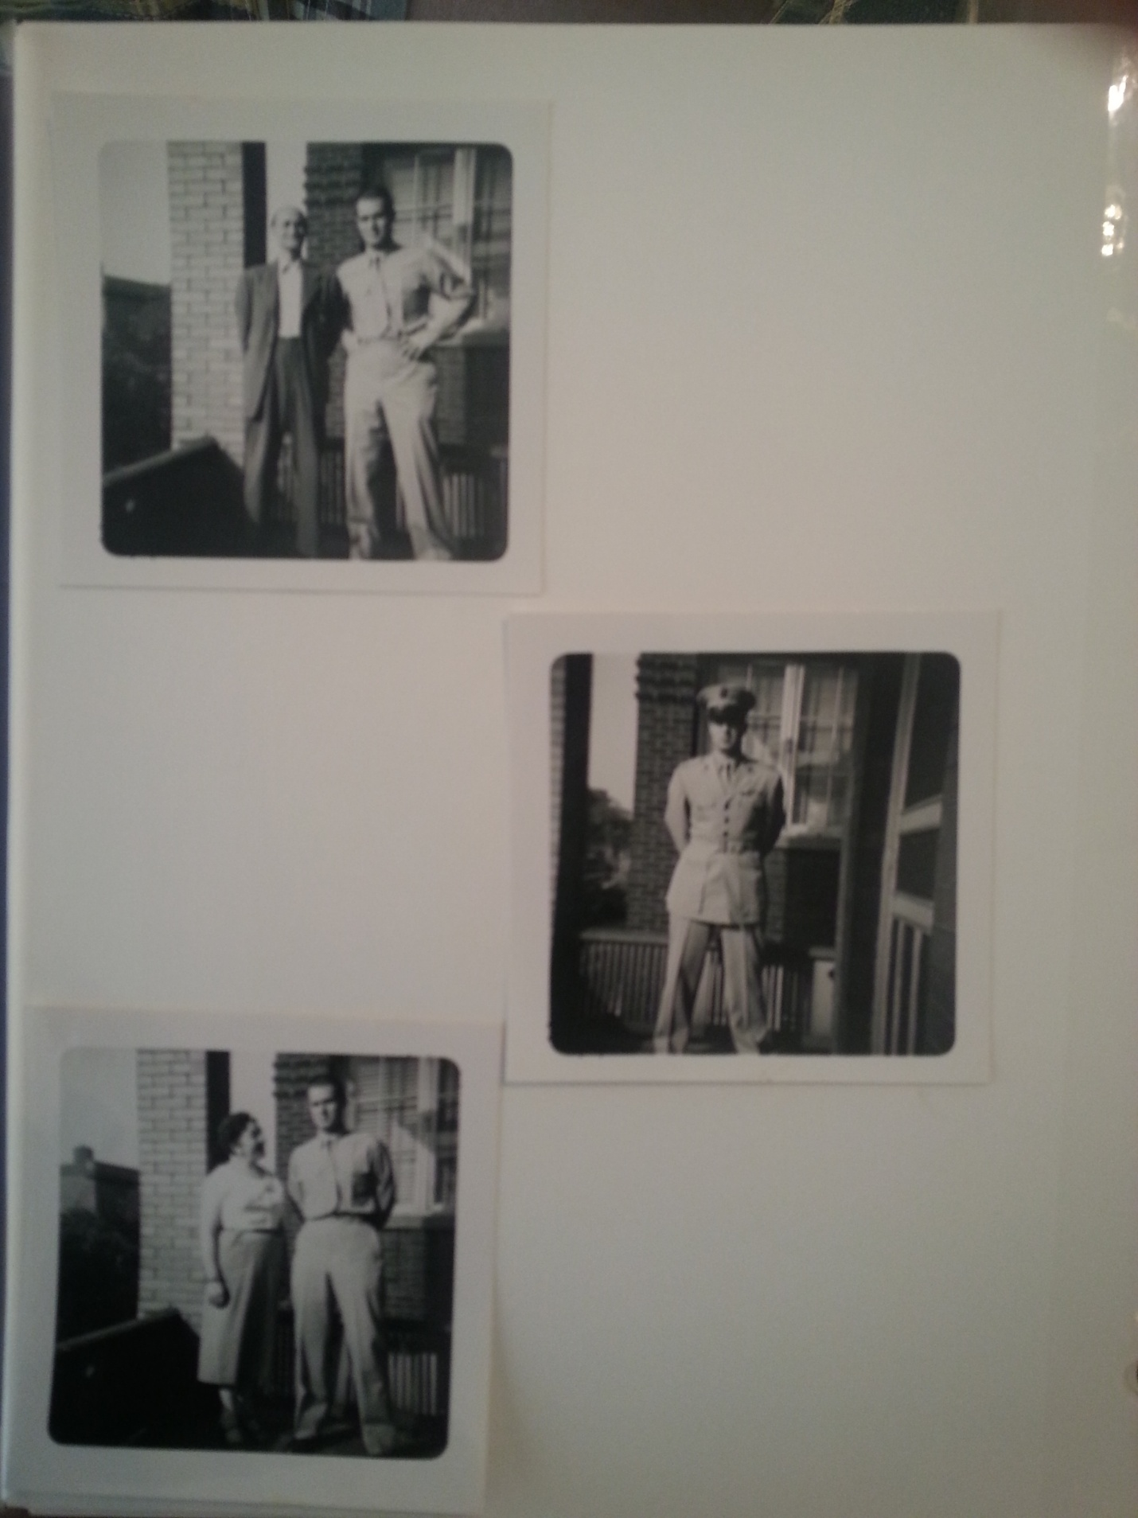

On my first visit home after finishing officer training.
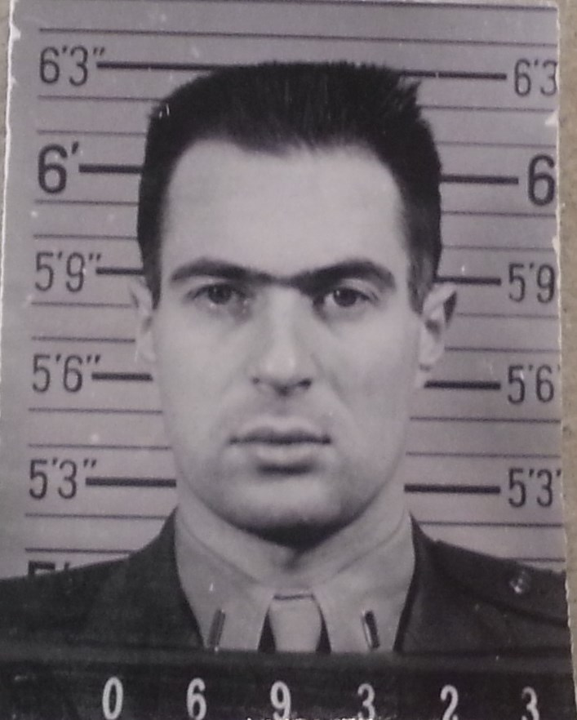
My official Marine photo.

I have a son and a daughter. We lived in Orange County, California from 1958 until I moved to Las Vegas in 1995.

The 75th anniversary of Kristallnacht commemoration program we had in Henderson (November, 2013) was enlightening for me. Since my parents never spoke about the events of that time in Germany, I really did not understand much about what happened. The keynote speaker, Michael Berenbaum, enlightened me about Kristallnacht and I learned more than I ever knew before. I was never able to figure out why my father was not tattooed or why he was released from Dachau. When Berenbaum mentioned that Jews with enough means could leave, it finally made sense.

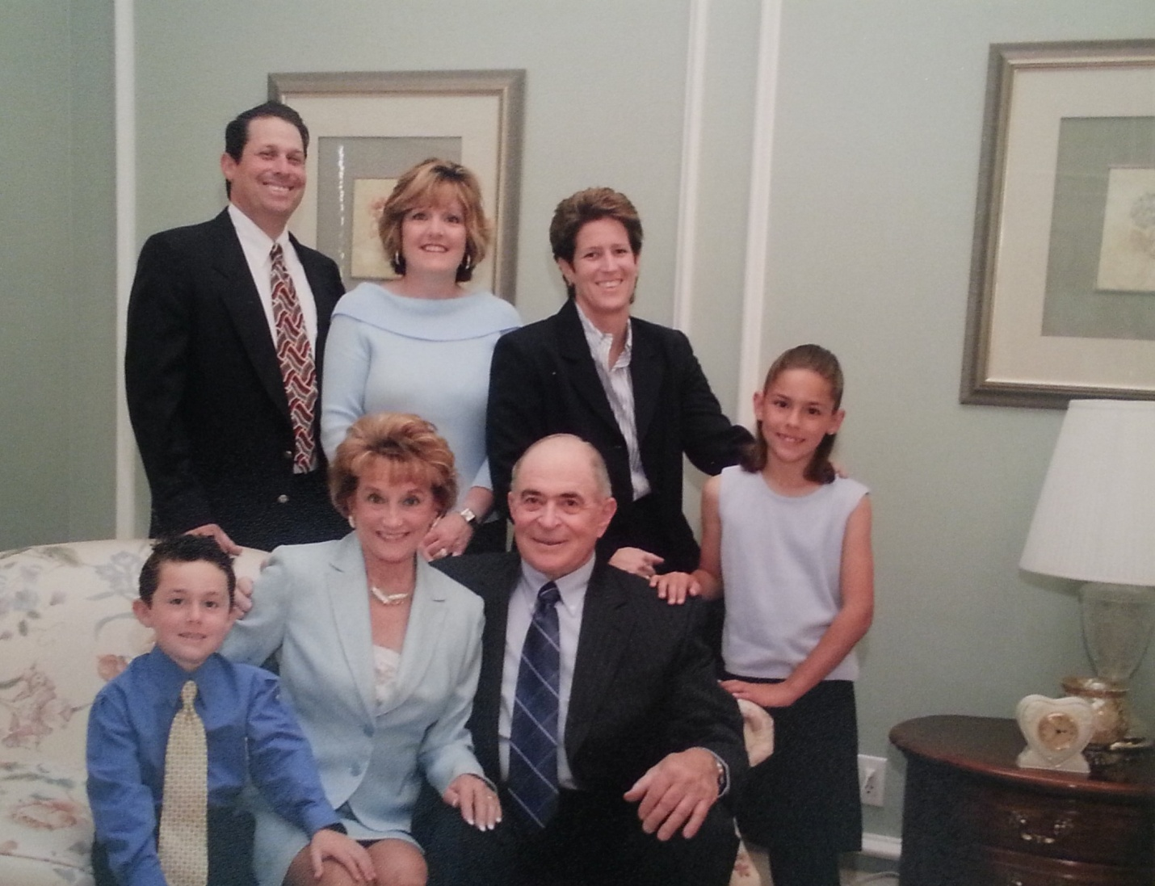
My family: back row: my son Brian and his wife, Gina; my daughter Dina. Front: grandson Tyler, my wife Marian, myself and granddaughter Alexandra.

